Design and Verification of an Application Specific Integrated Circuit (ASIC)

Senior Project II



Kevin Cao, Whitley Forman, Dhruvit Naik,

Zachary Nelson* and Julie Swift

*Team Leader

Dr. Orlando Hernandez and Dr. Larry Pearlstein

May 2016

**Fulfillment Page**

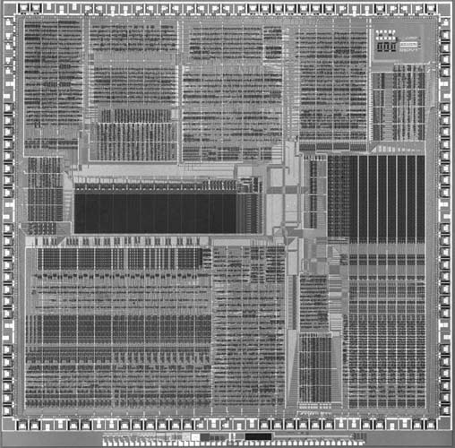

Submitted to the Faculty of the Electrical and Computer Engineering Department

of The College of New Jersey

Written and Researched by:

Kevin Cao

Whitley Forman

Dhruvit Naik

Zachary Nelson

Julie Swift

In partial fulfillment of the Bachelor of Science degree in Electrical and Computer Engineering

**Acknowledgements**

The team would like to acknowledge Ian Patel’s work on helping to set up the realistic FPGA test environment. Ian wrote the PSoC microcontroller code to generate an I2S audio stream and capture it back from the FPGA. He also wrote Matlab code that produced different types of waveforms in I2S format. We would also like to thank MOSIS for sponsoring the chip fabrication aspect of the project through the MOSIS Educational Program (MEP).

**Abstract**

The goal of this project is to gain experience in VLSI design by designing a chip that will process digital streaming audio data. More specifically, we will implement a 512-tap digital finite impulse response (FIR) filter, which will be applied to an input stream in order to create an output stream. We used the I2C protocol to allow a host to control the chip and the serial I2S protocol for transferring digital audio streams in and out.

Our hardware design was represented using Verilog register-transfer level (RTL) code. Development has been done using Xilinx ISE Design Suite 14.7. Test-benches were also designed and implemented using Verilog. The end goal of the project is to implement the design on a field-programmable gate array (FPGA). We will bring up our FPGA design with a realistic environment including an audio source, audio sink, and a microcontroller for reading and writing registers. We also plan to send a simple CMOS integrated circuit design for fabrication by MOSIS that will help us gain experience in physical chip design and prepare future groups to fabricate our full design.

**Keywords:** Application-specific integrated circuit (ASIC), Very large scale integration (VLSI) I2S, I2C, Digital filtering

**Table of Contents**

List of Tables 5

List of Illustrations 6

Nomenclature 8

Introduction 9

Specifications 11

Chapter 1: Background – Z. Nelson 12

Chapter 2: System Design – Z. Nelson 14

Chapter 3: I2S Interface – K. Cao 17

Chapter 4: Digital Filtering – D. Naik 37

Chapter 5: Register Block – J. Swift 52

Chapter 6: I2C Slave Interface – W. Forman 61

Chapter 7: Simulation/Verification – K. Cao and D. Naik 75

Chapter 8: FPGA Implementation - Zachary Nelson 80

Chapter 9: EDA Tools and Physical Design – D. Naik, J. Swift, and K. Cao 86

Chapter 10: Conclusion – Z. Nelson 90

References 91

Appendix A: Project Overview 92

Appendix B: Management 98

Appendix C: Source Code 130

Appendix D: Test Benches 131

Appendix E: Industry Specifications 132

**List of Tables**

Table 1.1: Comparison of MOSIS Academic Account Types 13

Table 3.1: Interface Signals for I2S Input 20

Table 3.2: Interface Signals for Synchronizer Sub-Module 24

Table 3.3: Interface Signals for Deserializer Sub-Module 25

Table 3.4: Interface Signals for BIST Generator Sub-Module 27

Table 3.5: Interface Signals for Multiplexer Sub-Module 28

Table 3.6: Interface Signals for FIFO Sub-Module 29

Table 3.7: Interface Signals for I2S Output 31

Table 3.8: Interface Signals for Serializer Sub-Module 35

Table 4.1: Interface Signals for Filter 39

Table 4.2: Interface Signals for Finite State Machine 41

Table 4.3: Interface Signals for Filter Storage Module 42

Table 4.4: Interface Signals for Mux Module 43

Table 4.5: Interface Signals for Accumulator Module 44

Table 4.6: Interface Signals for Shift Round Truncate Module 45

Table 5.1: Register Mapping of Each Bit in the Address it is Stored 54

Table 6.1: I2C Register table 66

Table 8.1: Verilog Signal to FPGA Mapping 80

**List of Illustrations**

Fig. I.1: Process of Designing a System on a Chip 9

Fig. 1.1: Multi-Project Wafer 12

Fig. 2.1: Top Level Drawing of Chip 14

Fig. 2.2: Detailed Top-Level Drawing of Chip 15

Fig. 2.3: FPGA Testing Environment 16

Fig. 3.1: Overall Chip Diagram with I2S Interfaces Highlighted 18

Fig. 3.2: I2S Input Block Diagram 19

Fig. 3.3: Sample of I2S Input Interface Simulation 21

Fig. 3.4: Sample of Synchronizer Simulation 25

Fig. 3.5: Sample of Deserializer Simulation 26

Fig. 3.6: Sample of BIST Generator Simulation 27

Fig. 3.7: Sample of Multiplexer Simulation 28

Fig. 3.8: Sample of FIFO Simulation 30

Fig. 3.9: Block Diagram of I2S Output Interface 30

Fig. 3.10: Sample of I2S Output Interface Simulation 32

Fig. 3.11: Sample of Serializer Simulation 36

Fig. 4.1: Frequency Response of Filter Structures 37

Fig. 4.2: Chip Diagram with Filter Highlighted 38

Fig. 4.3: Top Level Block Diagram of Filter 39

Fig. 4.4: Detailed Block Diagram of Filter 40

Fig. 4.5: Finite State Machine: States and Transitions 44

Fig. 4.6: Impulse Response of 512-Tap Low-Pass Filter 46

Fig. 4.7: Simulation of Accumulator 46

Fig. 4.8: Simulation of Filter Storage Module Test 1 47

Fig. 4.9: Simulation of Filter Storage Module Test 2 47

Fig. 4.10: Simulation of Mux 47

Fig. 4.11: Simulation of Filter Test 1 48

Fig. 4.12: Simulation of Filter Test 2 48

Fig. 4.13: Simulation of Filter Test 3 49

Fig. 4.14: Simulation of Filter Test 4 49

Fig. 4.15: Simulation of Filter Test 5 50

Fig. 5.1: Chip Diagram with Register Highlighted 52

Fig. 5.2: Internal Micro-Architecture of Register 53

Fig. 5.3: Top Level Interface Design of reg.v 53

Fig. 5.4: The Start of the Test Fixture Simulation 57

Fig. 5.5: Bits trig_i2si_fifo_overrun_clr and trig_i2so_fifo_underrun_clr are Triggered 58

Fig. 5.6: Bits Triggered in Second Testbench 58

Fig. 5.7: Test data properly being written from the I2C into the Register Part 1 59

Fig. 5.8: Test data properly being written from the I2C into the Register Part 2 59

Fig. 6.1: I2C Chip Diagram Highlight 61

Fig. 6.2: I2C Full Coefficient Time Load Calculation 62

Fig. 6.3: I2C block diagram in 64

Fig. 6.4:Open Drain Schematic 64

Fig. 6.5: I2CState Machine Flow Diagram 68

Fig. 6.6: I2C Previous block diagram versions 68

Fig. 6.7: I2CDeserializer Block Diagram 70

Fig. 6.8: I2CSequencer Block Diagram 71

Fig. 6.9: I2CSerializer Block Diagram 72

Fig. 6.10: I2CIsim Full Register Write Transaction (Truncated) 73

Fig. 6.11: I2CRead Register Transaction 74

Fig. 7.1: Lowpass Filter: Square Wave Samples 0 - 1000 76

Fig. 7.2: Lowpass Filter: Square Wave Samples 2000 - 3000 77

Fig. 7.3: Highpass Filter: Square Wave Samples 0 - 1000 77

Fig. 7.4: Highpass Filter: Square Wave Samples 2000 - 3000 78

Fig. 7.5: Average Filter: Square Wave Samples 0 - 1000 78

Fig. 7.6: Average Filter: Square Wave Samples 2000 – 3000 79

Fig. 8.1: FPGA Testing Set Up 83

Fig. 8.2: FPGA Waveforms (Pass-Through Filter) 84

Fig. 9.1: Project Manager Window 86

Fig. 9.2: New Project Wizard – Screen 1 87

Fig. 9.3: New Project Wizard – Screen 2 87

Fig. 9.4: 38 x 40 μm 25Ω Resistor 88

Fig. 9.5: 40 x 40 μm Spiral Inductor 89

**Nomenclature**

**ASIC**: Application Specific Integrated Circuit

**BIST**: Built in Self-Test

**CIF**: Caltech Intermediate Form

**DIP**: Dual in-line package

**EDA**: Electronic Design Automation

**FPGA**: Field Programmable Gate Array

**FSM**: Finite-State Machine

**GDSII**: Graphic Data System II

**I2C**: Inter-Integrated Circuit

**I2S**: Integrated Interchip Sound

**IC**: Integrated Circuit

**LSB**: Least Significant Bit

**MEP**: MOSIS Educational Program

**MPW**: Multi-Project Wafer

**MSB**: Most Significant Bit

**OCP**: Open Cavity Plastic

**PCB**: Printed Circuit Board

**RO**: Read Only

**RTL**: Register-Transfer Level

**RTR**: Ready to Receive

**RTS**: Ready to Send

**RW**: Read/Write

**WO**: Write Only

**XFC**: Transfer Complete

**VLSI:** Very Large Scale Integration

**Introduction**

The goal of this project is to design a chip that is capable of processing digital streaming audio data and apply a 512-tap filter to the input stream. The design was implemented and tested on a Nexys 4 Artix-7 FPGA board. We also are close to submitting a simple circuit to MOSIS for fabrication in order to gain experience with using EDA tools. Two senior project groups for next year will be using certain aspects of our project. One group will be taking the Verilog code that we designed and tested and will fabricate a chip out of it. This group can also use the information that we recorded about using the EDA tools. The other group will be designing a RISC-V processor that may reuse some of the code that we have written. It should be noted that the terms VLSI and ASIC will be used interchangeably throughout the report and refer to designing the chip.

In industry, some of the advantages of an FPGA are it can be reprogrammed, there is no manufacturing involved, and it is as simple as just downloading code onto a board. Some of the advantages of an ASIC include being a fully custom design so that the device is manufactured to the designer’s specifications, a lower unit cost when producing in high volume, a smaller chip since there are no unwanted components included, higher clock rates, and lower power dissipation. ASICs are used ubiquitously throughout industry (e.g. smartphones, laptops) and a major part of our senior project was learning the steps for producing one. We chose our application to be audio processing because digital audio filtering has a wide range of real world applications. We are implementing an extremely high order filter that is capable of producing almost any type of frequency response. The chip’s application is relatively simple because the bulk of the time was spent going through the chip design process since this is the first chip any of the students have designed.

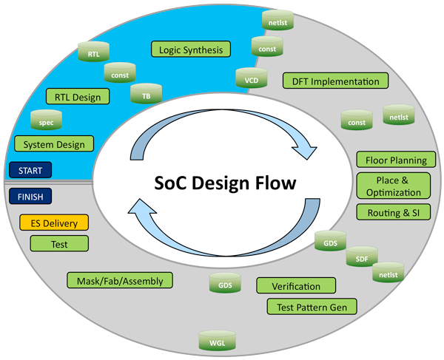

**Fig. I.1:** Process of Designing a System on a Chip

Even though we will not be following every step, Fig. I.1 shows the general process for designing a chip. The first task is system design where the requirements of the system are documented and the major functionality of the chip is described. The second task is RTL design which involves writing code in a hardware description languages (HDL) such as Verilog in order to create a high-level representation of the chip. The next step is logic synthesis which involves turning the RTL design into a netlist of logic gates. Floor planning involves determining the location of the major blocks on the IC schematic. Place and optimization is placing all of the electronic components, circuitry, and logic elements into a limited amount of space in an effective manner. Routing is connecting all of the different components and must follow the rules and limitations of the fabrication process. This step is mostly done automatically by an EDA tool but sometimes has to be done manually. It should be noted that testing and verification will be performed throughout the entire process. The last step is submitting a verified design to be fabricated (commonly in the form of a GSDII file).

**Specifications**

**General:**

* Maximum Clock Rate: 100 MHz
* Clock frequency will be a minimum of 1200 times the audio sampling rate

**I2S:**

* I2S input and output interfaces comply with I2S standard, included here in Appendix E
* Maximum Serial Clock Rate: 1.44 MHz
* Audio input sample rates ranges of 8 kilosamples/sec - 48 kilosamples/sec
* Digital audio bit clock and word select lines will be controlled from I2S master, which can be our chip, or the external I2S source
* Audio input and output must have same sample rate – our chip will be the time-base master on the output I2S interface
* Audio input and output will be two 16 bit channels (i.e. one stereo pair)

**Filter:**

* Filter Design: FIR Filter
* 512-tap filter, 16-bit coefficients, all independently settable
* Programmable filter coefficients to achieve different filter types
* Maintain integer headroom of 4 bits

**I2C:**

* 8-bit slave address space
* 12-bit register address space
* Data transfer rate of up to 400 kbits/second desired (both I2C standard and fast modes supported)
* Slave only capability
* Write operation (Burst write functionality)
* Read operation (Single read, optional burst read request)
* User selectable slave address with strap pins
* Simple strobe interface to register block (read and write)

**Register:**

* Simple strobe interface to I2C block
* Provides read/write access to control/status registers, including the following
  + Source select bit (I2S vs. BIST)
  + Filter bypass bit (pass through or filter input streams)
  + 512 16-bit filter coefficients
  + Overflow/saturation detector
  + Audio FIFO overrun/underrun

**Chapter 1: Background – Z. Nelson**

*1.1 Who is MOSIS?*

The simple chip that we are designing will be produced by MOSIS, at no cost to The College of New Jersey. MOSIS was the first well-known multi-project wafer (MPW) service, and was established by DARPA (Defense Advanced Research Projects Agency) in 1981. The acronym MOSIS stands for Metal Oxide Semiconductor Implementation Service and the company has processed over 60,000 IC designs over the last 30 years [1]. The MOSIS Service is known for MPWs, which is how they are able to keep the cost of fabrication low. A MPW is when multiple IC designs are shared on a single wafer and an illustration of this concept in shown in Figure 1.1. This means that designs from private companies and students could be on the same wafer. The reasoning behind this approach is that the cost of fabrication can be kept at a reasonable price if the cost of mask making, wafer fabrication and assembly are shared throughout multiple projects. This idea of a MPW is also attractive because designers can create a prototype of their design without making a huge investment. It should also be noted that MOSIS offers using a single project for a wafer (dedicated run) for all processes and can start the fabrication at any time.

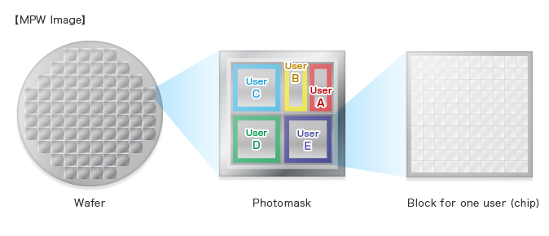

**Fig. 1.1:** Multi-Project Wafer

*1.2 Fabrication Process*

MOSIS offers three different options for an accredited college or university to use. These options are registering for a Commercial account, a MOSIS Educational Program (MEP) Instructional account, or a MOSIS Educational Program (MEP) Research account. A comparison of these three accounts is listed on MOSIS’s website and is also shown in Table 1.1. Our advisors registered for a MEP Instructional account and we will be using a GlobalFoundaries 130 nm8RF process.

**Table 1.1:** Comparison of MOSIS Academic Account Types

|  |  |  |  |
| --- | --- | --- | --- |
| **Topic** | **Commercial** | **MEP Instructional** | **MEP Research** |
| Primary Purpose | Customers pays for fabrication and packaging | Classroom instruction | Unfunded research |
| Available Processes | All | 1. ON Semi 0.50 $μm$ CMOS (C5N)  2. GlobalFoundaries 180 *nm* CMOS (7HV) | 1. ON Semi 0.50 $μm$ CMOS (C5N)  2. GlobalFoundaries 130 *nm* SiGe BICMOS (8HP)  3. GlobalFoundaries 130 *nm* CMOS (8RF-DM) |
| Size Limits | No restrictions | 5 deliverable parts of a project no larger than 1.5 mm x 1.5 mm | Less than 16 ${mm}^{2}$ |
| Number of Submissions per Year | Unlimited | Annual request subject to review | One submission per academic year per institution after approval of proposal |
| Run Restrictions | All MPW runs except for MEP-only | MEP-only and space available for COM runs | Space available for COM runs |
| IP Access through MOSIS | Yes | No | Yes |
| Fabrication Costs | Customer pays fabrication cost | Free | Free |
| Packaging | No restrictions, customer pays | Free ceramic and OCP packaging; lids cannot be sealed. Fully encapsulated packaging not available. | No restrictions, customer pays |

*1.3 Submitting a Design to MOSIS*

When submitting a MPW run, MOSIS has specified certain steps that need to be taken in order to submit a design. The first step is to submit a new project request by logging onto their website. The designer then needs to assign their Export Control Classification Number (ECCN) before they make a fabrication request. Next, a fabrication request needs to be made specifying the process that will be used. The last step is to submit that actual design layout to MOSIS in either Caltech Intermediate Form (CIF) or Graphic Data System II (GSDII) format. Both of these formats are used to describe the layout of the integrated circuit and will be generated by an EDA tool.

**Chapter 2: System Design – Z. Nelson**

The system design of our project started in April 2015 when we wrote a senior project proposal. The proposal discussed the basic functionality that should be accomplished and how the tasks should be broken down. A top level block diagram of the chip is shown in Fig. 2.1. The chip was broken down into five major modules. These modules included the I2S input interface, I2S output interface, filter, register block, and I2C slave interface. Kevin’s responsibility was the I2S interface, Dhruvit’s was the filter, Julie’s was the register, and Whitley’s was the I2C interface. Over the 2015 summer, each team member worked on creating a specification document for their module.

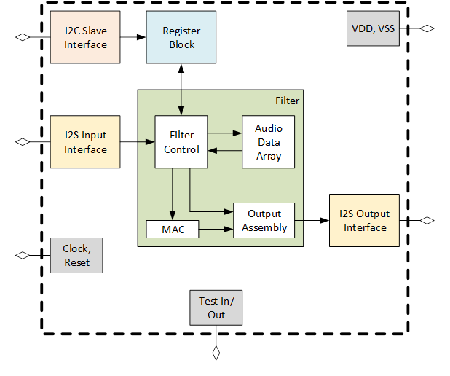

**Fig. 2.1:** Top Level Drawing of Chip

The main purpose of the I2S input interface was to convert a serial audio stream into left and right 16-bit parallel data. This module also included a Built in Self-Test (BIST) feature that would generate a predefined sawtooth signal as the audio data stream. After the audio stream was converted into parallel data, it was put through a 512-tap FIR filter in the filter module. The filter audio signal was then converted back to the I2S serial standard in the I2S output interface. The combination of these three modules was how data flowed within our chip.

**Data Flow:** I2S Input Interface 🡪 Filter 🡪 I2S Output Interface

The control flow of the chip started with the I2C slave interface module reading or writing register values to the chip. The register block is where the actual filter coefficient values were stored along with other information such as chip info, control bits, and status bits. The filter block would then read the 512 filter coefficients from the register block in order to implement the FIR filter.

**Control Flow:** I2C Slave Interface 🡪 Register Block 🡪 Filter

The next step in the system design process was creating block documents that stored the details of each module. These block documents can be found on the GitHub repository. After the interfaces for each module were agreed upon, we created a detailed schematic of the top-level module of our chip (refer to Fig. 2.2).

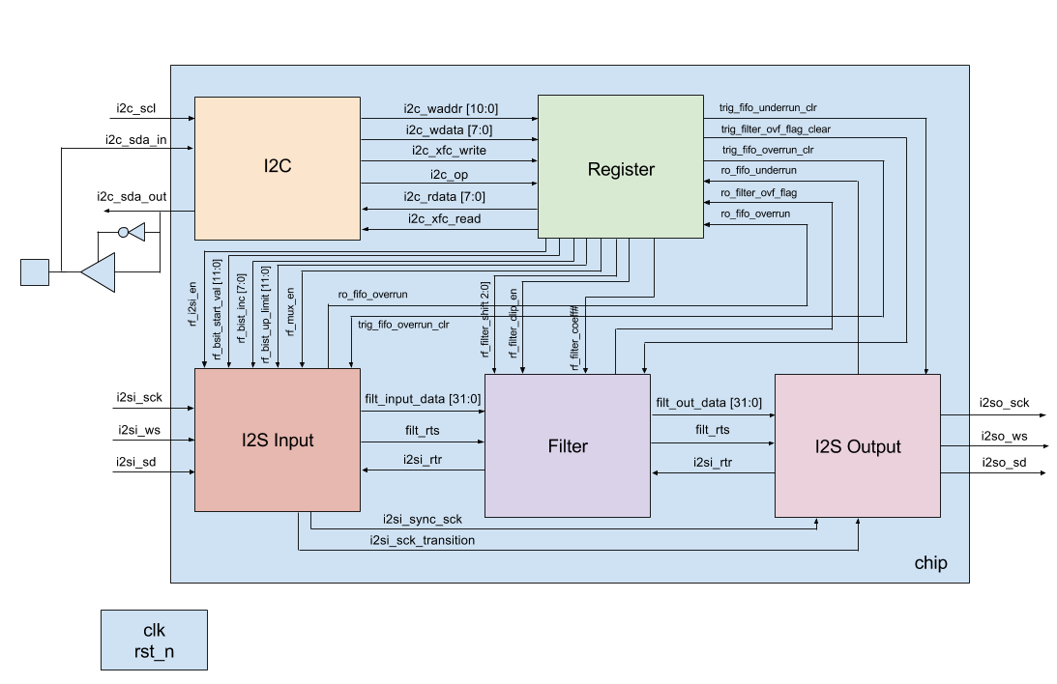

**Fig. 2.2:** Detailed Top-Level Drawing of Chip

The PSoC microcontroller will be used to generate the audio stream and provide I2C read/write access for the chip. Since we will create the audio stream in the PSoC environment, we should know exactly what the output stream will be based on the filter coefficients we are using. The microcontroller will also have the ability to read and write filter coefficients to the chip. This is an important feature of our project because the user will be able to manually set and check the values of all 512 filter coefficients. A diagram of the PSoC microcontroller interfaced with the FPGA is shown in Fig. 2.3.

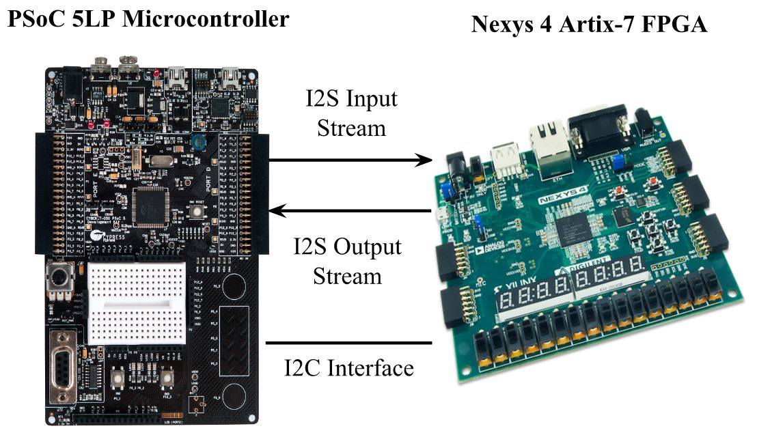

**Fig. 2.3:** FPGA Testing Environment

**Chapter 3: I2S Interface – K. Cao**

*3.1 Introduction*

Integrated Interchip Sound (I2S) buses are used to pass digital audio data into our chip for processing, and to carry processed digital audio streams that are outputted by our chip. I2S is an electrical serial bus interface standard that is used for connecting digital audio devices together. I2S is used to communicate pulse-code modulation (PCM) audio data between integrated circuits in an electronic device. PCM is a standard format for digital audio in computers. It is a method used to digitally represent sampled analog signals.

The **i2s_in** block is responsible for receiving the I2S signals that are passed to our chip, and converting this to a natural parallel PCM format, suitable for processing by the filter block. The **i2s_out** block is responsible for converting parallel PCM data produced by the filter block to a serial I2S stream, for output by the chip.

*3.2 I2S Bus Specification*

The I2S protocol contains three lines: serial data bus (SD), a bit clock (SCK), and word select (WS). These three lines are used to reduce the number of pins required and to keep wiring simple. The SCK signal pulses once for each discrete bit of data on the data line and its frequency can be calculated by multiplying the sample rate, number of bits per channel, and the number of channels. The WS signal informs the chip whether the left or right channel is being currently sent. I2S allows a device to have two channels that send data over the same data line. In this chip when WS is 0, data is being sent over the left channel and when WS is 1, data is being sent over the right channel. The WS signal is a 50% duty signal that has the same frequency as the audio sample frequency.

The SD signal is a serial representation of a two’s complement signed value, and is transmitted with the most significant bit (MSB) first. The transmitter and receiver may have different natural word lengths. The transmitter and receiver doesn’t need to know how many bits the other can handle. The least significant data bits are set to 0 when the receiver’s word length is greater than the transmitter word length. However, if the sent bits are larger than the word length of the receiver, then the bits after the least significant bit are ignored. The MSB is always located in the same position, however, the least significant bit (LSB) position depends on the word length. The MSB of the new word is also always sent one clock period after the WS signal changes. The serial data being transmitted can either be synchronized with either the trailing or leading edge of the clock signal. In this implementation the serial data is synchronized with the leading edge. However, the serial data must be latched by the receiver on the leading edge of serial clock signal. The WS signal is also changes with the leading edge of the serial clock and is set to change one clock period before the MSB is transmitted. This early transition allows the slave transmitter to derive synchronous timing of the serial data.

*3.3 I2S Interfaces*

The I2S interfaces for the custom chip were split into two Verilog modules, **i2s_in** and **i2s_out**. The **i2s_in** module represented the receiver and handled all data being inputted into the I2S interface, and the **i2s_out** module represented the transmitted and handled all data being outputted. The following figure displays the overall block diagram of the chip, with the I2S interfaces highlighted.

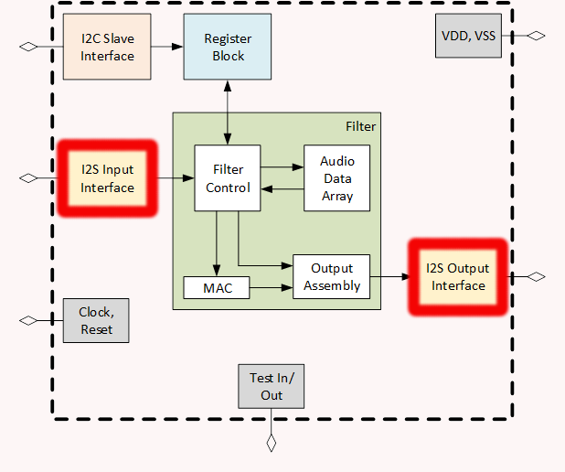

**Fig. 3.1:** Overall Chip Diagram with I2S Interfaces Highlighted

*3.4 I2S Input Interface*

The I2S input interface handles all input audio and relays it to the filter for processing. It is primarily responsible for reading in serialized data and converting it back into parallel data. The I2S Input interface is made of five different sub-modules, the synchronizer, deserializer, Audio Built-In Self-Test (BIST) generator, mux, and FIFO. The following figure displays the block diagram of the I2S input interface with all of its signals and sub-modules.

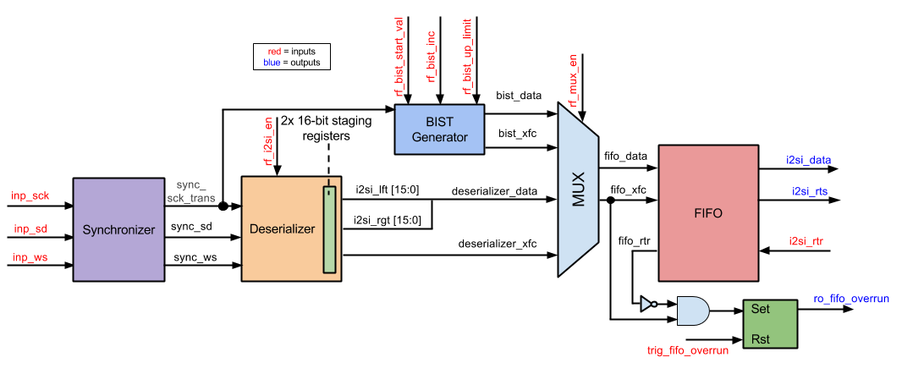

**Fig. 3.2:** I2S Input Block Diagram

The following table displays all the input and output signals the I2S input interface interacts with. The table provides the name, direction, bit size, and a short description of each signal.

**Table 3.1:** Interface Signals for I2S Input

|  |  |  |  |
| --- | --- | --- | --- |
| **Signal Name** | **Direction** | **Bits** | **Comment** |
| **General** | | | |
| clk | in | 1 | Master Clock |
| rst_n | in | 1 | Reset |
| **I2S Input Interface** | | | |
| inp_sck | in | 1 | Digital Audio Bit Clock |
| inp_sd | in | 1 | Digital Audio Serial Data |
| inp_ws | in | 1 | Word Select |
| **Control/Status Register Fields** | | | |
| trig_fifo_overrun_clr | in | 1 | Reset FIFO Overrun |
| ro_fifo_overrun | out | 1 | Input Audio FIFO Overrun |
| rf_i2si_en | in | 1 | Serializer Enable Bit |
| rf_mux_en | in | 1 | Built in Self-Test (BIST) |
| rf_bist_start_val | in | 12 | Start Value |
| rf_bist_inc | in | 8 | Increment |
| rf_bist_up_limit | in | 12 | Upper Limit |
| **Streaming Audio Interface with Filter Block** | | | |
| i2si_rtr | in | 1 | Ready to Receive |
| i2si_rts | out | 1 | Ready to Send |
| i2si_data | out | 32 | Output Digital Audio |

The signal inp_sck is the digital audio bit clock of the I2S interface, inp_sd is the serial data that is being sent in, and inp_ws is the word select signal that informs the module whether the left or right audio channel is being received. The signals i2si_rtr and i2si_rts are the handshake interface signals interacting with the filter block. They inform the I2S input interface when the filter block is ready to receive data, and inform the filter block when the I2S input interface is read to send data. The i2si_data signal contains the 32 bit words that will be sent to the filter block for processing. The rf_i2si_en signal informs the I2S input block to start converting data from serial into parallel. The rf_mux_en signal is the select bit that informs the I2S input interface either to output the deserialized data or the BIST data to the filter block. The signals rf_bist_start_val, rf_bist_inc, and rf_bist_up_limit are used as parameters to create a sawtooth wave to test the chip. The signal ro_fifo_overrun indicates whether data is written to the block faster than it can be read. The trig_fifo_overrun signal indicates whether or not to clear the ro_fifo_overrun signal.

The I2S input interface was verified by inputting a list of 32 bit words into the inp_sd signal line. The i2si_data signal was then observed to see if it outputted the same words inputted. To make verification easier, two outputs files were created with the input and output words. A brief summary at the bottom of the text files confirmed if the test was successful or not. The inputted words were tested with random 32 bit values, and values coming from the BIST generator. It was observed that the same data inputted is also outputted within the block and appears to be working. The select bit for the multiplexer was also toggled to verify that the data outputted came from either the BIST or input serial data. It was confirmed that the data outputted was dependent on the select bit and the block was functioning properly. The i2si_rts signal line was also observed. The signal is supposed to pulse after each half word within the block. When observing the test benches this can be seen functioning correctly. Additional testing was conducted to test the underrun and overrun signals. Testing showed that both signals trigger under the correct conditions, and the signals can be cleared with the proper reset signals.

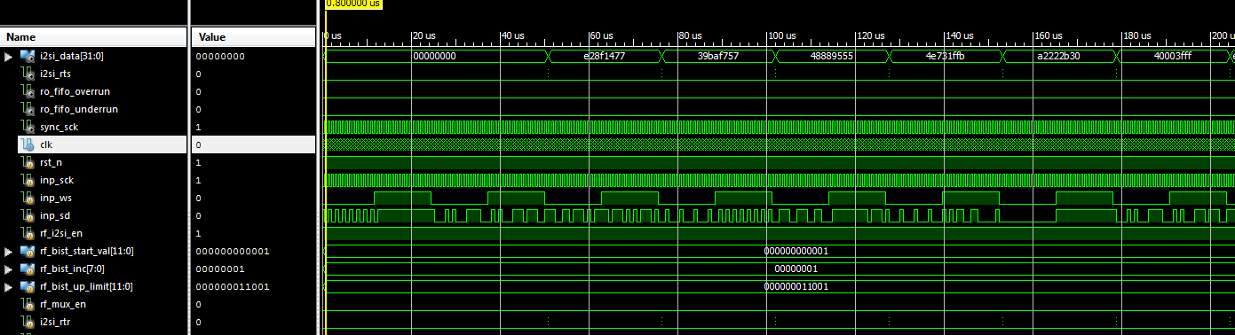

**Fig. 3.3**: Sample of I2S Input Interface Simulation

Sample of I2S Input Interface Text File

Input: d6095663 --- Output: d6095663 --- Pass

Input: 7b0d998d --- Output: 7b0d998d --- Pass

Input: 84655212 --- Output: 84655212 --- Pass

Input: e301cd0d --- Output: e301cd0d --- Pass

Input: f176cd3d --- Output: f176cd3d --- Pass

Input: 57edf78c --- Output: 57edf78c --- Pass

Input: e9f924c6 --- Output: e9f924c6 --- Pass

Input: 84c5d2aa --- Output: 84c5d2aa --- Pass

Input: f7e57277 --- Output: f7e57277 --- Pass

Input: d612db8f --- Output: d612db8f --- Pass

Input: 69f296ce --- Output: 69f296ce --- Pass

Input: 7ae84ec5 --- Output: 7ae84ec5 --- Pass

Input: 495c28bd --- Output: 495c28bd --- Pass

Input: 582d2665 --- Output: 582d2665 --- Pass

Input: 6263870a --- Output: 6263870a --- Pass

Input: 22802120 --- Output: 22802120 --- Pass

Input: 45aacc9d --- Output: 45aacc9d --- Pass

Input: 3e96b813 --- Output: 3e96b813 --- Pass

Input: 380dd653 --- Output: 380dd653 --- Pass

Input: dd6b2ad5 --- Output: dd6b2ad5 --- Pass

Input: 4a023eae --- Output: 4a023eae --- Pass

Input: e91d72cf --- Output: e91d72cf --- Pass

Input: 4923650a --- Output: 4923650a --- Pass

Input: 0aca4c3c --- Output: 0aca4c3c --- Pass

Input: bdf2618a --- Output: bdf2618a --- Pass

Input: b34134d8 --- Output: b34134d8 --- Pass

Input: f3781289 --- Output: f3781289 --- Pass

Input: 0deb65b6 --- Output: 0deb65b6 --- Pass

Input: f9c613ae --- Output: f9c613ae --- Pass

Input: 02bcdd2a --- Output: 02bcdd2a --- Pass

Input: 9a0bbe71 --- Output: 9a0bbe71 --- Pass

Input: 4185554f --- Output: 4185554f --- Pass

Input: 603b333a --- Output: 603b333a --- Pass

Input: 327e4b15 --- Output: 327e4b15 --- Pass

Input: 9bf14bd9 --- Output: 9bf14bd9 --- Pass

Input: 0762fb4c --- Output: 0762fb4c --- Pass

Input: 559fa18f --- Output: 559fa18f --- Pass

Input: a9f860b7 --- Output: a9f860b7 --- Pass

Input: 569f945c --- Output: 569f945c --- Pass

Input: c05b3789 --- Output: c05b3789 --- Pass

Input: 32493ed0 --- Output: 32493ed0 --- Pass

Input: c0d7fc51 --- Output: c0d7fc51 --- Pass

Input: 2f967f0c --- Output: 2f967f0c --- Pass

Input: cec2edc8 --- Output: cec2edc8 --- Pass

Input: 5a77ed3d --- Output: 5a77ed3d --- Pass

Input: db12007e --- Output: db12007e --- Pass

Input: 816de739 --- Output: 816de739 --- Pass

Input: 8f1ff6d3 --- Output: 8f1ff6d3 --- Pass

Input: 2f858878 --- Output: 2f858878 --- Pass

Input: 595b4b49 --- Output: 595b4b49 --- Pass

Input: ae3faf2a --- Output: ae3faf2a --- Pass

Input: 63583886 --- Output: 63583886 --- Pass

Input: 0c8ef29c --- Output: 0c8ef29c --- Pass

Input: 99fabc26 --- Output: 99fabc26 --- Pass

Input: 1773b4a3 --- Output: 1773b4a3 --- Pass

Input: a82f92b3 --- Output: a82f92b3 --- Pass

Input: 565f0d44 --- Output: 565f0d44 --- Pass

Input: fdf736cb --- Output: fdf736cb --- Pass

Input: 1ae6db5a --- Output: 1ae6db5a --- Pass

Input: c129e2ed --- Output: c129e2ed --- Pass

Input: 6cdab665 --- Output: 6cdab665 --- Pass

Input: e2b594df --- Output: e2b594df --- Pass

Input: 1979ff44 --- Output: 1979ff44 --- Pass

Input: 0cd00b2a --- Output: 0cd00b2a --- Pass

Input: adabcf0e --- Output: adabcf0e --- Pass

Input: addcbc9a --- Output: addcbc9a --- Pass

Input: 72fd02c3 --- Output: 72fd02c3 --- Pass

Input: ed56e94e --- Output: ed56e94e --- Pass

Input: 7667340a --- Output: 7667340a --- Pass

Input: b9b68a38 --- Output: b9b68a38 --- Pass

Input: 8779c4b8 --- Output: 8779c4b8 --- Pass

Input: bf945d93 --- Output: bf945d93 --- Pass

Input: 2c04ca59 --- Output: 2c04ca59 --- Pass

Input: 69dbde4d --- Output: 69dbde4d --- Pass

Input: b7d9266d --- Output: b7d9266d --- Pass

Input: e27649ca --- Output: e27649ca --- Pass

Input: 2db67195 --- Output: 2db67195 --- Pass

Input: 1a469b04 --- Output: 1a469b04 --- Pass

Input: 61f70769 --- Output: 61f70769 --- Pass

Input: bab48d88 --- Output: bab48d88 --- Pass

Input: d928042d --- Output: d928042d --- Pass

Input: 30c79c2e --- Output: 30c79c2e --- Pass

Input: e408451c --- Output: e408451c --- Pass

Input: a6fd0729 --- Output: a6fd0729 --- Pass

Input: 901c6786 --- Output: 901c6786 --- Pass

Input: 08dac63d --- Output: 08dac63d --- Pass

Input: a766c470 --- Output: a766c470 --- Pass

Input: 047399ba --- Output: 047399ba --- Pass

Input: b35e79fa --- Output: b35e79fa --- Pass

Input: 05d5f61a --- Output: 05d5f61a --- Pass

Input: 00b96137 --- Output: 00b96137 --- Pass

Input: 379621c0 --- Output: 379621c0 --- Pass

Input: 9f261ab6 --- Output: 9f261ab6 --- Pass

Input: 837d0fdc --- Output: 837d0fdc --- Pass

Input: 5786ff78 --- Output: 5786ff78 --- Pass

Input: 9b7e80db --- Output: 9b7e80db --- Pass

Input: b6cf2b79 --- Output: b6cf2b79 --- Pass

Input: e4faee61 --- Output: e4faee61 --- Pass

Input: 091778a1 --- Output: 091778a1 --- Pass

Input: 91869650 --- Output: 91869650 --- Pass

Number of Comparisons: 100

Number of Successful Comparisons: 100

Number of Failed Comparisons: 0

*3.4.1 Synchronizer*

The synchronizer sub-block takes the inputs of serial clock, word select, and serial data and delays the signals and sync them with the master clock. This is done in order to ensure that no metastability occurs. The sub-block was also created to consolidate and shorten the amount of code needed to be written. Multiple blocks make use of the delayed and synced signals. It was appropriate to define these signals once and then to output them to the other blocks that need them. The inputs and outputs of the synchronizer sub-block can be seen in the following table.

**Table 3.2:** Interface Signals for Synchronizer Sub-Module

|  |  |  |  |
| --- | --- | --- | --- |
| **Signal Name** | **Direction** | **Bits** | **Comment** |
| **General** | | | |
| clk | in | 1 | Master Clock |
| rst_n | in | 1 | Reset |
| **Synchronizer Input Interface** | | | |
| _sck | in | 1 | Digital Audio Bit Clock |
| _ws | in | 1 | Word Select |
| _sd | in | 1 | Digital Audio Serial Data |
| **Synchronizer Output Interface** | | | |
| sck | out | 1 | Delayed and Synced Serial Clock |
| sck_transition | out | 1 | Serial Clock Level to Pulse Converter |
| ws | out | 1 | Delayed and Synced Word Select |
| sd | out | 1 | Delayed and Synced Serial Data |

The _sck signal is the serial clock input signal and sck is the same signal synced and delayed by 2 master cycles. The sck_transition signal is a level to pulse converter of the serial clock. The signal is high anytime sck transitions from 0 to 1. The _ws signal is the word select input signal and ws is the same signal synced and delayed by 4 master clock cycles. The _sd signal is the serial data input signal and sd is the same signal synced and delayed by 4 master clock cycles.

The synchronizer was verified by checking if the _sck, _ws, and _sd signals were delayed by correct amount of clock cycles. Within the sample simulation that the sck signal was delayed by 2 clock cyles, and both the ws and sd signals were delayed by 4 clock cycles. In addition, the level to pulse converter signal, sck_transition was verified as high each time sck transitioned from low to high.

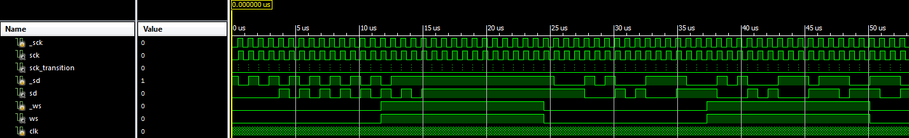

**Fig. 3.4:** Sample of Synchronizer Simulation

*3.4.2 Deserializer*

The deserializer sub-block is responsible for taking the audio serial data and converting it to parallel data. The list of inputs and outputs of the deserializer sub-block can be seen in the following table.

**Table 3.3:** Interface Signals for Deserializer Sub-Module

|  |  |  |  |
| --- | --- | --- | --- |
| **Signal Name** | **Direction** | **Bits** | **Comment** |
| **General** | | | |
| clk | in | 1 | Master Clock |
| rst_n | in | 1 | Reset |
| **Deserializer Input Interface** | | | |
| sck_transition | in | 1 | Serial Clock Level to Pulse Converter |
| in_sd | in | 1 | Digital Audio Serial Data |
| in_ws | in | 1 | Word Select (Left/Right Audio Channel) |
| **Deserializer Output Interface** | | | |
| out_lft | out | 16 | Left Audio Channel |
| out_rgt | out | 16 | Right Audio Channel |
| out_xfc | out | 1 | Read Data Transfer Complete |
| **Control/Status Register Fields** | | | |
| rf_i2si_en | in | 1 | I2S input Enabled |

The inputs sck_transition, in_sd, and in_ws are the outputs coming from the synchronizer sub-block. These are the level to pulse converter of the serial clock and the delayed and synced signals of the serial data and word select signals. The rf_i2si_en signal is an enable bit for the deserializer sub-block. The signals out_lft and out_rgt are the outputs of the left and right audio parallel data respectively. The signal out_xfc informs the FIFO that the transfer of a word has been completed.

The deserializer was verified by running a simulation that checked if the left and right output channels properly read in the input of the serial data signal. First it was verified that the serializer began properly outputting data after it becomes active. After properly becoming active the inputted data was verified to match up with the output data. It was also ensured that the data was properly stored into the proper channels depending on the value of the word select signal. Next the least significant bit was checked to see if it was stored after the first clock cycle after the word select signal transitioned. Lastly, the xfc signal was verified to pulse after the last bit of the right channel was stored.

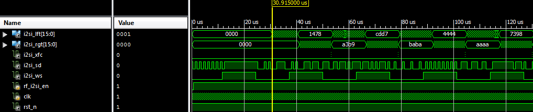

**Fig. 3.5:** Sample of Deserializer Simulation

*3.4.3 Audio Built-In Self-Test (BIST) Generator*

The BIST generator sub-block is used to create a saw-tooth wave to test the I2S input interface. The saw-tooth wave is then outputted to the multiplexer. The following table lists the inputs and outputs of the BIST generator sub-block.

**Table 3.4:** Interface Signals for BIST Generator Sub-Module

|  |  |  |  |
| --- | --- | --- | --- |
| **Signal Name** | **Direction** | **Bits** | **Comment** |
| **General** | | | |
| clk | in | 1 | Master Clock |
| rst_n | in | 1 | Reset |
| sck_transition | in | 1 | Serial Clock Level to Pulse Converter |
| **BIST Reg Interface** | | | |
| rf_bist_start_val | in | 12 | Start Value |
| rf_bist_inc | in | 8 | Increment |
| rf_bist_up_limit | in | 12 | Upper Limit |
| **BIST Output Interface** | | | |
| i2si_bist_out_xfc | out | 1 | Transfer Complete |
| i2si_bist_out_data | out | 32 | Output Data |

Signals rf_bist_start_val, rf_bist_inc, and rf_bist_up_limit are used to create a saw-tooth wave. The signals inform what value to start at, how much to increment by, and what the upper limit of the saw-tooth wave is respectively. The signals i2si_bist_out_data is the output data describing the saw-tooth wave, and i2si_bist_out_xfc is the output that represents that a saw-tooth wave word transfer was complete.

The BIST generator was verified by running a simple test that set the starting value to 0x800. The data value was then incremented on every 32nd pulse of the serial clock by a value of 0x700. The xfc output signal was verified by checking if it was high after the data incremented. The sub-block was further tested by ensuring that the output was reset to starting value after the output data reaches the upper limit of the BIST generator.

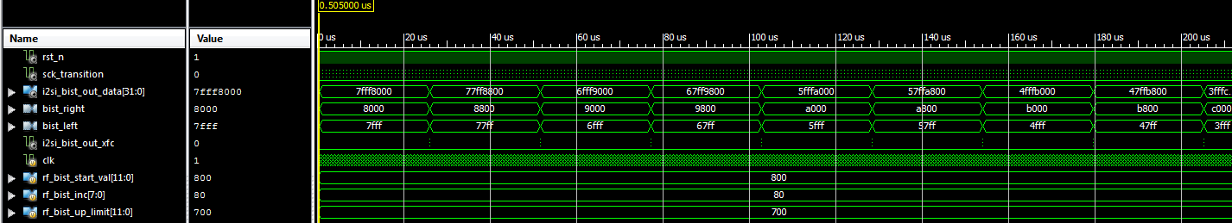

**Fig. 3.6:** Sample of BIST Generator Simulation

*3.4.4 Multiplexer*

The multiplexer sub-block is responsible for outputting either the BIST data and xfc output signals or the deserializer data and xfc output signals. The following table lists the multiplexer’s input and output signals.

**Table 3.5:** Interface Signals for Multiplexer Sub-Module

|  |  |  |  |
| --- | --- | --- | --- |
| **Signal Name** | **Direction** | **Bits** | **Comment** |
| **Data Lines Input Interface** | | | |
| in_0_data | in | 32 | Input 0 Data |
| in_0_xfc | in | 1 | Input 0 Transfer Complete |
| in_1_data | in | 32 | Input 1 Data |
| in_1_xfc | in | 1 | Input 1 Transfer Complete |
| **Enabled Bit** | | | |
| sel | in | 1 | Select Bit |
| **Multiplexer Output Interface** | | | |
| mux_data | out | 32 | Data Output |
| mux_xfc | out | 1 | Transfer Complete Output |

The signals in_0_data, in_0_xfc, in_1_data, and in_1_xfc are the outputs of either the BIST generator or deserializer data and xfc signals. The sel signal is the select bit that either outputs the BIST data and xfc or deserializer data and xfc signals. The signals mux_data and mux_xfc represent the data and xfc signals being outputted to the FIFO sub-block.

The multiplexer was verified by running a simple simulation that inputted two sets of values for the pairs in_0 and in_1. The enabled bit was then toggled to see if the multiplexer outputted the correct pair of values.

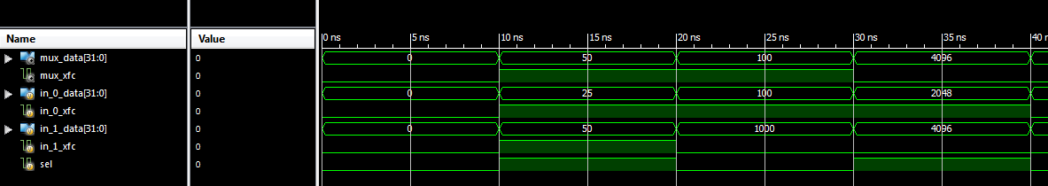

**Fig. 3.7:** Sample of Multiplexer Simulation

*3.4.5 First-In-First-Out (FIFO) Buffer*

The FIFO sub-block organizes and manipulates a data buffer, where the first entry is the first output. In this particular block the FIFO is responsible for manipulating the audio data inputted and outputted in the I2S interfaces. The following table lists the inputs and outputs of the sub-block.

**Table 3.6:** Interface Signals for FIFO Sub-Module

|  |  |  |  |
| --- | --- | --- | --- |
| **Signal Name** | **Direction** | **Bits** | **Comment** |
| **General** | | | |
| clk | in | 1 | Master Clock |
| rst_n | in | 1 | Reset |
| **Streaming Audio Interface with Multiplexer** | | | |
| fifo_inp_data | in | 32 | Input Data |
| fifo_inp_rts | in | 1 | Write Client Asserts Ready to Send |
| fifo_inp_rtr | out | 1 | Output FIFO Asserts Ready to Receive |
| **Streaming Audio Interface with Filter Block** | | | |
| fifo_out_data | out | 32 | Output Data |
| fifo_out_rts | out | 1 | Output FIFO Asserts Ready to Send |
| fifo_out_rtr | in | 1 | Read Client Asserts Read to Receive |

The fifo_inp_data is the parallel audio data being transferred into the FIFO block. The fifo_inp_rts and fifo_inp_rtr signals are the handshaked interface signals that inform whether data is ready to be sent and read respectively between the multiplexer and filter if in the I2S input interface or between the filter and FIFO if in the I2S output interface. The fifo_out_data signal is the parallel audio output data being sent to either the filter block if in the I2S input interface or serializer if in the I2S output interface. The fifo_out_rts and fifo_out_rtr signals are the handshaked interface that signals whether data is ready to be sent between the filter and FIFO if in the I2S input interface or read between the FIFO and filter if in the I2S output interface.

The FIFO sub-block was verified by queuing and de-queuing random values within a test bench. A quick simulation was run to check if the FIFO queued and de-queued the values defined within the test bench. If the FIFO was full the FIFO should have stopped queuing more data into the buffer, and if the FIFO was empty the FIFO should have outputted nothing from the buffer.

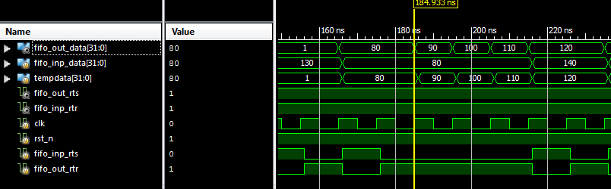

**Fig. 3.8:** Sample of FIFO Simulation

*3.5 I2S Output Interface*

The I2S output interface is primarily responsible for converting the received parallel audio data from the filter block to serial data as an output. The I2S output interface is made of two sub-blocks, the serializer and FIFO. The following diagram shows the sub-blocks that make the I2S_out block and displays the input, output, and interconnecting signals.

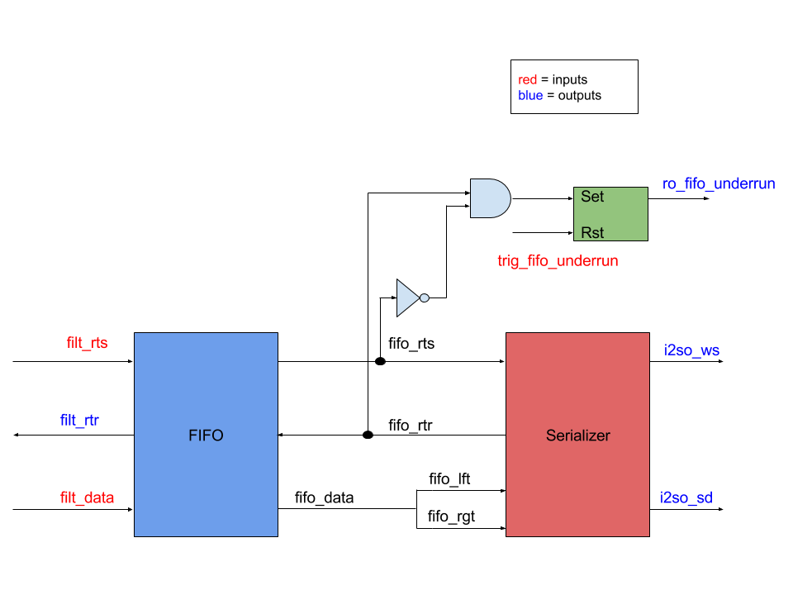

**Fig. 3.9:** Block Diagram of I2S Output Interface

The following table displays all the input and output signals the I2S output interface interacts with. The table provides the name, direction, bit size, and a short description of each signal.

**Table 3.7:** Interface Signals for I2S Output

|  |  |  |  |
| --- | --- | --- | --- |
| **Signal Name** | **Direction** | **Bits** | **Comment** |
| **General** | | | |
| clk | in | 1 | Master Clock |
| rst_n | in | 1 | Reset |
| **Streaming Audio Interface with Filter Block** | | | |
| sck_transition | in | 1 | Serial Clock Pulse Converter |
| filt_data | in | 32 | Parallel Digital Audio |
| filt_rtr | out | 1 | Ready to Receive |
| filt_rts | in | 1 | Ready to Send |
| **I2S Output Interface** | | | |
| i2so_sck | out | 1 | Digital Audio Bit Clock |
| i2so_ws | out | 1 | Word Select (Left/Right Audio Channel) |
| i2so_sd | out | 1 | Digital Audio Serial Data |
| **Control/Status Register Fields** | | | |
| trig_fifo_underrun_clr | in | 1 | Reset FIFO Underrun |
| ro_fifo_underrun | out | 1 | Output Audio FIFO Underrun |

The sck_transition signal is the level to pulse converter signal that will be provided by the I2S input interface. The signal filt_data will be provided by the filter block that contains the 32-bit parallel audio data. The signals filt_rtr and filt_rts are the handshaked interface signals that indicate whether the filter is ready to send data and the I2S output interface is ready to receive data. The i2so_sck is the serial clock that is outputted in the I2S Input interface that will be transmitted to the I2S output interface. The i2so_ws is an output signal that indicates whether the data being transmitted belongs either to the left or right channel. The i2so_sd signal is the serial data that is converted from the parallel audio input data. The ro_fifo_underrun signal indicates whether the data being fed to the I2S output interface is slower than the rate it can process the data, and the trig_i2so_fifo_underrun_clr signal clears the ro_fifo_underrun bit.

The I2S output interface was verified by inputting a list of 32 bit words and confirming that they were being serialized upon exiting the block. To make verification easier, the test bench rebuilt the serial data back into a parallel form based on the word select signal. It was confirmed that the input matched the output within the text files, thus the serializer was working.

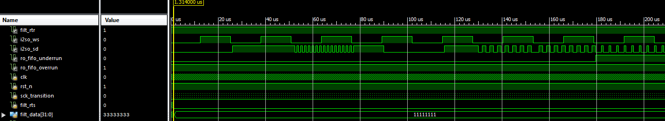

**Fig. 3.10**: Sample of I2S Output Interface Simulation

Sample of I2S Output Interface Text Files

Input: 12153524 --- Output: 12153524 --- Pass

Input: c0895e81 --- Output: c0895e81 --- Pass

Input: 8484d609 --- Output: 8484d609 --- Pass

Input: b1f05663 --- Output: b1f05663 --- Pass

Input: 06b97b0d --- Output: 06b97b0d --- Pass

Input: 46df998d --- Output: 46df998d --- Pass

Input: b2c28465 --- Output: b2c28465 --- Pass

Input: 89375212 --- Output: 89375212 --- Pass

Input: 00f3e301 --- Output: 00f3e301 --- Pass

Input: 06d7cd0d --- Output: 06d7cd0d --- Pass

Input: 3b23f176 --- Output: 3b23f176 --- Pass

Input: 1e8dcd3d --- Output: 1e8dcd3d --- Pass

Input: 76d457ed --- Output: 76d457ed --- Pass

Input: 462df78c --- Output: 462df78c --- Pass

Input: 7cfde9f9 --- Output: 7cfde9f9 --- Pass

Input: e33724c6 --- Output: e33724c6 --- Pass

Input: e2f784c5 --- Output: e2f784c5 --- Pass

Input: d513d2aa --- Output: d513d2aa --- Pass

Input: 72aff7e5 --- Output: 72aff7e5 --- Pass

Input: bbd27277 --- Output: bbd27277 --- Pass

Input: 8932d612 --- Output: 8932d612 --- Pass

Input: 47ecdb8f --- Output: 47ecdb8f --- Pass

Input: 793069f2 --- Output: 793069f2 --- Pass

Input: e77696ce --- Output: e77696ce --- Pass

Input: f4007ae8 --- Output: f4007ae8 --- Pass

Input: e2ca4ec5 --- Output: e2ca4ec5 --- Pass

Input: 2e58495c --- Output: 2e58495c --- Pass

Input: de8e28bd --- Output: de8e28bd --- Pass

Input: 96ab582d --- Output: 96ab582d --- Pass

Input: b2a72665 --- Output: b2a72665 --- Pass

Input: b1ef6263 --- Output: b1ef6263 --- Pass

Input: 0573870a --- Output: 0573870a --- Pass

Input: c03b2280 --- Output: c03b2280 --- Pass

Input: 10642120 --- Output: 10642120 --- Pass

Input: 557845aa --- Output: 557845aa --- Pass

Input: cecccc9d --- Output: cecccc9d --- Pass

Input: cb203e96 --- Output: cb203e96 --- Pass

Input: 8983b813 --- Output: 8983b813 --- Pass

Input: 86bc380d --- Output: 86bc380d --- Pass

Input: a9a7d653 --- Output: a9a7d653 --- Pass

Input: 359fdd6b --- Output: 359fdd6b --- Pass

Input: eaa62ad5 --- Output: eaa62ad5 --- Pass

Input: 81174a02 --- Output: 81174a02 --- Pass

Input: d7563eae --- Output: d7563eae --- Pass

Input: 0effe91d --- Output: 0effe91d --- Pass

Input: e7c572cf --- Output: e7c572cf --- Pass

Input: 11844923 --- Output: 11844923 --- Pass

Input: 0509650a --- Output: 0509650a --- Pass

Input: e5730aca --- Output: e5730aca --- Pass

Input: 9e314c3c --- Output: 9e314c3c --- Pass

Input: 7968bdf2 --- Output: 7968bdf2 --- Pass

Input: 452e618a --- Output: 452e618a --- Pass

Input: 20c4b341 --- Output: 20c4b341 --- Pass

Input: ec4b34d8 --- Output: ec4b34d8 --- Pass

Input: 3c20f378 --- Output: 3c20f378 --- Pass

Input: c48a1289 --- Output: c48a1289 --- Pass

Input: 75c50deb --- Output: 75c50deb --- Pass

Input: 5b0265b6 --- Output: 5b0265b6 --- Pass

Input: 634bf9c6 --- Output: 634bf9c6 --- Pass

Input: 571513ae --- Output: 571513ae --- Pass

Input: de7502bc --- Output: de7502bc --- Pass

Input: 150fdd2a --- Output: 150fdd2a --- Pass

Input: 85d79a0b --- Output: 85d79a0b --- Pass

Input: b897be71 --- Output: b897be71 --- Pass

Input: 42f24185 --- Output: 42f24185 --- Pass

Input: 27f2554f --- Output: 27f2554f --- Pass

Input: 9dcc603b --- Output: 9dcc603b --- Pass

Input: 1d06333a --- Output: 1d06333a --- Pass

Input: bf23327e --- Output: bf23327e --- Pass

Input: 0aaa4b15 --- Output: 0aaa4b15 --- Pass

Input: 78d99bf1 --- Output: 78d99bf1 --- Pass

Input: 6c9c4bd9 --- Output: 6c9c4bd9 --- Pass

Input: 31230762 --- Output: 31230762 --- Pass

Input: 2635fb4c --- Output: 2635fb4c --- Pass

Input: 4fa1559f --- Output: 4fa1559f --- Pass

Input: 47b9a18f --- Output: 47b9a18f --- Pass

Input: 7c6da9f8 --- Output: 7c6da9f8 --- Pass

Input: dbcd60b7 --- Output: dbcd60b7 --- Pass

Input: cfc4569f --- Output: cfc4569f --- Pass

Input: ae7d945c --- Output: ae7d945c --- Pass

Input: adcbc05b --- Output: adcbc05b --- Pass

Input: 44de3789 --- Output: 44de3789 --- Pass

Input: a4ae3249 --- Output: a4ae3249 --- Pass

Input: e8233ed0 --- Output: e8233ed0 --- Pass

Input: ebfec0d7 --- Output: ebfec0d7 --- Pass

Input: a8c7fc51 --- Output: a8c7fc51 --- Pass

Input: 4b212f96 --- Output: 4b212f96 --- Pass

Input: 061d7f0c --- Output: 061d7f0c --- Pass

Input: e12ccec2 --- Output: e12ccec2 --- Pass

Input: 6457edc8 --- Output: 6457edc8 --- Pass

Input: bb825a77 --- Output: bb825a77 --- Pass

Input: 1ef2ed3d --- Output: 1ef2ed3d --- Pass

Input: 090cdb12 --- Output: 090cdb12 --- Pass

Input: bf05007e --- Output: bf05007e --- Pass

Input: 36e5816d --- Output: 36e5816d --- Pass

Input: 1cd9e739 --- Output: 1cd9e739 --- Pass

Input: 0fd28f1f --- Output: 0fd28f1f --- Pass

Input: e9ebf6d3 --- Output: e9ebf6d3 --- Pass

Input: 42d92f85 --- Output: 42d92f85 --- Pass

Input: bc148878 --- Output: bc148878 --- Pass

Number of Comparisons: 100

Number of Successful Comparisons: 100

Number of Failed Comparisons: 0

*3.5.1 Serializer*

The serializer sub-block is where the parallel audio data is converted into serial data. The following table shows the inputs and outputs of the serializer sub-block.

**Table 3.8:** Interface Signals for Serializer Sub-Module

|  |  |  |  |
| --- | --- | --- | --- |
| **Signal Name** | **Direction** | **Bits** | **Comment** |
| **General** | | | |
| clk | in | 1 | Master Clock |
| rst_n | in | 1 | Reset |
| **Serializer Input Interface** | | | |
| sck_transition | in | 1 | Serial Clock Level to Pulse Converter |
| filt_i2so_lft | in | 16 | Left Audio Channel |
| filt_i2so_rgt | in | 16 | Right Audio Channel |
| filt_i2so_rts | in | 1 | Ready to send |
| filt_i2so_rtr | out | 1 | Ready to read |
| **Serializer Output Interface** | | | |
| i2so_sd | out | 1 | Digital Audio Serial Data |
| i2so_ws | out | 1 | Word Select |

As previously stated the sck_transition signal is the output created from the synchronizer sub-block. The signals filt_i2so_lft and filt_i2so_rgt are the parallel audio data channels that were outputted by the FIFO. The filt_i2so_rts and filt_i2so_rtr are the handshaked interface signals that indicate whether the FIFO is ready to send and the serializer is ready to read data. However, it is important to note in this case that the serializer only cares when the rtr signal becomes high on its first instance. The serializer will continue to be active regardless if the rtr signal becomes 0 again. The i2so_sd and i2so_ws as mentioned before are the output of the I2S output interface of the serial data and word select signals.

The serializer sub-block was verified by running a test bench that fed in data to the left and right channels. To ensure that the block was working properly it needed to become active after the first rtr signal that goes from low to high. After becoming active the serial data output should correspond to the input data coming in from the left and right channel depending on the value of word select. These conditions were all verified within the test bench simulation.

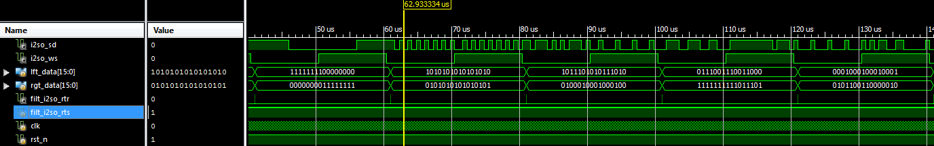

**Fig. 3.11:** Sample of Serializer Simulation

**Chapter 4: Digital Filtering – D. Naik**

*4.1 Introduction*

The main function of the ASIC chip is as a digital filter for audio processing. A digital filter operates on an input signal and produces a new signal, or filtered signal. In DSP, two of the most basic uses of a digital filter are signal separation and signal restoration. Separation is done when an input signal is polluted with interference, noise, or other signals. Filtering, removes any unwanted features from an input signal. Restorations is used when the signal has been distorted. One example of restorations is when an image is focused after being acquired due to a shaky lens. These filters are implemented in many types of devices and range in complexity. More advance filters are used for enhancements, compensation for listening room dynamics, special effects, and many other features. For example, MP3 players have a multitude of digital filters structures for different applications within the system. The four most basic types of filters are high pass, low pass, band pass, and band reject. Below in Figure 3.1, shows the frequency response of each filter structure. A digital filter can be represented with its frequency response, which is the discrete Fourier transform of its impulse response.

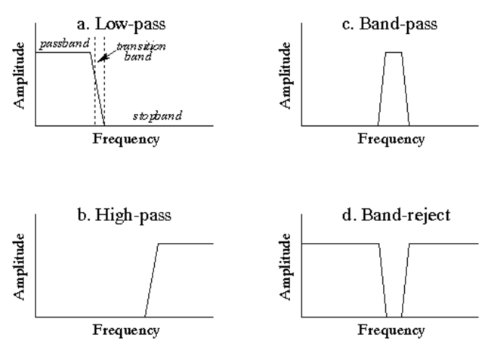

**Fig. 4.1:** Frequency Response of Filter Structures

Above, each filter structure has 3 interesting regions. The passband is the area in which frequency is allowed to pass freely. The stopband is the area in which the frequency is attenuated. Finally, the transition band is the transition between the passband and the stopband. Digital filters can be implemented two ways: by convolution and by recursion. Convolution is also called finite impulse response or FIR and recursion is called infinite impulse response or IIR. In FIR filters the filter coefficients are derived from the impulse response of the system. The given filter coefficients characterize the type of the digital filter. Convolution is defined by the equation:

$$y\left[n\right]=\sum_{k=0}^{N-1}{h\left[k\right]x[n-k]}$$

Here x is the discrete time input signal and h is the filter coefficients/impulse response. For the TCNJ ASIC, the filter will have 512 taps or 512 delays. Thus the filter will need to store, present and past inputs and index them appropriately.

In order to design a digital filter for audio processing, the human auditory system needs to be taken into consideration. The perception of continuous sound, can be separated into three parts: loudness, pitch, and timbre. Our audio quality goal will be to match the sound quality from a high fidelity compact disc. The specifications for the sound quality are the following. The chip will support sampling rates up to 48 kHz with precision of 16 bits per audio channel (left and right). The bit depth refers to the number of bits of precision when quantizing the sampled signal. The number of bits reduces the quantization error. Thus reducing the “hiss” associated with lower bit precision.

*4.2 Filter*

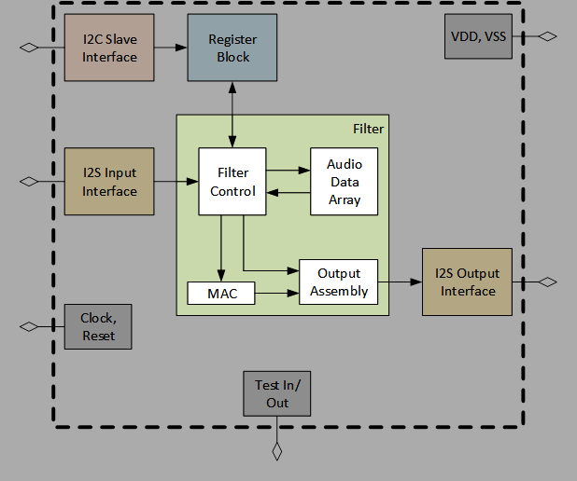The filter block is a sub-block of the top level chip. Figure 3.2 shows the filter with respect to the other interfaces.

**Fig. 4.2:** Chip Diagram with Filter Highlighted

The filter interfaces with the I2S input and output blocks, and the Register block. The incoming audio signal is streamed in from the I2S input as serial data. Both channels (right and left) are sent as the same data line. In addition to providing control bits for the shift and clip, the register is responsible for providing the filter with filter coefficients. The input signal, including past input samples are convolved with the filter coefficients. Before the filter output is sent to the I2S output, three operations are performed: rounding, shifting, and clipping. Figure 3.2 is the top level view of the filter. Table 3.1 describes the corresponding signals for the top level filter.

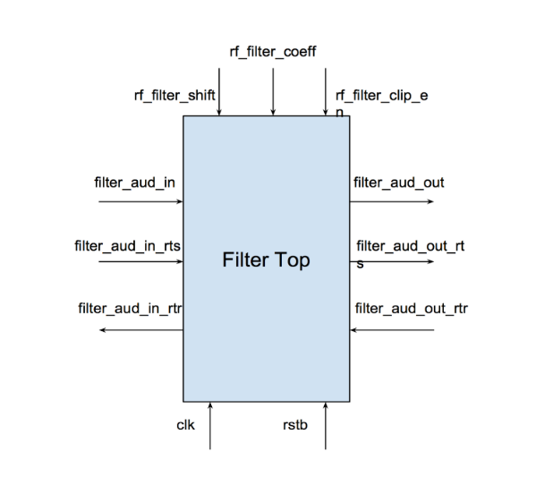

**Fig. 4.3:** Top Level Block Diagram of Filter

**Table 4.1:** Interface Signals for Filter

|  |  |  |  |
| --- | --- | --- | --- |
| **Signal Name** | **Direction** | **Bits** | **Comment** |
| General | | | |
| clk | in | 1 | Master Clock |
| rstb | in | 1 | Asynchronous Reset |
| Audio In | | | |
| filter_aud_in | in | 32 | Input Digital Audio |
| filter_aud_in_rts | in | 1 | Input FIFO Asserts Ready to Send |
| filter_aud_in_rtr | out | 1 | Filter STM Asserts Ready to Receive |
| Audio Out | | | |
| filter_aud_out | out | 32 | Output Digital Audio |
| filter_aud_out_rts | out | 1 | Filter STM Asserts Ready to Send |
| filter_aud_out_rtr | in | 1 | Output FIFO Asserts Read to Receive |
| Register Fields | | | |
| rf_filter_shift | in | 3 | number of bit positions to shift |
| rf_filter_clip_en | in | 1 | 1-perform clipping 0-no clipping |
| rf_filter_coeff [0:511] | in | 8192 | Filter coefficient |

Referring to Table 3.3, *rstb*, represents an asynchronous reset. An asynchronous reset is typically active low, meaning that it triggers on the negedge as opposed to a synchronous reset, which is often active high. The advantage of using an asynchronous reset is, the reset has priority over any signal, including the master clock. This allows the block to reset with or without the presence of a clock. The second signals to consider are *filter_aud_in* or *filter_aud_out*. These digital audio signals contain bits for both audio channels. The right audio channel bits are stored in the first 16 LSB [15:0] and the left audio channel bits are stored in the first 16 MSB [31:16]. The final signal to consider further is *rf_filter_coeff*. The filter coefficients are assumed to be stable. If they change during any calculation of an output sample the result will be unpredictable. Figure 3.3 is a more detailed block diagram of the filter. Two things of note. First the multiplication will be signed multiplication. This is done by defining wires and registers as signed type. Secondly, there will be two instantiations of the accumulator for left and right audio signals. *Filter_aud_in* will be split into two before the multiplication and concatenated before the three operations.

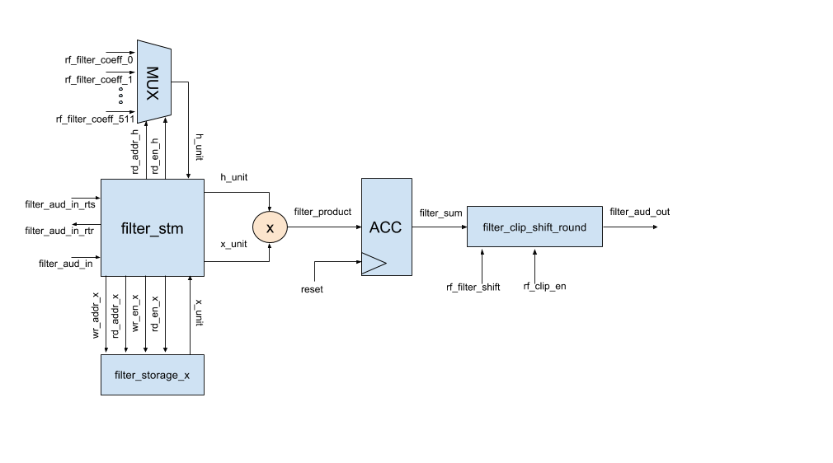

**Fig. 4.4:** Detailed Block Diagram of Filter

The following subsections, will highlight specific submodules of the filter and describe them in detail.

*4.2.1 Filter State Machine*

The filter is controlled by a centralized finite state machine (FSM). A FSM can only function in a single state, or the current state. It is defined by its different states and trigger conditions (transitions). The states of a FSM can be encoded in various ways – one convient encoding is known as One-Hot. In a One-Hot encoding each state is represented by a single bit. For the TCNJ ASIC, the filter has 4 different states, so for this instance 4 flip-flops will be reserved to represent the filter FSM. Table 3.2 shows the highlights and describes the signals for the FSM.

**Table 4.2:** Interface Signals for Finite State Machine

|  |  |  |  |
| --- | --- | --- | --- |
| **Signal Name** | **Direction** | **Bits** | **Comment** |
| General | | | |
| clk | in | 1 | Master Clock |
| rstb | in | 1 | Asynchronous Reset |
| Audio Signals | | | |
| filter_aud_in | in | 32 | Input Digital Audio |
| rf_filter_coeff | in | 16 | Filter Coefficient |
| filter_aud_out | out | 32 | Output Digital Audio |

In addition to the signals described above, the submodule uses additional internal wires and signals. These specific signals can be found in the Source Code section in the Appendix.

**IDLE:**

The FSM enters the IDLE state if, and only if, the RESET signal is asserted. Upon assertion of XFC the FSM will transition to the TRANSFER state.

**TRANSFER:**

Once XFC is asserted, the filter will transition into the TRANSFER state. In this state, *filter_aud_in* is written into the storage module and the write pointer is incremented. Once the transfer is complete, read enable for the storage module and *filter_aud_in_rtr* are deasserted. The FSM will transition to MULTIPLY_1ST after this is complete.

**MULTIPLY_1ST:**

The convolution phase is separated into two states because the accumulator needs to load the first product. After the first computation is completed the state will transition to MULTIPLY.

**MULTIPLY:**

In the MULTIPLY_1ST and MULTIPLY states the FSM access the storage module for computation. The TCNJ ASIC filter is a 512 tap filter. The filter needs to access previous inputs, as far as 511 inputs from the past. Further discussion of the storage module is found in the next subsection. The 512 most recent input samples are multiplied against a corresponding filter coefficient. The filter coefficients are accessed from 0 to 511 for each iteration of the states. The inputs are accessed from the newest input to the input from the last iteration. Below are a few iterations of the convolution process.

1. y[0] = h[0] x[0] + h[1] x[-1] + … + h[510] x[-510] + h[511] x[-511]
2. y[1] = h[0] x[1] + h[1] x[0] + … + h[510] x[-509] + h[511] x[-510]
3. y[2] = h[0] x[2] + h[1] x[1] + … + h[510] x[-508] + h[511] x[-509]

Each of these products are computed each clock cycle. Each of these products are sent to an accumulator, which stores the sum of products until the next iteration. The accumulator will store a 40-bit signal, so there is little chance of an overflow. This 40-bit signal is rounded, clipped, and shifted and is ready to be sent to the Output I2S. Once the state is ready for a new input, read enable for both storage modules is deasserted and *filter_aud_in_rtr* is asserted. The filter will go through each of the discussed states until the chip is reset and the filter will transition into the IDLE state.

*4.2.2 Filter Storage Module*

The storage module is responsible for storing, indexing, writing, and reading the input signal. Table 3.3 shows the highlights and describes the signals for the Filter Storage Module. These signals are representations for both instances of the submodule.

**Table 4.3:** Interface Signals for Filter Storage Module

|  |  |  |  |
| --- | --- | --- | --- |
| **Signal Name** | **Direction** | **Bits** | **Comment** |
| General | | | |
| clk | in | 1 | Master Clock |
| Write Data | | | |
| wren | in | 1 | 1-wrdata will be written into wrptr |
| wrptr | in | 9 | Current Location of Write Pointer |
| wrdata | out | 32 | Data to be Written |
| Read Data | | | |
| rden | out | 1 | 1-rddata will be read from rdptr |
| rdptr | in | 9 | Current Location of Read Pointer |
| rddata | out | 32 | Data Being Read |

In addition to the signals stated above, the storage module defines a 2D array. The width of the array is 32 bits and the depth is 512 locations. The array behaves in a circular manner. Once the *wrptr* or *rdptr* indexes the last position it will wrap back to the beginning of the array. Consequently, the data will be overwritten. The signals *wren*, *rden*, *wrptr*, and *rdptr* are controlled by the state machine.

*4.2.3 Mux*

The storage module is sufficient for indexing and reading filter coefficients but does not satisfy our requirements. Using the storage module will be inefficient in reading the filter coefficients because the data is already stored in Register block and would be redundant to write them in an array located in the Filter block. Instead, a mux can be used to read the correct filter coefficients using a bus of wires.

In the Register block, a single filter coefficient is represented by two signals: rf_filter_coeff*n*_a and rf_filter_coeff*n*_b. Instead of reading two signals for a single filter coefficient, the mux concatenates the two wires into a single wire. Signal rf_filter_coeff*n*_a is stored in the first 8 LSB [7:0] and rf_filter_coeff*n*_b is stored in the first 8 MSB [15:8]. Below in Table 3.4, shows the signals for the mux submodule. A clock is placed to keep it in sync with *filter_aud_in* values.

**Table 4.4:** Interface Signals for Mux Module

|  |  |  |  |
| --- | --- | --- | --- |
| **Signal Name** | **Direction** | **Bits** | **Comment** |
| General | | | |
| clk | in | 32 | Signal being performed on |
| Select Data | | | |
| rden | in | 1 | Read enable |
| rdptr | in | 9 | Location of data to be selected |
| rf_filter_coef[0:511] | in | 8196 | Filter Coefficient |
| rddata | out | 15 | Selected Data |

*4.2.3 Accumulator*

An accumulator, at the posedge clock, takes the input signal and adds it to the current value that is stored in a D flip-flop. The resulting value is stored for future computations until the accumulator is reset. To avoid overflow, the value being stored will be 40 bits long. The signals are defined in the below table. When *enable* is asserted, the accumulator will function as normal. When *load* is enabled, *D* is set to the new value.

**Table 4.5:** Interface Signals for Accumulator Module

|  |  |  |  |
| --- | --- | --- | --- |
| **Signal Name** | **Direction** | **Bits** | **Comment** |
| General | | | |
| clk | in | 1 | Master Clock |
| rstb | in | 1 | Asynchronous Reset |
| Control Signals | | | |
| enable | in | 1 | 1-Accumulate 0-Idle |
| load | in | 1 | Load new value |
| Input/Output Data | | | |
| D | in | 32 | Input Value |
| Q | out | 40 | Current Total |

*4.2.3 Shift, Round, and Truncate*

This module is to receive the final accumulated value and perform shifting, rounding, and truncating. The final value is a 16-bit value representing digital audio data. Below is a diagram of the arithmetic.

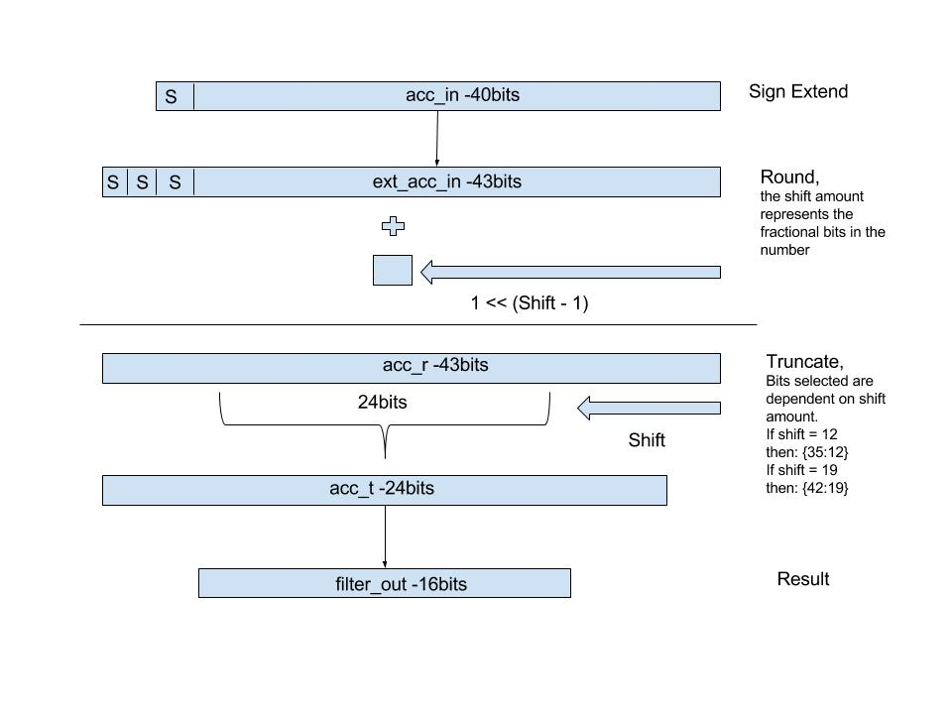

**Fig 4.5:** Finite State Machine: States and Transitions

**Table 4.6:** Interface Signals for Shift Round Truncate Module

|  |  |  |  |
| --- | --- | --- | --- |
| **Signal Name** | **Direction** | **Bits** | **Comment** |
| General | | | |
| clk | in | 1 | Master Clock |
| rstb | in | 1 | Asynchronous Reset |
| Control Fields | | | |
| rf_shift | in | 3 | Shift Amount |
| rf_clip | in | 1 | Allow clipping when overflow |
| trig_filter_ovf_flag | in | 1 | Reset overflow flag |
| ro_filter_ovf_flag | out | 1 | Triggered when overflow occurs |
| Audio Data | | | |
| acc_in | in | 40 | Final accumulator input |
| filter_out | out | 16 | Output Digital Audio |

*4.3 Verification*

To verify the Filter Block, I performed two types of tests, individual unit testing for each submodule and full block level test. The full block level test was to verify the functionality of the block. I did testing of actual filter responses. The following sections will outline testing from the lowest module to the highest module. As far as functionality, the filter block passes all the current tests. The filter was also verified with the entire chip in the Verification Section. This was done by using filter coefficients produced by the Matlab FDA toolbox. Below are is an example impulse response of 512-tap Low-Pass filter. Using coefficients produced by Matlab, I compared results from the Verilog simulation with a Java Model.

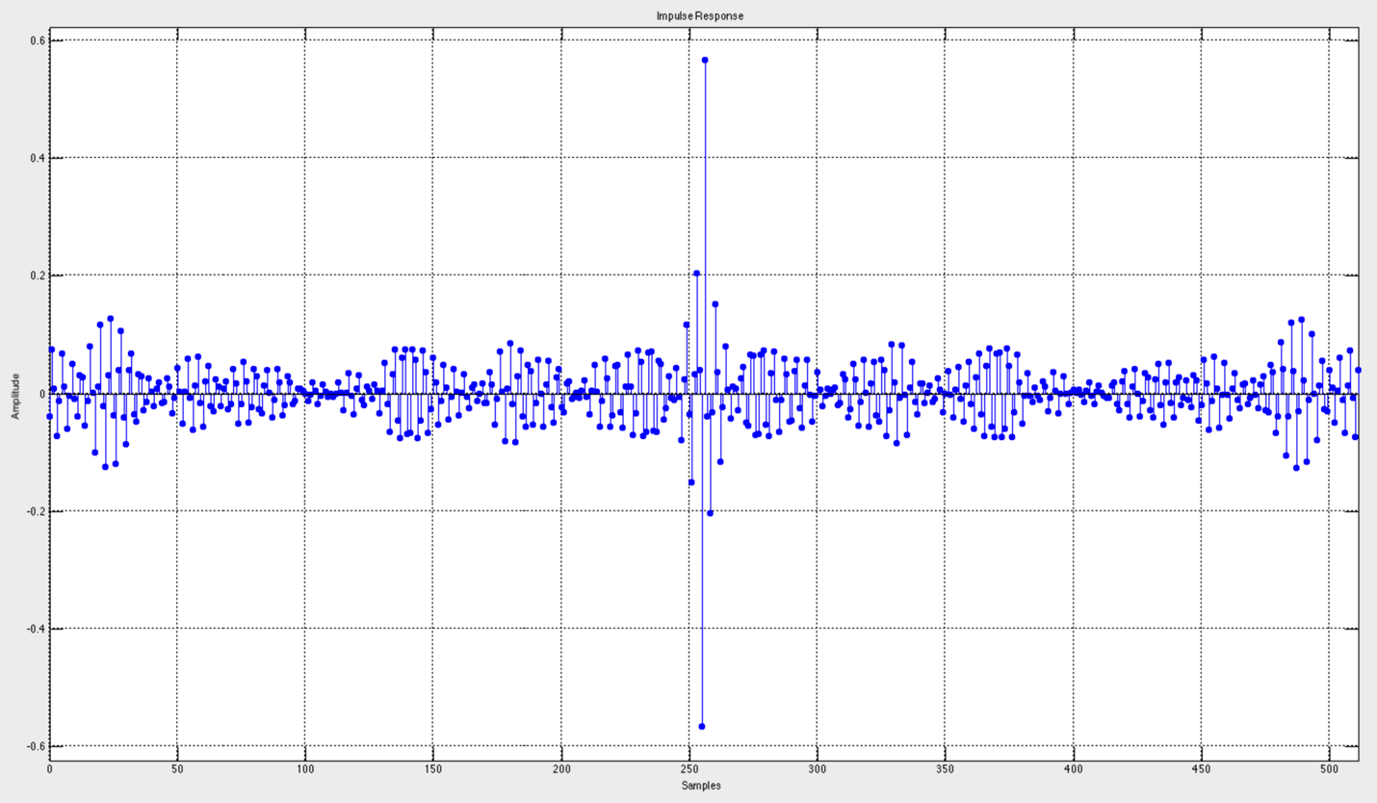

**Fig. 4.6:** Impulse Response of 512-Tap Low-Pass Filter

*4.3.1 Accumulator*

To verify the Accumulator, I tested three functions: loading, normal operation, and reset. The first test was to verify when load and enable were both asserted. What I expected was that the output would not accumulate and would equal to the input signal. The second test was to verify when load = 1’b0 and enable = 1’b1. I expected to see the accumulator increment by the input signal each clock cycle. The output signal has a 4 bit overhead to avoid overflow. The final test was to check what occurred when rstb = 1’b0. I expected the reset to take priority over the other signals and set the output to 1’b0. Below is the simulation output. All three of my assertions were proven correct.

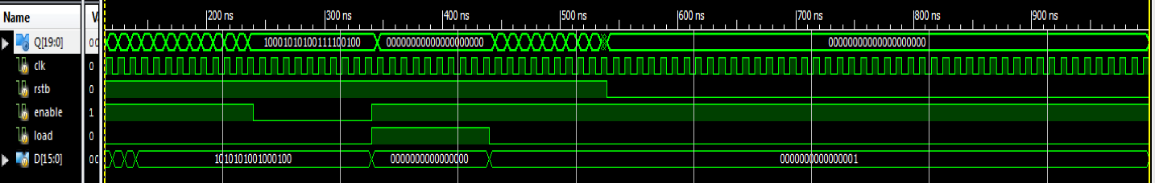

**Fig. 4.7:** Simulation of Accumulator

*4.3.2 Filter Storage Module*

To verify the Filter Storage Module, I first tested basic writing and reading. I set the *wren = 1’b1*. I expect this to allow the module to write into the array at the given pointer. Starting with *wrdata = 32’hAAAAAAAA*, then *wrdata = 32’hBBBBBBBB*, and finally *wrdata = 32’hCCCCCCCC*. I increment the *wrptr* by 1’b1 after a 100 ns delay. To verify the values were stored correctly, I set *wren = 1’b0* and *rden = 1’b1*. I read the array from ram[0] to ram[2], by incrementing *rdptr* by 1’b1 after a 100ns delay. To verify that the data is not lost when reading it, once I reached ram[2], I decremented by 1’b1 after 100ns delay. I expected to see *rddata = 32’hAAAAAAAA*, *rddata = 32’hBBBBBBBB*, *rddata = 32’hCCCCCCCC*. *rddata = 32’hCCCCCCCC*, *rddata = 32’hBBBBBBBB*, *rddata = 32’hAAAAAAAA*. Below is the simulation output. My assertions were proven correct.

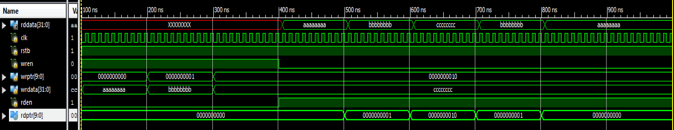

**Fig. 4.8:** Simulation of Filter Storage Module Test 1

The second, test I performed was to check how storage module performed when the write and read pointer went above 511. I expect the storage module to perform circularly. To perform this test, I incremented the *wrptr* by 513. I expected the pointer to go back to *wrptr = 1‘d1*. The write data was *wrdata = 32’hBBBBBBBB*. I then read ram[1]. I expected to have an output

of *rddata = 32’hBBBBBBBB*. Below is the simulation output.

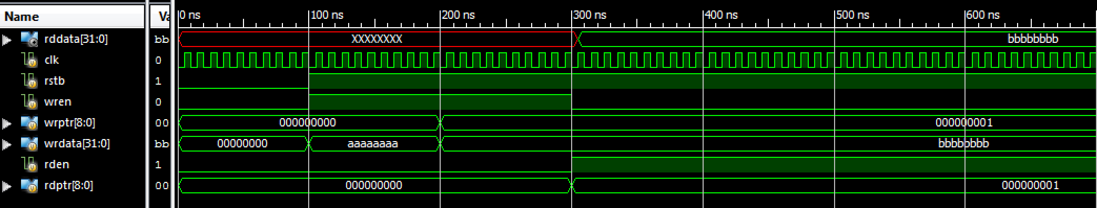

**Fig. 4.9:** Simulation of Filter Storage Module Test 2

*4.3.3 Mux*

To verify the mux, I tested if I received the correct 16 bit filter_coefficients. In addition, I tested if the mux correctly concatenated *rf_filter_coeffn_a* and *rf_filter_coeffn_b*. The ‘a’ component is stored from [7:0] and the ‘b’ component is stored from [15:8]. I set *rf*_filter_coeff(0-8)_*a* to 8’h00 to 8’h08, respectively. For *rf_filter_coeff(0-8)_b*, I set it to 8’h08 to 8’h00, respectively. For example, *rf_filter_coeff0* should output *16’h0800*. Another example would be, rf*_filter_coeff3* should output *16’h0503*. My test was successful as seen in the simulation output below.



**Fig. 4.10:** Simulation of Mux

*4.3.4 Filter STM/Filter*

I tested by filter state machine by testing my top level. For the first test I observed if the states were transitioning properly. For my design, the filter will kick-off when XFC is complete. After a delay of 100ns, I asserted *aud_in_rts*. Below is my simulation. Note: for testing I am using an 8 tap filter. In the simulation once the filter kicks-off, it will cycle through the states until it is reset around 1000ns. The *do_transfer, do_multiply_1st, and do_multiply* represent when the states are running. For my STM implementation, it takes a single clock cycle to transition.

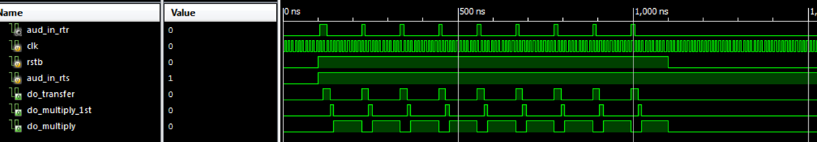

**Fig. 4.11:** Simulation of Filter Test 1

The next test I performed was to vary the *aud_in_rts* signal from deasserted to asserted. It is possible for the I2S block to be not ready to send data when the filter block is ready to take data. To test this, I asserted aud_in_rts and deasserted it after 100ns. I then waited 400ns to asserted it again. The MULTIPLY states will not be affected by this, but the TRANSFER state will get delayed until *aud_in_rts* is asserted again.

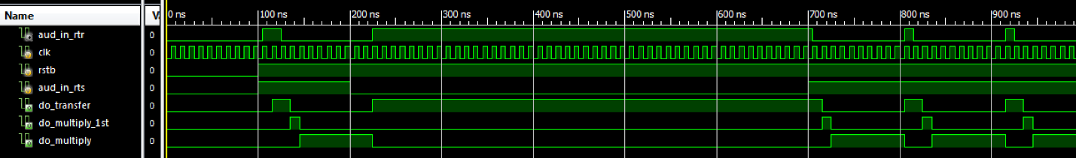

**Fig. 4.12:** Simulation of Filter Test 2

Above the simulation, shows that the TRANSFER state is prolonged as it is waiting for XFC to be complete before it can transfer aud_in and change states. This can be proven by the simulation below. Here when *aud_in_rtr* and *aud_in_rts* are both deasserted the *aud_in data* will not be stored in the ram array. Around 700ns, *aud_in_rts* is asserted and *aud_in* is transferred into the current *wrptr*. After the transfer the state changes to the MULTIPLY_1ST stage.

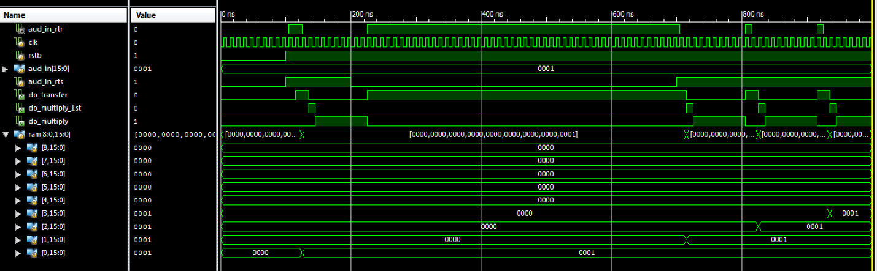

**Fig. 4.13:** Simulation of Filter Test 3

The next test I performed was to observe the behavior of the read pointer for both the mux and storage module. I am expecting the read pointer for the storage module to decrement and increment for the mux. Each cycle should have 8 (or the number of Taps) increments or decrements.

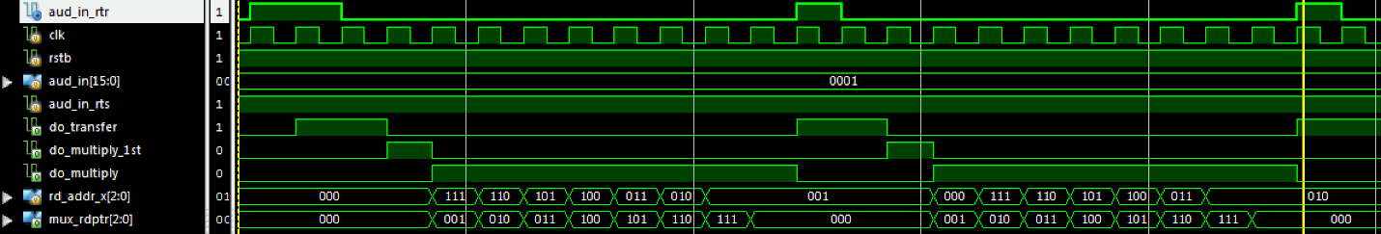

**Fig. 4.14:** Simulation of Filter Test 4

Note that the last clock cycle of the multiply state is superfluous for the current cycle. Also for the read pointer for the storage module (*rd_addr_x*), it starts at the current location of the writer pointer. This proves that the filter follows, which is the convolution process.

1. y[0] = h[0] x[0] + h[1] x[-1] + … + h[510] x[-510] + h[511] x[-511]
2. y[1] = h[0] x[1] + h[1] x[0] + … + h[510] x[-509] + h[511] x[-510]
3. y[2] = h[0] x[2] + h[1] x[1] + … + h[510] x[-508] + h[511] x[-509]

The next test, was functionality of the filter. Here are the following testing parameters:

*rf_coeff0_b | rf_coeff0_a = 16’h0001*

*rf_coeff1_b | rf_coeff1_a = 16’h0002*

*rf_coeff2_b | rf_coeff2_a = 16’h0003*

*rf_coeff3_b | rf_coeff3_a = 16’h0004*

*rf_coeff4_b | rf_coeff4_a = 16’h0005*

*rf_coeff5_b | rf_coeff5_a = 16’h0006*

*rf_coeff6_b | rf_coeff6_a = 16’h0007*

*rf_coeff7_b | rf_coeff7_a = 16’h0008*

The audio values vary from *32’h00000000* to *32’h00FF00FF*, again the 16 most MSB are the left audio and 16 most LSB are the right. We are assuming that the I2S is always ready to send. In addition, I am only clipping and not shifting currently. The state machine outputs a 40bit audio out signal (due to the accumulator), so at the filter.v level the audio out is defined by:

*assign aud_out = convo_signal[39:8];*

Below is the simulation result.

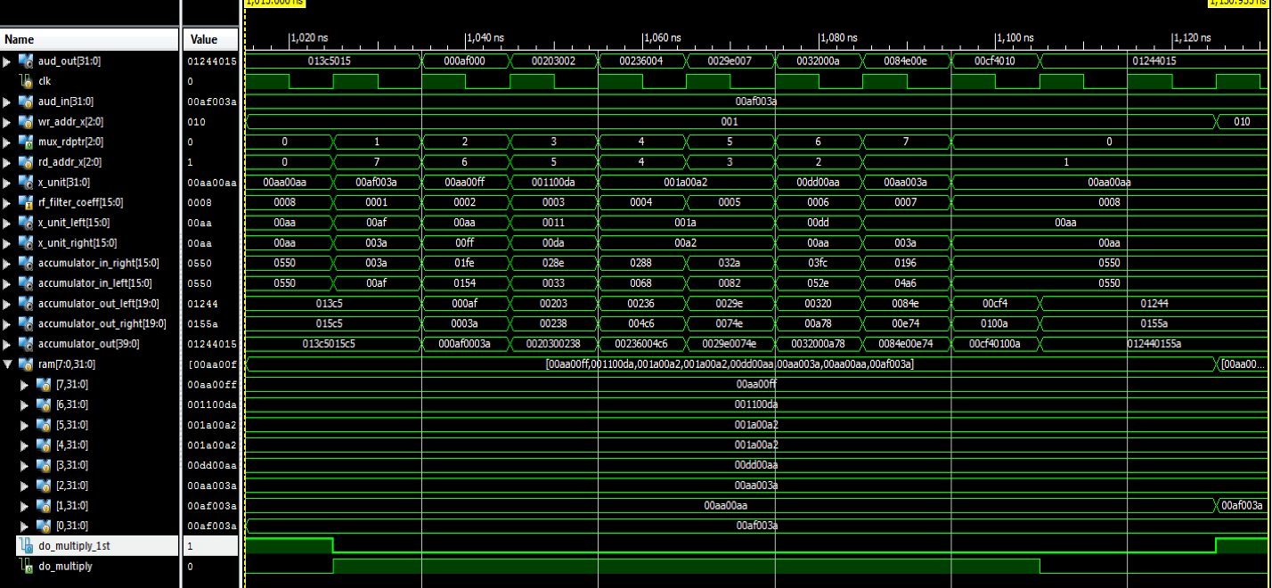

**Fig. 4.15:** Simulation of Filter Test 5

To check our simulation, I am going to check the results by hand. Note: all values in Hex

Here is the input signal and impulse response:

*x[n] = {00af003a, 00aa00aa, 00aa003a, 00dd00aa, 001a00a2, 001a00a2, 001100da, 00aa00ff}*

*xleft[n] = {00af, 00aa, 00aa, 00dd, 001a, 001a, 0011, 00aa}*

*xright[n] = {003a, 00aa, 003a, 00aa, 00a2, 00a2, 00da, 00ff}*

*h[n] = {0001, 0002, 0003, 0004, 0005, 0006, 0007, 0008}*

The sum of products is defined by:

Note: I am using hex values for the index values

*y[0] = x[0]h[0] + x[7]h[1] + x[6]h[2] + x[5]h[3] + x[4]h[4] + x[3]h[5] + x[2]h[6] + x[1]h[7]*

There are two multipliers and accumulators for left and right audio. The calculations, done with WolframAlpha.com , are the following:

*Left:*

*yLeft = 00af*0001 + 00aa*0002 +0011*0003 + 001a*0004 +001a*0005 + 00dd*0006 +00aa*0007 + 00aa*0008*

*yLeft = 0x01244*

*Right:*

*yRight = 003a*0001 + 00ff*0002 +00da*0003 + 00a2*0004 +00a2*0005 + 00aa*0006 +003a*0007 + 00aa*0008*

*yRight = 0x0155a*

If I concatenate yLeft and yRight, I get *y = 0x012440155a*. Then we clip the least significant bit to get a 32-bit value of *0x01244015*.

This matches what we get in our simulation.

**Chapter 5: Register Block – J. Swift**

*5.1 Introduction*

The register block provides storage and access for control and status information. In Fig 5.1 the interaction of register block and the other blocks can be observed. The I2C slave interface sends byte-wide control data to the register block. Many of the registers represent filter coefficients and act as the filter’s parameters. These parameters can be changed by the user and written to the register block to control the audio filter behavior. Each filter coefficient is represented by two 8 bit values that are concatenated when sent to the filter control block. The I2C must be able to specify an address and write data to the specified address for the register to hold. When reading data, the I2C block will be able to read the stored data of a specified address. When an underrun occurs in the I2S’s FIFO, the register block will be able to clear the sticky bit that is flagged when the filter is producing data at a lower rate than the I2S Output is consuming.

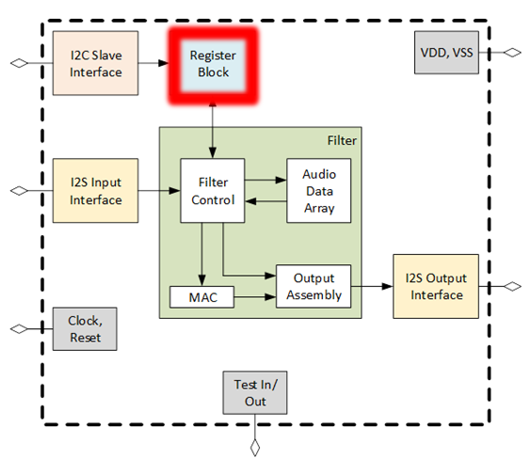

**Fig. 5.1:** Chip Diagram with Register Highlighted

Internally, the register block is broken down into a data demultiplexer that takes the write enable, address, and write data, and writes to the appropriate register bits based on the address. With the rising edge of the write enable, the data demultiplexer allows data to be stored in the register. This low level logic is controlled by the rising edge of the clock, which can be seen in Fig 5.2.

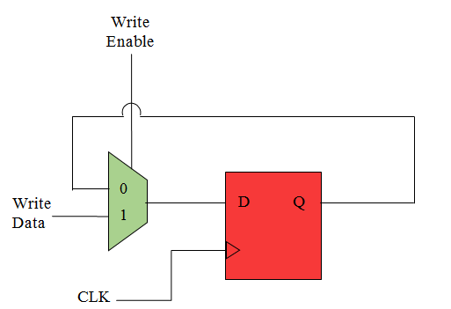

**Fig. 5.2:** Internal Micro-Architecture of Register

*5.2 Interfaces*

The top level interface of the register block is described in Fig 5.3 which shows the signal’s flow of direction and number of bits in each signal. The addr input signal is an 11-bit variable that holds the value of the address in the register block in which data can be read from or written to.

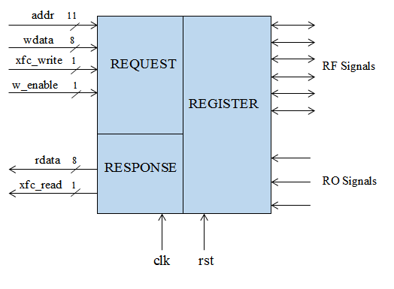

**Fig. 5.3:** Top Level Interface Design of reg.v

The wdata is an input variable array that writes 8-bits of data to a specified 11-bit address. Similarly, the rdata output array returns the 8-bits of data demanded by any signal request of a specified address. The write_xfc is an input 1-bit transfer signal that indicates when the transfer of the data written is complete. The read_xfc is an output 1-bit signal that similarly goes high when read data transfer is complete. Master clock, clk, and reset, rst, are 1 bit signals that regulate activity to occur on the positive edge of the clock or the negative edge of the rst signal. Lastly, the i2s_inoverrun will turn into a sticky bit that is manipulated when I2S FIFO has an overrun or underrun condition.

*5.3 Register Mapping*

The register map seen in Table 4.1 includes a list of all the signals assigned to an address and shows the breakdown of bits in each address. The natural 32-bit word aggregation is indicated in bold. Each signal is prefixed with “ro” or “rf” in the beginning of the field name. When a signal is prefixed with “ro” it means the signal represents a “Read Only” field, and is an input signal to the register block.  The “rf” prefix indicates that the signal is a “Read/Write” register bit, and is an output signal. The CONTROL signals are either on, meaning they are set to the value 1, or off when set to a value of 0. The I2S_CLOCK_CONTROL are addresses that control the clock for the I2S module. The STATUS addresses are 1 bit signals used when the I2S FIFO exhibits an overrun or underrun in which the signals will then be set to a value of 1 to alert the FIFO malfunction. BIST addresses will be dedicated to I2S’s predefined sawtooth wave. The read/write BIST signals are responsible for the starting value of the sawtooth wave, incrementing the sawtooth wave, and determining the upper limit of the sawtooth wave. The I2C_REG_INDIR_ADDR is the address register used for indirect addressing via I2C. Lastly, the 512 filter coefficients are broken down into two 8 bit coefficients with parts a and b. Each subdivided coefficient is assigned to an address in which data can be written and read from.

**Table 5.1:** Register Mapping of Each Bit in the Address it is Stored

|  |  |  |  |  |  |  |
| --- | --- | --- | --- | --- | --- | --- |
| **Address** | **Register Name** | **Field Name** | **Bits** | **Description** | **RO/WO/RW** | **Default Value** |
| **0x004** | **CONTROL** |  |  |  |  |  |
| 0x004 |  | rf_i2si_bist_en | 0:0 | 0- audio source is i2si. 1- audio source is BIST | RW | 0x1 |
| 0x004 |  | rf_filter_shift | 3:1 | number of bit positions to shift after filter accumulator | RW | 0xF |
| 0x004 |  | rf_filter_clip_en | 4:4 | 1- performs clipping 0- no clipping | RW | 0x1 |
| **Address** | **Register Name** | **Field Name** | **Bits** | **Description** | **RO/WO/RW** | **Default Value** |  |
| 0x004 |  | rf_i2si_en | 5:5 | Enable bit for Deserializer. 0 = inactive, 1 = active | RW | 0x01 |
| **0x008** | **STATUS** |  |  |  |  |  |
| 0x008 |  | trig_fifo_overrun | 0:0 | i2s input audio fifo overrun clear | WO | NA |
| 0x008 |  | ro_fifo_overrun | 1:1 | i2s input audio fifo overrun | RO | 0 |
| 0x008 |  | trig_fifo_unerrun | 2:2 | i2s output fifo underrun clear | WO | NA |
| 0x008 |  | ro_fifo_underrun | 3:3 | i2s output audio fifo underrun | RO | 0 |
| 0x008 |  | trig_filter_ovf_flag_clear | 4:4 | filter overflow flag clear | WO | NA |
| 0x008 |  | ro_filter_ovf_flag | 5:5 | filter overflow flag | RO | 0 |
| **0x00C** | **BIST** |  |  |  |  |  |
| 0x00C |  | rf_i2si_bist_incr | 7:0 | increment of sawtooth wave | RW | 0x010 |
| 0x00D |  | rf_i2si_bist_start_val_a | 7:0 | start value of sawtooth wave | RW | 0x80 |
| 0x00E |  | rf_i2si_bist_start_val_b | 3:0 |  | RW | 0x0 |
| **0x010** | **BIST** |  |  |  |  |  |
| 0x010 |  | rf_i2si_bist_upper_limit_a | 7:0 | upper limit of the sawtooth wave | RW | 0x7F |
| 0x011 |  | rf_i2si_bist_upper_limit_b | 3:0 |  | RW | 0xF |
| **0x0400** | **FILT_COEFFS_0_1** |  |  |  |  |  |
| 0x0400 |  | rf_filter_coeff0_a | 7:0 | Filter Coefficient 0 | RW | 0x0 |
| 0x0401 |  | rf_filter_coeff0_b | 7:0 | Filter Coefficient 0 | RW | 0x0 |
| **Address** | **Register Name** | **Field Name** | **Bits** | **Description** | **RO/WO/RW** | **Default Value** |
| 0x0402 |  | rf_filter_coeff1_a | 7:0 | Filter Coefficient 1 | RW | 0x0 |
| 0x0403 |  | rf_filter_coeff1_b | 7:0 | Filter Coefficient 1 | RW | 0x0 |
| **0x0404** | **FILT_COEFFS_2_3** |  |  |  |  |  |
| 0x0404 |  | rf_filter_coeff2_a | 7:0 | Filter Coefficient 2 | RW | 0x0 |
| 0x0405 |  | rf_filter_coeff2_b | 7:0 | Filter Coefficient 2 | RW | 0x0 |
| 0x0406 |  | rf_filter_coeff3_a | 7:0 | Filter Coefficient 3 | RW | 0x0 |
| 0x0407 |  | rf_filter_coeff3_b | 7:0 | Filter Coefficient 3 | RW | 0x0 |
| **0x7FC** | **FILT_COEFFS_510_511** |  |  |  |  |  |
| 0x07FC |  | rf_filter_coeff510_a | 7:0 | Filter Coefficient 510 | RW | 0x0 |
| 0x07FD |  | rf_filter_coeff510_b | 7:0 | Filter Coefficient 510 | RW | 0x0 |
| 0x07FE |  | rf_filter_coeff511_a | 7:0 | Filter Coefficient 511 | RW | 0x0 |
| 0x07FF |  | rf_filter_coeff511_b | 7:0 | Filter Coefficient 511 | RW | 0x0 |

*5.4 Sub-Blocks*

*5.4.1 trig_generator.v*

The trig_generator.v is responsible for generating a signal to clear the overrun and underrun status bits. The two output bits, trig_i2si_fifo_overrun_clr and trig_i2so_fifo_underrun_clr, are initialized to zero when not rst. If the address is the 11-bit hexadecimal number 0x00C and the xfc_write is set to one, then the if-statement returns true and the trigger bits are edited. Trig_i2si_fifo_overrun_clr and trig_i2so_fifo_underrun_clr are first initialized to zero in order to allocate them later only in the case of an overrun or underrun. When the data transfer is complete, meaning the XFC is 1, and the address is 0x00C, two if-statements are then checked. One stating that when data written to 0x00C is 0, the trig_i2si_fifo_overrun_clr bit is set to 1, and the other stating that when data written to 0x00C is 2, the trig_i2so_fifo_underrun_clr bit is set to 1. These 2-bits in the address 0x00C report back to the I2S block where the FIFO is signaled to either have an overrun or underrun.

*5.4.2 register.v*

The register.v is responsible for initializing all the signals and filter coefficients along with assigning all signals/coefficients to the proper address. The 16-bit filter coefficients are initialized to zero and the rest of the signals are initialized to the hexadecimal default values given in Table 4.1. When the write enable (w_enable) and the write file transfer (wxfc) are both 1, a case statement is entered; given an address, the corresponding bit(s) within the address are broken down and assigned to the data written to the register. A second always block includes setting the read file transfer (rxfc) to not-write enable (~w_enable) and write file transfer (wxfc). An if-statement states that if not-write enable and write file transfer are 1, the case-statement can begin. When entering the case-statement, a specified address is can be called and the stored data can be read. The register.v allows data to be written to an address that correlate to specific signal(s), and allows data to be read from signal(s) that are stored in a specific address.

*5.5 Test Fixtures*

*5.5.1 trig_generator_testbench.v*

The purpose of the trig_generator_testbench.v is to write data to the address and trigger the trig_i2si_fifo_overrun_clr and trig_i2so_fifo_underrun_clr bits at the appropriate time. First the test fixture initializes the count and clk variables to zero to create a fresh simulation. The wdata is set to 8-bit address 8’hFF. The count variable counts to the hexadecimal value 20 where the 11-bit address is then initialized by 4 every time the count variable is incremented as seen in Fig 5.4. The rising edge of the XFC signals that the transfer of data has been completed, which allows data to be written to the address space and increment the address signal by 4 from 0000 to 0100. This test fixture writes to every address in order to ensure data is properly being written and stored.

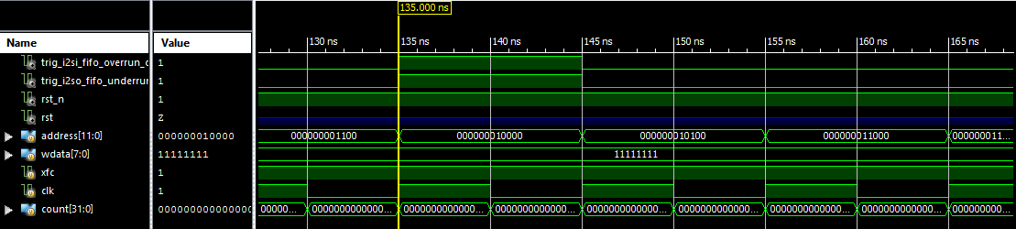

**Fig. 5.4:** The Start of the Test Fixture Simulation

When the count variable reaches 20 and the hexadecimal value 0x00C is reached, the trig_i2si_fifo_overrun_clr and trig_i2so_fifo_underrun_clr bits are triggered to becomes 1 as seen in Fig 5.5. After the address 0x00C, or binary address 1100, goes low, the trigger bits go high for the length of the next address. This shows that the trigger bits are recognizing an overrun and underrun from the I2S FIFO because the conditions, XFC = 1, and address = 0x00C, are true. After the next clock cycle, the trigger bits will reset back to 0 because the I2S will have been signaled that an error has occurred in the buffer. A clock cycle after the address is incremented to 0x020, the XFC goes low to 0 and everything has reset again.

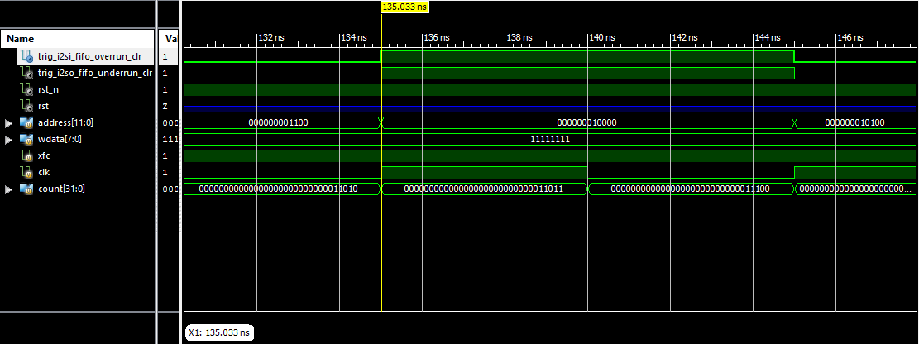

**Fig. 5.5:** Bits trig_i2si_fifo_overrun_clr and trig_i2so_fifo_underrun_clr are Triggered

*5.5.2 trig_generator_testbench1.v*

The second testbench for the trigger generator differs from the first testbench by initializing the address first to the 11-bit address 0x00C. Like the first testbench, when wdata is less than the address 0x020, wdata is incremented by 1 and the XFC is set to 1. The overrun trigger bit is signaled every clock cycle when the XFC goes high. The underrun trigger bit is signaled through the duration of four addresses, or two clock cycles, and when the XFC is set to 1. The testbench in Fig 5.6 indicates the trig_generator.v is fully functional because the overrun trigger bit is cleared every time data is trying to be written to the full I2S FIFO, and the underrun trigger bit is cleared every four addresses when the empty I2S FIFO is trying to be read.

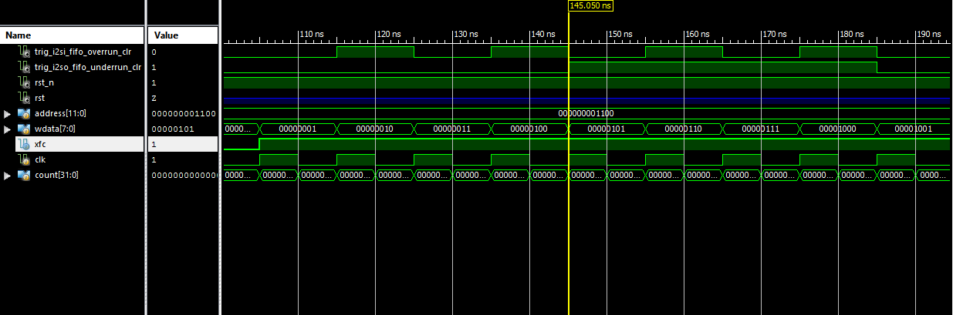

**Fig. 5.6:** Bits trig_i2si_fifo_overrun_clr and trig_i2so_fifo_underrun_clr are Triggered in Second Testbench

*5.5.3 i2c_reg_test_automated.v*

To test the register.v file, a testbench was created that incorporated the I2C block. I2C was set up in a subsystem test with the register to check that coefficients could properly be written, read, and stored properly from the I2C into the register block. Test data was loaded into the 512 two-part coefficients and the state of the coefficient registers were set to the 11-bit address 0x400. The slave address was set to the hexadecimal value 0xD5 with the 3-bit I2C address bits set to the binary value 101. After waiting 100ns for the global reset, a series of conditions were produced in order to serialize the slave address and the read/write bit, and serialize the two-part register address. The resultant waveforms generated showed the test data being properly written and stored within to the register.

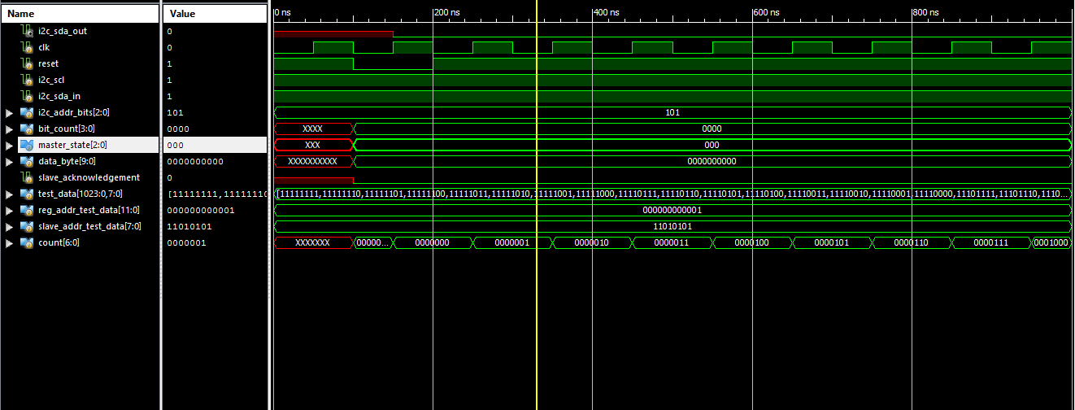

**Fig. 5.7:** Test data properly being written from the I2C into the Register Part 1

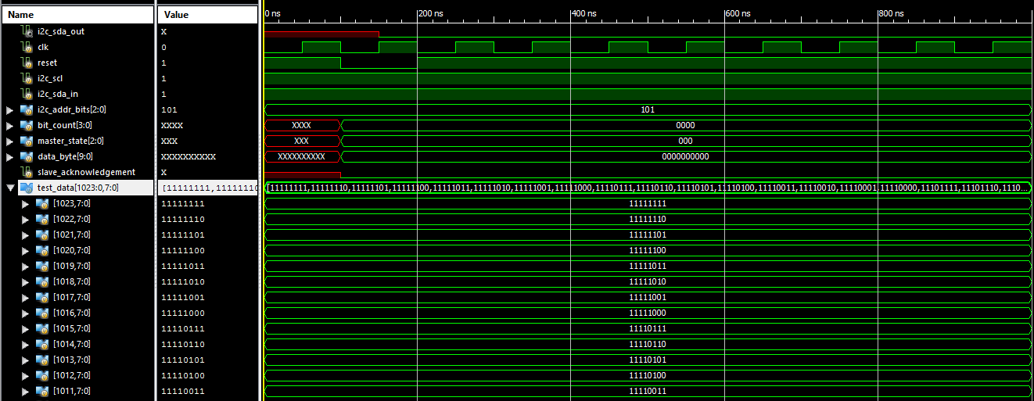

**Fig. 5.8:** Test data properly being written from the I2C into the Register Part 2

*5.6 C Code Involvement*

*5.6.1 initialize_coeffs.c*

To initialize all 512 16-bit filter coefficients to a hexadecimal value of 0, a C program was generated in order to generate the thousand lines of code. Each coefficient is split into 8 bits, creating coefficients a and b. This created 1024 lines of Verilog code that was generated into a filter_coeffs_initialized text file that would loop 512 times and print the correct formatting of each coefficient. The C program generated both coefficients a and b with a variable y incremented each loop cycle. The code outputs the two tabs such that when copying the code from the text file into Xilinx, it is formatted correctly. A pointer to the 16 bit hexadecimal 0 value is next to each coefficient in order to initialize all filter coefficients to zero.

*5.6.2 set_coeffs.c*

To assign all 1024 8-bit filter coefficients to the correct address, a C program was created to generate the correct number of tabs, case statement of the 11-bit hexadecimal address, and a new line of the name of the coefficient pointing to the 8-bit written data variable. In C, there is a compatible hexadecimal format that permits an integer to be incremented by hexadecimal 0x01 while still including the correct hexadecimal character formatting as hexadecimal should. After the address case statement, the correct name of the filter coefficient is expressed in which coefficients a and b are toggled between such that every other for loop iteration switches between coefficient a and coefficient b. The 1024 coefficients are properly formatted such that the contents of filter_coeffs_set.txt could be copied and pasted into Xilinx directly.

*5.6.3 set_read_coeffs.c*

The set_read_coeffs.c program generates the correct formatting for the case-statement that varies slightly from set_coeffs.c. The fprintf() statement is rearranged from set_coeffs.c to have rdata point to the signal requesting to be read, instead of having the signal point to wdata. The 1024 filter coefficients are created that same way as set_coeffs.c, but printed differently to the text file such that the filter block is able to read the filter coefficients values that are written in the first always block.

**Chapter 6: I2C Slave Interface – W. Forman**

*6.1 Introduction*

The I2C Slave interface of this chip serves a basic function to the system as a whole, to take filter coefficient values defined by the user outside of the chip and transfer them to the chip’s register block. As an additional verification functionality it can then read the values from the register block to ensure that they were written properly. The I2C bus was chosen over other busses such as RS-485, RS-232, CAN-bus and SPI because of its slave acknowledgement capabilities, multiple clock rates, low pin count and widespread usage in the industry. The function of the bus is to take in serial data from a master controller and convert it to a parallel format and then deliver it to the register block with the operation code, data and register address at the same time using a single strobe transfer for all parameters. If the operation is a read operation, then there is an added function to then take data information from the register block as parallel data and then transmit it back to the master I2C controller over the bus in a serial format. The block can be seen in Fig. 5.1 of the overall system chip diagram highlighted in red.

I2C was created and maintained by Philips Semiconductor now known as NXP semiconductor. Several updates to the original specification from 1982 have been made to keep up with the changing semiconductor industry to allow for faster transfer speeds up to 5 MHz from the original 100 kHz speed.

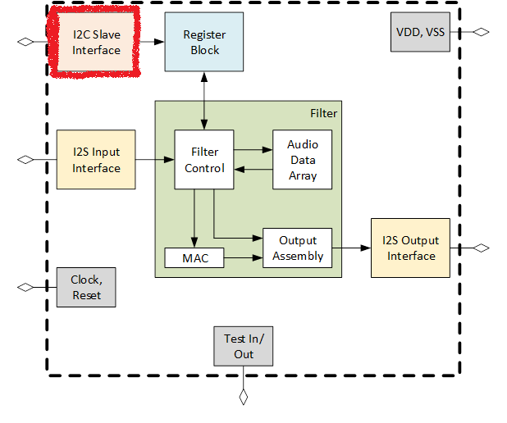

**Fig. 6.1:** I2C Chip Diagram Highlight

*6.2 Requirements*

When analyzing the scope of the project and the *I2C-bus specification and user manual [2]* document UM10204 from NXP semiconductor, several decisions were made about the functionality of the I2C block in regards to the necessity of the project and the time constraints to implement them. Several functions were not included in this project and the overall requirements were defined before any RTL coding was started. A more concise definition of the current requirements can be seen in section 5.2.1 and the tradeoff study which decided what functionality to include and exclude is found in section 5.2.2.

*6.2.1 Current Requirements*

Below is a list of the requirements for the current design of the I2C block of the chip being made with reasoning and some details of each.

* The I2C-bus specifies that a slave of the bus must be able to respond to a master unit when called. There are 2 different slave address sizes to choose from, 7 bit and 10 bit, our group decided that the 7-bit address mode was optimal as there would more than likely only be 1 slave on the bus at any given time so the 10-bit addressing would not be necessary.
* The register address size is 12 bits so in the case of I2C where data is sent only in bytes, 8 bits, before an acknowledge bit, the address space must be broken up into 2-byte sized data transmissions separated by acknowledge bits.
* The data to be written to each register is 8 bits so a normal byte transaction is sufficient to transfer the data to be written or read.
* The data transfer rate of I2C comes in several speeds. For the needs of this project the standard mode speed of 100 kHz maximum and fast mode of 400 KHz maximum were considered. The chip clock frequency is to be 10 MHz so the fast mode plus at 1 MHz was considered to be too fast and could possibly cause problems as far as sampling at 1:10, so the fast mode with a ratio of 1:25 was chosen to be the fastest speed. Also the group considered that with an address space of 12 bits and a data width of 8 bits that all 4096 filter coefficients could be written in 0.0921 seconds, as seen in figure ##, which would be fast enough for our purposes.

$$512 registers*9\frac{bits}{transition}=4608 bits total$$

$$\frac{4608 bits}{400 kbits/second}=0.01152 seconds$$

**Fig. 6.2:** I2C Full Coefficient Time Load Calculation

For this application, our chip needed only to be a slave for to a user.

* The burst write functionality is necessary to efficiently transmit large amount of sequential addressed data. Our I2C interface will be made to have a start address transmitted and then repeated bytes of data come in. Part of the functionality of the I2C block will be to increment the address associated with each byte of data by incrementing the address from the original address with each incoming data byte.
* The read functionality will be similar to the write functionality where the master will transmit an address to be read from and then the I2C block will be capable of serving repeated sequential read requests.
* The slave address of the chip could have been hardcoded into the chip, but it was decided by the group that having user selectable off chip switched for the 3 LSB of the address was appropriate. This will be realized through pull-up resistors or DIP switches in the FPGA board and test PCB that will be created when the final chip comes back from manufacturing.
* The transfer method from the I2C block to the register block will be done with a simple strobe. When the data, address and operational code are ready for transmission then a single bit for 1 clock cycle will go high and then low.

*6.2.2 Trade-off Study*

Several I2C functions found in the specification were left out due to the scope of this project. Below is a list of functions that were left out and short reasoning for them not being necessary.

* Clock stretching by a slave was considered unnecessary as our chip will not be running other processes during operation and there in theory will never be a time when it is busy and needs to delay transmission.
* Arbitration was deemed unnecessary as for our purposes we will be testing one chip on the bus at a time with a single master.
* Software reset was deemed unnecessary as this is an optional feature of I2C and not widely utilized.
* Bus clear was deemed unnecessary as this functionality would be useful in critical applications or a product for sale, but not for the scope of this project.
* Device ID was deemed unnecessary as our chip is not made by a manufacturer, is a single and only design by our team and will be the only revision.

*6.3 Top Block Interfaces*

The I2C Interface of this chip has only 3 external interfaces, the I2C master unit, the register block and the user definable slave address pins. Below is a detail of how each interface was implemented and in section 5.4.2 some of the previous designs that were changed.

*6.3.1 I2C Master*

The I2C master interfaces with the chips I2C slave module via a 2 wire interface using SCL and SDA lines which stand for serial clock and serial data respectively. Both of these single line wires are active high signals using pull-up resistors and the transitions of the signals are driven low by the transmitter during the transaction. The i2c_SCL input is only an input read by the slave and driven by the master, but the SDA line has both input and output directionality to it. Although specifically called i2c_SDA_in and i2c_SDA_out these two input and output lines would meetup during the EDA tools floor planning and place & route stages to become one line by using a MOSFET open drain configuration as seen in figure 5.4.

Data coming in on the SDA input line is sent in 1 byte increments so it was necessary that the deserializer be implemented in such a way that the first 2 bytes of data would be concatenated into a single 12-bit address register and the 4 MSB be discarded as they would all be zero.

During transmission of any data, the SCL line acts as a clock and the SDA line transition is only allowed during the low cycle of SCL. This fact was a large driver in signal filtering and conditioning of both SCL and SDA lines. To do this, it was decided that the SCL line would be double ranked through D flip-flops and the SDA line would be triple ranked through D flip-flops. This would stabilize the rise and fall times as well as filter out any spikes on each line that the logic circuitry would see. This also has a dual benefit as the signal transitions would now be matched in the chip’s clock domain making it easier to use in RTL synthesis.

The i2c_SDA_out wire acts as the data transmission line for the data read request implemented by the serializer but also the acknowledgement sent by the slave when it sends an ACK bit by driving the SDA line low after each byte received.

The I2C bus specification calls for many design details such as maximum bus capacitance, timing for different data conditions such as rise and fall times and frequencies. For the scope of the project for RTL synthesis rise and fall times and frequencies were considered as bus capacitance would not be a factor until EDA tools were being utilized as well as the test PCB being created. The frequencies for this block had already been chosen during the requirements phase of the project.

NEEDED BLOCK DIAGRAM

**Fig. 6.3:** I2C block diagram in

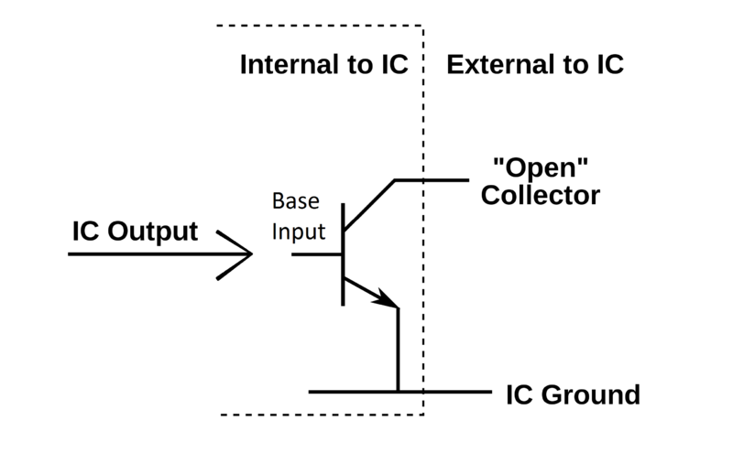

**Fig. 6.4:**Open Drain Schematic

*6.3.2 Register Block*

Interface with the register block in contrast with the I2C serial interface is much simpler. The interface between blocks is parallel where all bits are sent at once with a distinct wired connection for each bit and utilizing a single clock cycle strobe as a transfer signal rather than a fully handshake interface reduces wiring and complexity.

The output of the I2C to the register block consists of 4 lines, i2c_op, i2c_addr, i2c_wdata and i2c_xfc_write and each has a specific role in the data transmission transaction. The i2c_op wire is the operational code of the transaction and is either a high for a read and low for a write. The i2c_addr wire is actually 12 bits wide and this designates the current register address of the register block to be written to or read from depending on the operation code. The i2c_wdata wire is a byte wide and it has on it the data to be written during a write request and is neglected during a read request. When all data is ready in the operational code, address and data output wires to the register block the i2c_xfc_write, which is the strobe, is driven high for 1 clock cycle at which point the register block is told to capture the data, address and op code and perform its action depending on the operation code. If a write is requested, then the register write the data to that address and if a read is requested then the I2C block waits for the register to transmit back.

The input of the I2C block from the register block consists of 2 wires, the first is i2c_rdata which is 1 byte wide and holds the data from the requested read address, and the second is i2c_xfc_read which is the strobe of the transaction where the wire goes high for 1 clock cycle telling the I2C block to capture the data to be serialized on the isc_SDA_out wire of the I2C master interface.

*6.3.3 Slave Address Pins*

The user definable external address pins select the 3 LSB of the chip’s slave address. This would allow for more than 1 device to be put on the bus. The 3 bits would be selected by simply driving a pin on the chip’s package or a selected pin on an FPGA to be driven high and therefore would result in a user defined LSB address. The other 4 bits of the address are coded into the RTL and cannot be changed. 1010 was selected as the 4 MSB as this address space was allowed and open according the I2C bus specification. The logic for defining the address was not clocked and at any given moment is exactly what is defined by the pins without any delay as it was deemed unnecessary to clock this logic.

*6.4 Register Mapping*

The interconnections of the I2C block that do not interface outside the block connects all of the sub block together to form a cohesive unit. All of the data signals being transmitted can be seen in the table 5.1 register map as well as the control signals of the block diagram in figure 5.3.

**Table 6.1:** I2C Register table

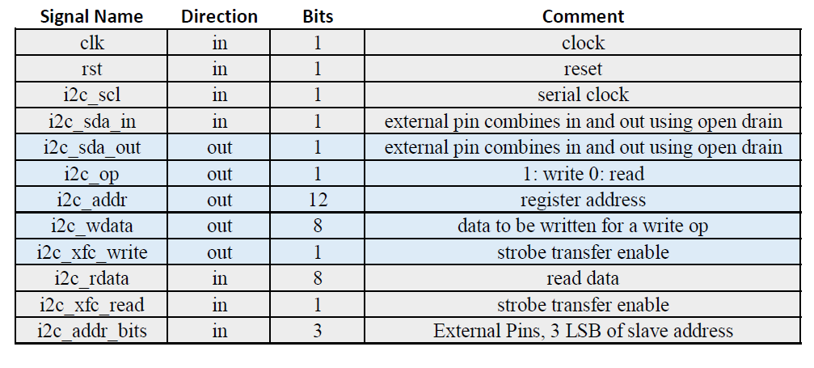

The data signal flow between the deserializer and the sequencer is similar to the interface between the sequencer and the register block i2c_RW is the same as i2c_op as well as serial_data being the same as i2c_wdata in width and information. The wire burst_addr is similar to i2c_addr in the fact that they are the same width and represent the data register address but burst_addr is the first address specified by the I2C master during a burst write or read. The sequencer increments the address as each new byte of data comes in. This is all controlled by the state of the machine and what is happening in regards to the data transitions being sent on the i2c_SDA_in and i2c_SCL interface signal.

*6.4.1 States*

The states of the I2C block is driven by events on the i2c_SDA_in and i2c_SCL interface wires and how and when their transitions happen with regard to one another. After certain timed events in the amount of data byte transactions as well as start and stop conditions drive how the control logic of the block that can been in the four wires addr_ack, data_ack, slave_ack and stop.

After a reset or a stop condition the block is an idle state. During this state the deserializer is the only active block and it is looking for a start condition on the SDA and SCL lines. When this occurs, it is still the only active block and it starts taking in 1 byte of serial data from the I2C master interface as the slave address call from the master and check it against the actual slave address. If the address is not the same then the system stays idle looking for another start condition, but if it is a match then the state changes to look for the burst start address after sending a pulse on the slave_ack wire to control the serializer to send a single ack pulse on the i2c_SDA_out wire and tell the I2C master that the slave is waiting for data.

Once this state is active the deserializer takes in 2 more bytes of data and concatenates them together to become the 12 bit burst_addr wire between the deserializer and the sequencer. Once the burst_addr has been captured then the slave_ack is driven high again as it does in between all received bytes of data to acknowledge to the master the reception of the data. The addr_ack also pulses so that the sequencer can take in the burst_addr and use it for sequencing.

Once these 2 bytes of data have been received as the burst_addr and the acknowledgement has been sent a state change is driven in the deserializer and now it knows that depending on the opcode bit that the data coming in will be of data to be filled into registers or that the address and opcode should be sent to the register block and a read was requested.

If a write request happens then after each data byte transmitted the deserializer pulses slave_ack for the acknowledgement over SDA as well as pulsing data_ack to the sequencer to notify it that the data has been captured is on the serial_data line between the deserializer and the sequencer. Every time that the data_ack is pulsed, then the sequencer updates the register address and the data and when it is ready it strobes i2c_xfc_write for one chip clock cycle to send the information to be written and then clears itself. This will happen continually until a stop or reset condition occurs. It is possible for a repeated start condition to occur after the slave acknowledgement in which case the slave looks for a slave address again. It is possible that in the event of a stream write data coming in that it will in fact be more than what the register block has allocated as valid address space. During future testing the team will decide if this functionality will be necessary as a control for invalid data and addresses. This would enlarge the size of I2C block and its complexity as there would be a need for an entire register block map to be coded into the sequencer block. This itself could cause unwanted operation so it will have to be decided as a group during testing to see if it is necessary or not. If a read was requested in the opcode, then the sequencer does not wait for data to be ready as it is not necessary and the sequencer will prepare the address and opcode to be strobe transferred to the register block. If a repeated start condition is send in lieu of an acknowledgement by the master, then this sequence will look again for a slave address and start the process over again.

The states can always be altered by a reset from the chip or from a stop condition seen on the I2C master interface. Either of these will force a reset of the whole block and goes back to state 0 and look for a start condition. With the structure described above the deserializer block is the state machine for the entire I2C block as it drives the state of the other blocks depending on what the master controller is requesting.

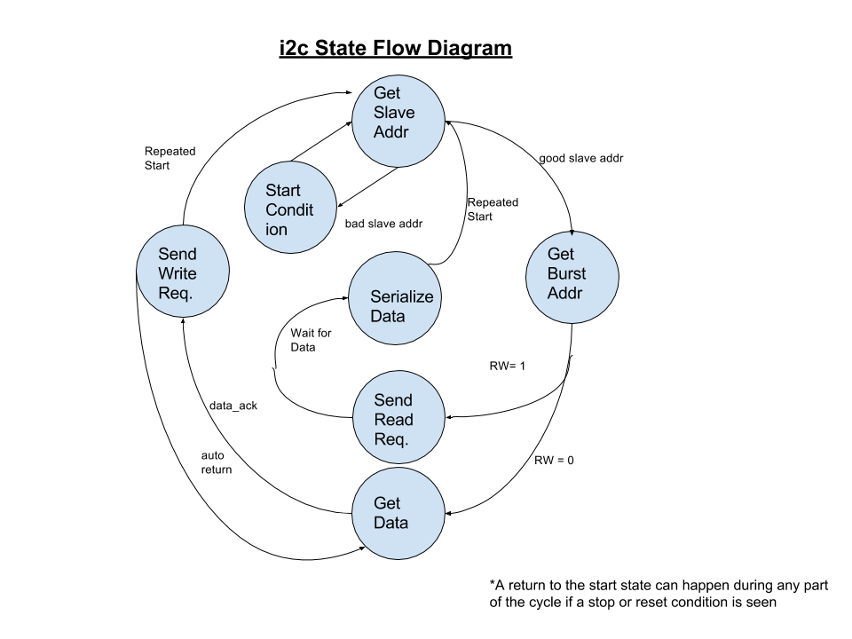

**Fig. 6.5:** I2CState Machine Flow Diagram

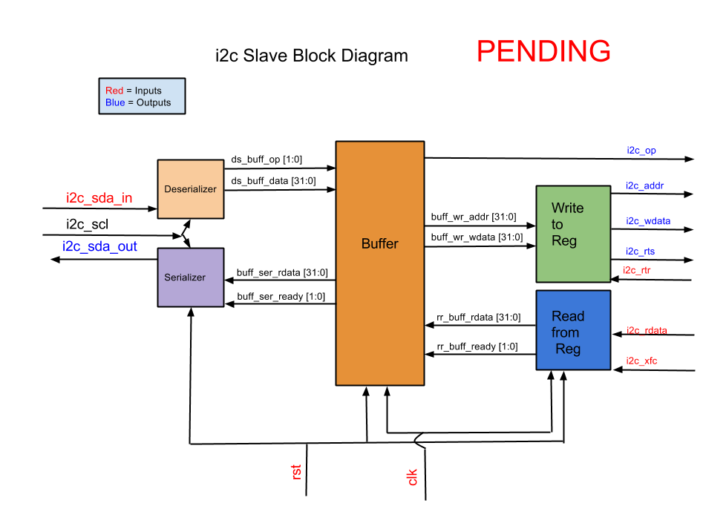

**Fig. 6.6:** I2C Previous block diagram versions

*6.5 Sub Blocks*

The I2C block was broken up into 3 distinct parts including the deserializer, the sequencer and the serializer. The design considerations are outlined in section 5.5.4 and details about the design of each sub block is outlined below in the following sections.

All sub-blocks use always statements for posedge clock and negedge reset to control when a reset happens. If statements are used inside of the always blocks to decide what happens based upon the state of each sub block. All always statements include as a first if statement a reset capability of all registers to be sent back to initial conditions.

*6.5.1 Deserializer*

The deserializer of this block became the defacto state control machine for the other sub blocks as it would be being controlled by the I2C master. The deserializer block has to perform several functions beyond simply deserializing the data coming from the master.

The deserializer must filter and condition the isc_SCL and the i2c_SDA_in signals in order to make them usable in the Verilog code. Edge detection pulses were extracted from each line after it went through the D flip flop ranking described above. States of the lines were also made during this conditioning step to have chip clock synched signals that were highly reliable during RTL synthesis.

To deserialize the data, there are 2 known possibilities in Verilog to accomplish this. The first being a shift register and the second being a case statement. Although the shift register was simple, the case statement seemed to give more control of multiple events occurring at the same time. The case statement is very similar to using a MUX where individual bits of a register are populated as a bit counter increments and sequential case statements become active. This allowed for the 8th case statement to include control signals to acknowledge, state change, and transfer data to different registers. Although logic intensive, this gave the designer a great deal of ease when it came to doing the multiple functionality of the block. The slave address, register address and data are all deserialized in the same way, but the different states of the machine drive how the control signals are handled.

The deserializer has to look for start and stop conditions coming from the I2C master. These conditions either turn on the deserializer to start deserializing data as well as checking the slave address coming in against the slave’s programmed address as well as extract the read or write enable bit from the LSB of the slave address sent and assign it to the i2c_RW line. Once this happens, a state change occurs and an acknowledgement signal sent to the serializer if the the addresses match or the deserializer resets itself and continues looking for another start condition.

Once a state change occurs from the slave address check then the deserializer goes into register address fetch mode where it takes in 2 bytes of serial data from the I2C master and then concatenates them to form the 12-bit register burst_addr signal. Once this occurs, another acknowledge signal is sent to the serializer in between the 2 bytes sent and after the second byte sent. At the same time the addr_ack signal is enabled going to the sequencer sub block to inform it that the address is ready to be received.

Depending on the i2c_RW bit at the strobe of the addr_ack signal, the deserializer will either reset itself if a read is requested as it has no purpose in the future of the transaction or it will go into data fetch mode. During data fetch mode the deserializer will continually deserialize data write it to the serial_data wire and then strobe the data_ack wire and then loop itself for another byte of data until a stop condition occurs.

The deserializer also has the capability to send out a stop signal when either a stop condition occurs or a reset occurs to ensure all other sub blocks have reset themselves.

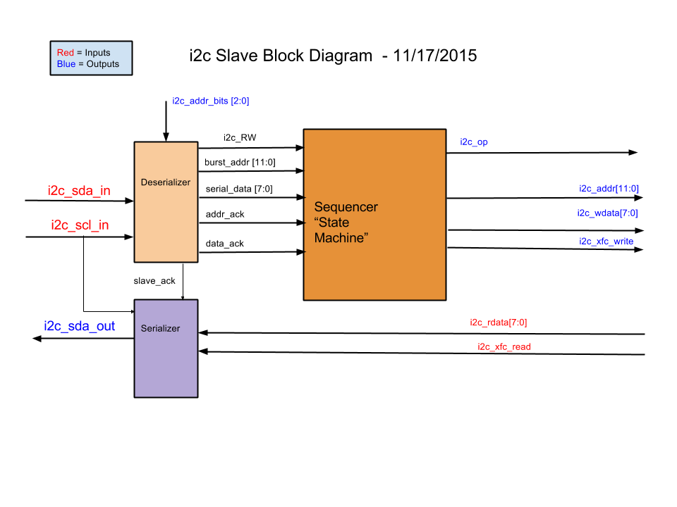

**Fig. 6.7:** I2CDeserializer Block Diagram

*6.5.2 Sequencer*

The sequencer block acts as slave of sorts to the deserializer block. Its sole purpose is to transfer data, address and operation code information to the register block. Depending on the acknowledge signals coming in it acts accordingly.

The sequencer acts similarly to the deserializer in that it conditions the acknowledge signals into single cycle pulses so that a signal is not captured more than once with the system clock always blocks. From this it will capture the address and data when these strobes occur.

This data is handled in two separate ways: the first during a read and the second during a write.

Upon a read opcode the sequencer simply captures the burst_addr into the i2c_addr output line and then strobes the i2c_xfc output line, and then after that resets itself. This is done using 3 if statements under the main always statement. A state variable for this sequence is used called xfc_ready which goes high when the data is captured so that at the next clock cycle the strobe occurs. Using the opcode as part of the if statement makes sure that this only occurs when a read is requested. The last step is to reset each signal again using an if statement and the i2c_xfc to control it. The opcode acts as a control object for how the I2C block interacts with the register block determining a read or write transaction.

During a write operation a very similar sequence occurs, but the strobe does not occur until a data-ack signal strobe has been seen. Using a similar if statement setup and the same state variable. This same variable is used because the if statements can be differentiated by the operational code. This sequence takes 4 if statement to complete and the first is the same as the read sequence where the address is captured as well as the opcode. Next the sequence waits until a data_ack signal is received to capture the data and then to enable xfc_ready. During this time another variable comes into play. The address is rewritten to have an increment variable added to the address. For the first instance of this if statement a 0 is added, but later the increment itself increments by 1 so during a burst write cycle the address is incremented each time this if statement goes active. The next if statement strobes the i2c_xfc for the opcode, address and data to be sent to the register block. This sequence will continue to loop and not reset itself until a stop condition is seen as a reset or a stop signal from the deserializer.



**Fig. 6.8:** I2CSequencer Block Diagram

*6.5.3 Serializer*

The serializer, like the sequencer, acts as a slave of sorts to the register block and to the deserializer. Its sole purpose is to either send acknowledge bits during the 9 bit of the byte transaction over the SDA line or to serialize the data that it receives from register block. It has no output except that of the SDA line.

Similarly, the serializer conditions that data on the SDA_in and SCL lines so that it is aware of when it can make transitions to the SDA out line which is during SCL low states.

Start and stop conditions are handled by using the slave_ack and i2c_xfc_read signals. If either one of these are asserted, then the system goes into a start condition.

To serialize the data there is an if statement under an always block that uses a new variable of serialize_done and the i2c_neg_edge_pulse signals. Inside of this if statement there is a case statement that will then write to the i2c_SDA_out line to serialize the data using the captured i2c_rdata from the register block during the i2c_xfc_read strobe sent by the register block. This case statement also uses a counter to sequentially increment the case statement MUX and at the last of the 8 bits it then writes to the serialize_done register. This register will then deactivate the if statement so no more data is written and causes a stop condition inside the sub block.

If the acknowledge signal is to be serialized, then another if statement under the same always block is enabled using the slave_ack signal and the i2c_neg_edge_pulse. Only 2 statements exist under this if statement and one is to set i2c_SDA_out high and then activate the serialize_done register. This will cause a stop condition and the whole sub block goes back to waiting for a signal from the deserializer of the register block.

There is essentially a mini state machine inside of the serializer that dictates how the data is serialized taking into account what is being serialized, an ack or data, and if that has occurred or not.



**Fig. 6.9:** I2CSerializer Block Diagram

*6.7 Test Fixture Implementation*

Testing for this block using Verilog test benches were employed by creating an I2C master in Verilog inside the test bench. A clock was defined that at 400 kHz to simulate an I2C SDA line and then the line was driven by the Verilog master in the test bench. Data for testing such as the slave address, register address and register data were defined in the test bench and could be manipulated to create different test stimulus. The test bench rubric that was now created is used for several tests to verify the I2C block is functioning the way it should namely with regard to full read and write transactions.

Earlier versions of test benches were also used for some simpler tests including start and stop condition, reset, deserialization of data and response to slave address. These test benches utilized hard coded, bit banged if you will, SDA and SCL transitions to mimic stimulus on the I2C bus similar to the full transaction test benches but simpler in usability as specific odd transitions could be made easily such as random stop conditions or clock delays.

*6.7.1 Start, Stop, Deserialize Address*

These tests utilized the simpler test bench rubric and multiple different stimulus patterns were created. Start conditions were created and every time the I2C block responded correctly and transitioned into state 1 where it was ready to deserialize a slave address.

Stop conditions regardless of their timing in the transaction always resulted in the deserializer sub block going back to state 0, erasing its data contents and sending out the stop to the other sub blocks to stop them if they were currently performing a task and resetting their temporary values back to state 0/reset conditions. Several of these were performed at normal places during the transaction and also randomly during a data transfer and the results were consistent.

When the correct start conditions were seen and data stimulus was driven on the SDA line by the test bench the I2C deserializer performed as expected and deserialized the address correctly each time. Once that was completed with 1 clock cycle the address was checked against the defined address pins and acted upon it. It was either driven into state 2 to start deserializing the address bytes while simultaneously sending out an ACK signal to the serializer sub block. The serializer sub block performed as expected, albeit with some tuning along the way, to send out correct stimulus to the open drain circuit that would eventually be crated in the chip.v module. Multiple addresses were made and on all tests the I2C module responded correctly to a right or wrong address at multiple different addresses.

*6.7.2 Write Registers*

In order to do a full write transaction, and then a full register transfer of all 512 filter coefficients a more automated solution was needed. For this the I2C master that was written for the test benches was utilized. A full set of 1024 byte size coefficients was created for this test module. Each coefficient was numbered in ascending order to go with the register it was supposed to go with, this made checking a simple task in Isim where several samples were analyzed throughout the registers and all were in place. A smaller version of this was used to set the chip status register to set the floating point offset and the BIST generator/I2S select. In conjunction with Kevin and Dhruvit this test also tested the I2S and BIST to confirm that they were working properly when selected.

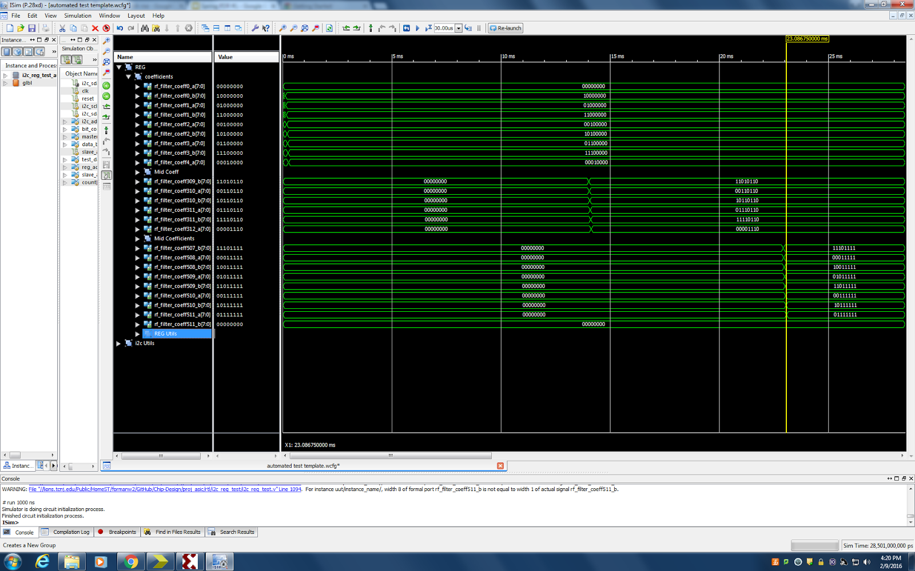

**Fig. 6.10:** I2CIsim Full Register Write Transaction (Truncated)

*6.7.3 Read Registers*

The read register test utilized the same I2C master test bench with relevant data to read specific registers. This I2C module is made to only read a single byte at a time and then call another register to read. This test was performed on a few random registers that was loaded previously by the same I2C master in the test bench. It was modified to do both transactions and what was read back was exactly what was written.

**Fig. 6.11:** I2CRead Register Transaction

*6.8 PSOC Controller*

In order to control the FPGA once it has been programmed there was a need to control the filter by writing and reading back filter coefficients via the I2C interface. The readily available PSOC 5LP was utilized due to its ease of use and predefined I2C functionality. Several control algorithms were created to send sets of filter coefficients defining a low pass, high pass and band pass filters.

*6.8.1 Structure/Interface*

A push button interface was written in PSOC Creator so that there would be three buttons and each would start an algorithm to transfer all 512 filter coefficients depending on the filter envelope selected and then exit and wait for more input.

*6.8.2 Test Data*

Separate header files were added to the project to define each filter type individually. These files were created by modify a C code script that helped create the coefficient registers themselves for the RTL design of this project and use it to create the list of 1024 byte size coefficient parts from Matlab where the filters were designed.

While this worked for testing purposes for this project, as a user application it would be desirable to be able to create any type of filter on the chip running the I2C master so that a few rotary encoders or potentiometers could change the filter parameters, (center frequency, Q and attenuation). This is above and beyond the scope of this project so this is just a thought on usability of the chip.

**Chapter 7: Simulation/Verification – K. Cao and D. Naik**

To verify the RTL design of the audio filtration ASIC, multiple simulations were run in Xilinx. Each simulation tested for a different filter configuration. A test bench for the top module of the chip was created. Each simulation was given the same input, a square wave. 10,000 words were inputted into I2S for each simulation. The input data values described a square wave with an amplitude of 3,276 and -3,276. This value is a tenth of the value of the max digital audio value for CD quality audio. This value was chosen to ensure that no overflow occurs within the filter block. If overflow occurred, the output audio would not be considered to be valid for testing. To ensure that the serial data inputted to the I2S block was being outputted instead of the BIST data, the enable signals for the I2S deserializer was set high and the enable signal for the multiplexer was set low.

The first type of verification that was performed was a simple pass through of data. The filter allows only the current input to output. The output of the chip was compared with the input data to ensure that the data matched exactly. This verified if data was moving through the chip correctly. Later tests would verify if the ASIC was capable of applying the correct filter. To have the input to simply pass through the filter, the very first filter coefficient was set to 1, and the rest of the 511 coefficients were set to 0. These coefficient values were changed within the register block when reset is asserted high. Then to simply apply the coefficients the reset signal is asserted.

The verification process for the lowpass, highpass, and average filters were similar to the pass through verification. The only difference in these verifications are the coefficients values. MATLAB was used to calculate the different coefficient values for each filter. Using the Filter Design and Analysis tool, or FDAtool, in MATLAB was used to calculate the different coefficient values for the lowpass and highpass filter. Matlab produced coefficient values that were in decimal format. Using the Java Program, the coefficients were converted into pairs of 2’s complementary binary numbers for each coefficient value. The register block was then edited each time when applying a new filter.

To verify the data for the lowpass, highpass, and average filters a model was created with Java. The Java model calculated the filtered values of the input data and stored the values within a text file. Within this file each line contained a word that was filtered by the chip. The various simulations within Xilinx also outputted a text file of the filtered input serial data in the same format as the Java model text file. Both text files were compared with each other to verify if the chip was working as intended.

Our initial tests for the low pass and high pass failed. The output for the Verilog simulations had similar shapes, but looked time shifted compared to the model. We hypothesized that there was a startup associated with the Verilog and the filter was not receiving the first couple I2S inputs due to it. After further digging, this was found to be true. After adjusting the input signal for the model to match the signal entering the filter module, the tests passed.

The filter takes time to reach steady state, dependent on the magnitude of the number of taps of the filter. For our FIR filter, the first 512-1024 inputs are deemed invalid. This is due to the filter not having enough past inputs to convolute correctly.

Our results are below. Each verification we graphed two periods. The first figure contains the first 1000 samples and the second figure contains samples 2000 to 3000. This is when the filter reaches steady state.

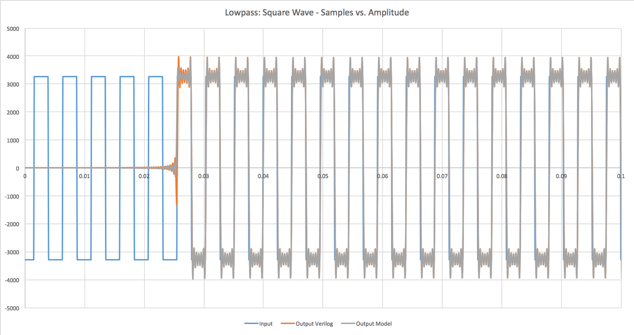

**Fig. 7.1:** Lowpass Filter: Square Wave Samples 0 - 1000

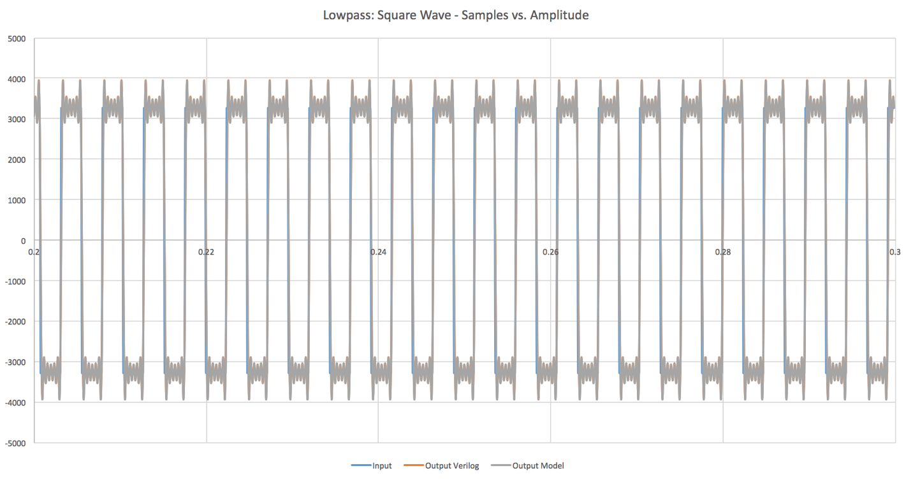

**Fig. 7.2:** Lowpass Filter: Square Wave Samples 2000 - 3000

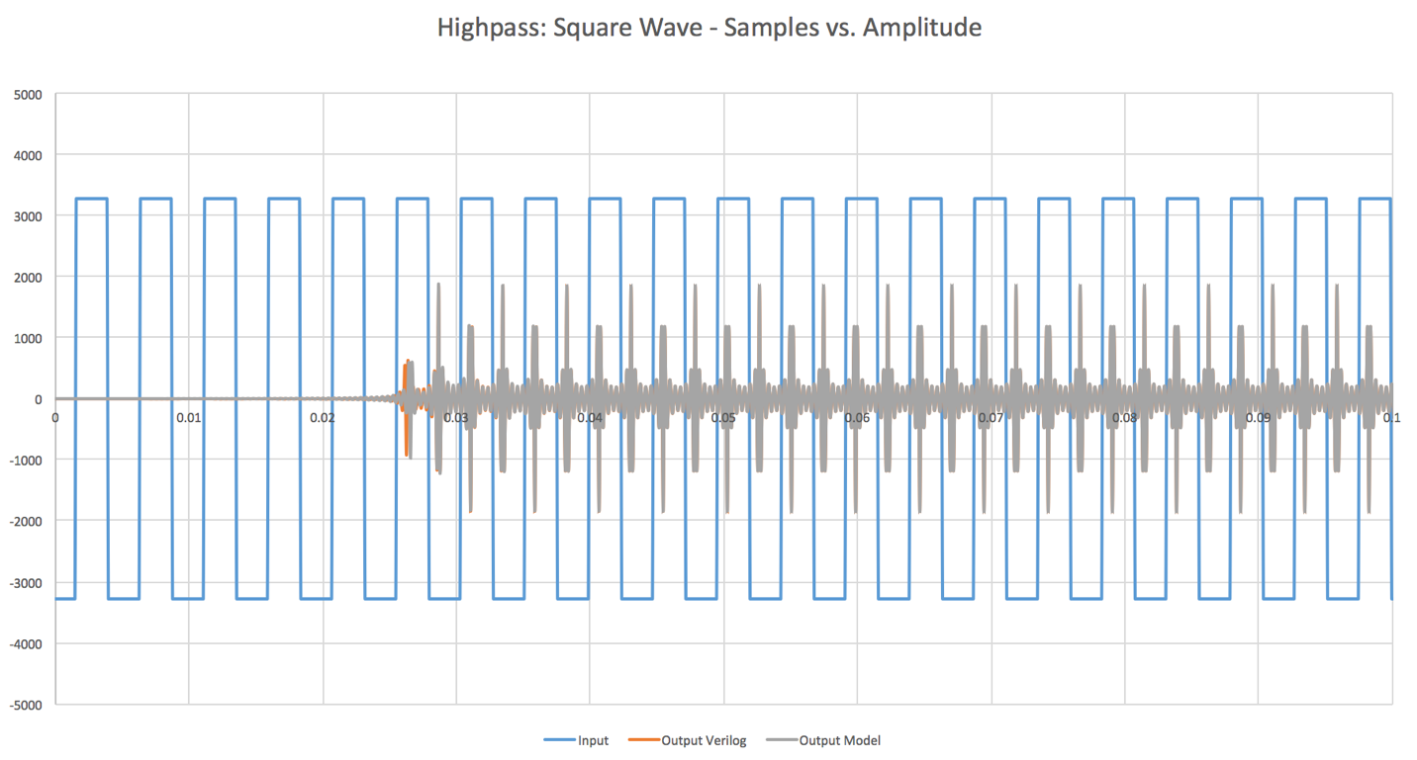

**Fig. 7.3:** Highpass Filter: Square Wave Samples 0 - 1000

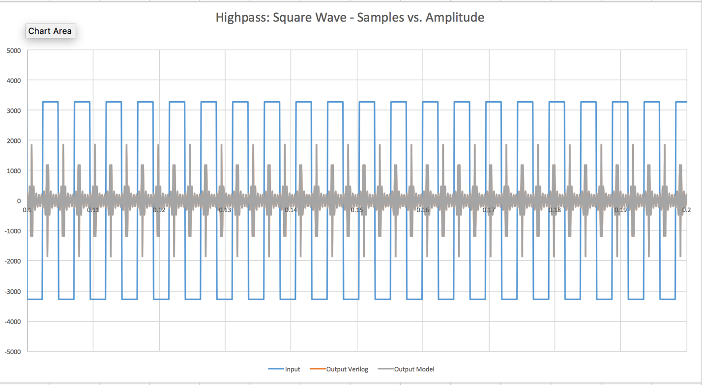

**Fig. 7.4:** Highpass Filter: Square Wave Samples 2000 - 3000

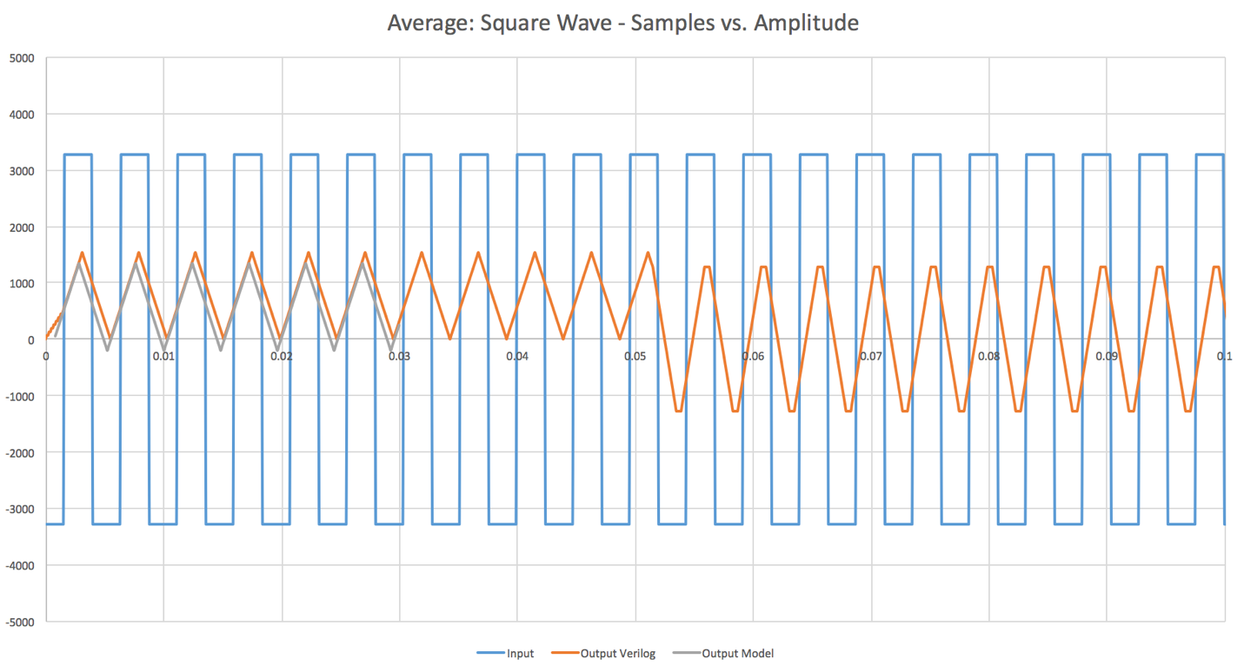

**Fig. 7.5:** Average Filter: Square Wave Samples 0 - 1000

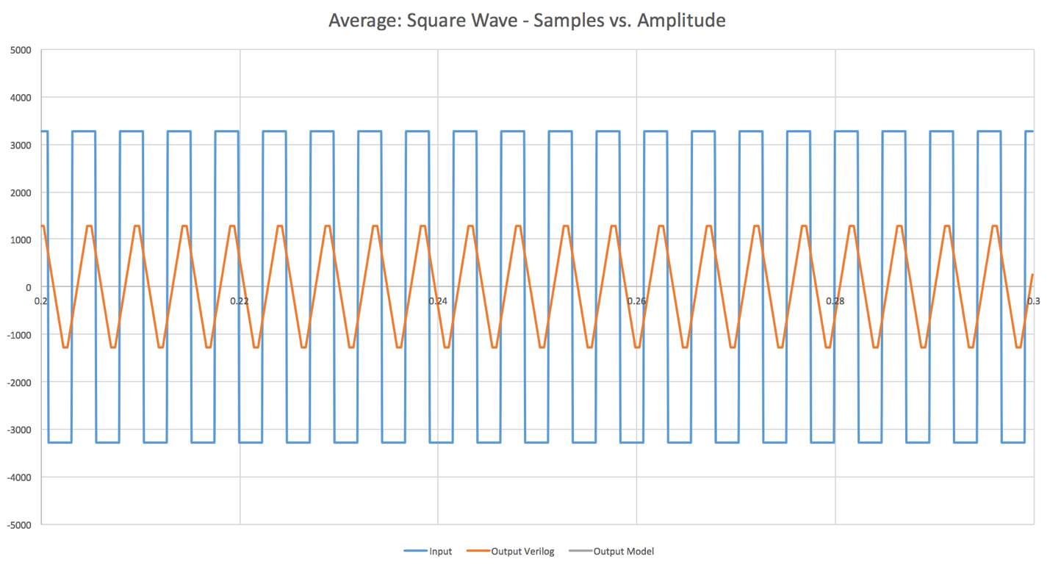

**Fig. 7.6:** Average Filter: Square Wave Samples 2000 – 3000

**Chapter 8: FPGA Implementation – Z. Nelson and W. Forman**

*8.1 Programming the FPGA*

The FPGA implementation was primarily a way to show that our design worked in realistic setting. The first step of the FPGA portion of the project was purchasing a Nexys 4 Artix-7 FPGA. After we received the FPGA, we needed to assign pins to the inputs and outputs of our design. Table 8.1 shows how we mapped the signals to the FPGA pins. The pin assignments were done using the PlanAhead software that is included in the Xilinx ISE Design Suite.

**Table 8.1:** Verilog Signal to FPGA Mapping

|  |  |  |  |
| --- | --- | --- | --- |
| Signal Name | Direction | FPGA Pin | PlanAhead Site |
| clk | in | internal (crystal) | E3 |
| rst_n | in | reset button | C12 |
| i2si_sck | in | JB3 | V11 |
| i2si_ws | in | JB4 | V15 |
| i2si_sd | in | JB7 | K16 |
| i2so_sck | out | JB8 | R16 |
| i2so_ws | out | JB9 | T9 |
| i2so_sd | out | JB10 | U11 |
| i2c_addr_bits | in | JA9:JA7 | DC18, C17, G13 |
| i2c_scl | in | JA1 | B13 |
| i2c_sda_in | in | JA2 | F14 |
| i2c_sda_out | out | JA3 | D17 |

Since we now had synthesized Verilog code and pin assignments, we could generate a programming file and download it to the FPGA. A FGPA programming guide was created and the steps are listed below.

**Step #1:** Click the Synthesize button in Xilinx ISE. (This will take several minutes)

**Step #2:** Click the Implement Design button in Xilinx ISE. (This will take several minutes)

**Step #3:** Click the Generate Programming File button in Xilinx ISE. (This will take several minutes)

**Step #4:** Plug in FPGA via USB.

**Step #5:** Under “Configure Target Device”, click the Manage Configuration Project (IMPACT) button. The ISE iMPACT tool window will now open.

**Step #6:** Run the wizard by clicking Edit\Launch Wizard. The “Welcome to iMPACT” window will open.

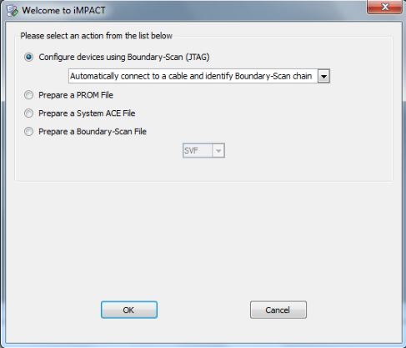

Click OK.

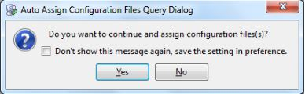

Click Yes.

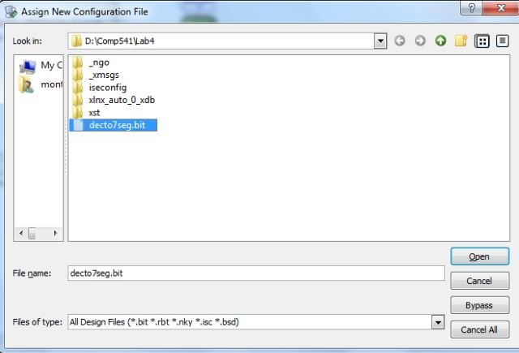

Select the .bit file that you generated in Step 3.

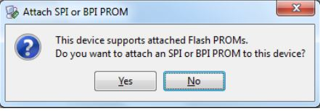

Select No.

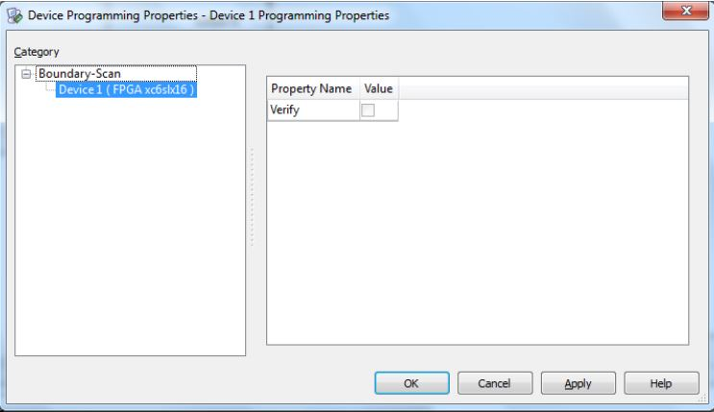

Click OK.

**Step #7:** If there are no errors, you will see an “Identify Succeeded” message. Right-click on the green Xilinx box and click program.

**Step #8:** Look at the port mappings in rtl_description.xlsx and configure test setup.

*8.2 I2S FPGA Testing*

Since our FPGA was now successfully programed, we needed to create I2S and I2C PSoC programs that could test the FPGA. Fig. 8.1 below shows the FGPA wired up to two PSoC microcontrollers (the I2S one is showed in the picture). The I2S program was created by Ian Patel and the I2C program was created by Whitley Forman. The I2S program was originally intended to generate and capture back I2S data to verify that the filtering component of the design was working. However, there was some kind of bug in the I2S capture that we could not fix. For some reason, we could not get accurate data captured back to the PC. The I2S program was successfully able to generate different types of input waveforms including sinusoidal, square, and triangular waves.

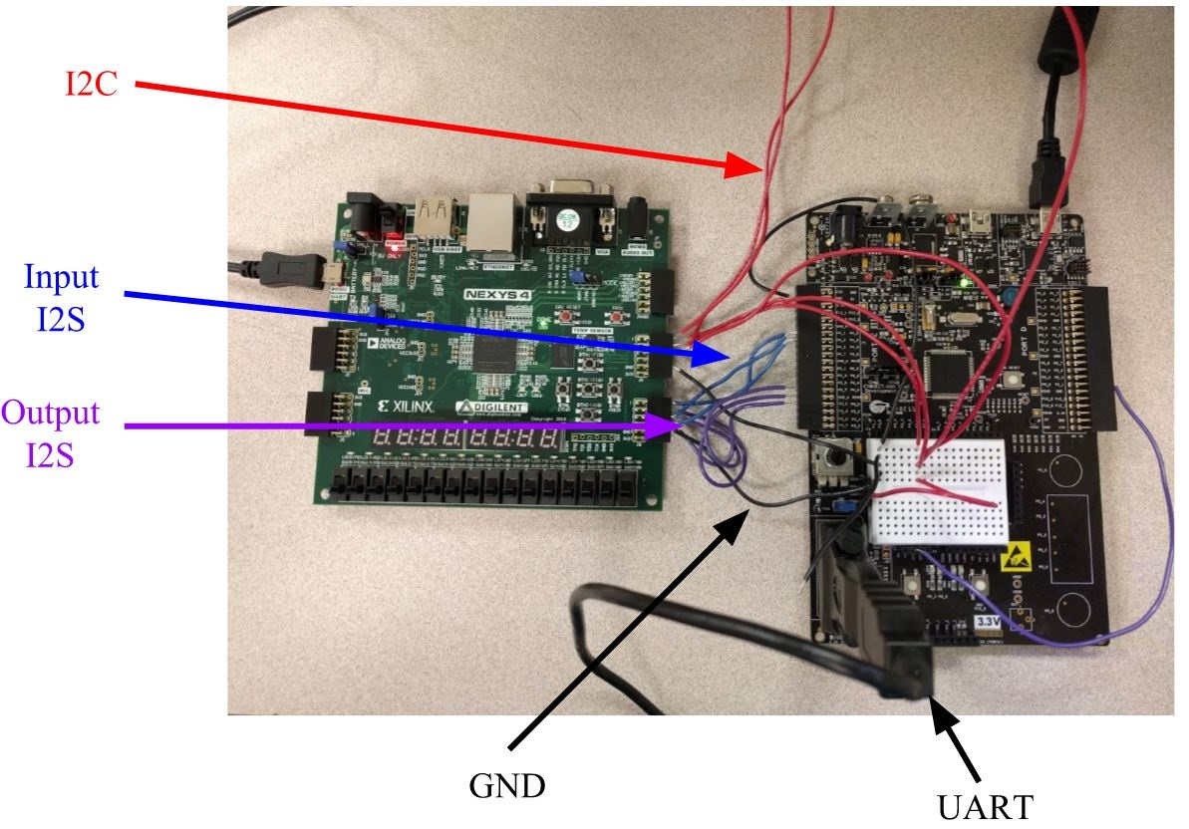

**Fig. 8.1**:FPGA Testing Set Up

Without the I2S capture working we were still able to do some testing of the FPGA. We first set the default filter coefficients to create a pass-through filter (the output signal is the same as the input signal). We then applied a square wave to the input since it can easily be observed on an oscilloscope. Fig. 8.2 show the serial clock and word select that was taken from the chip. Note that the input and output serial clock and word select matched in frequency. Fig. 8.2 also shows the square wave input and the corresponding output. It can be seen that output exactly matched the input besides being slightly delayed. This simple test gave us some physical proof that our design’s data flow worked not only in simulation but on hardware.

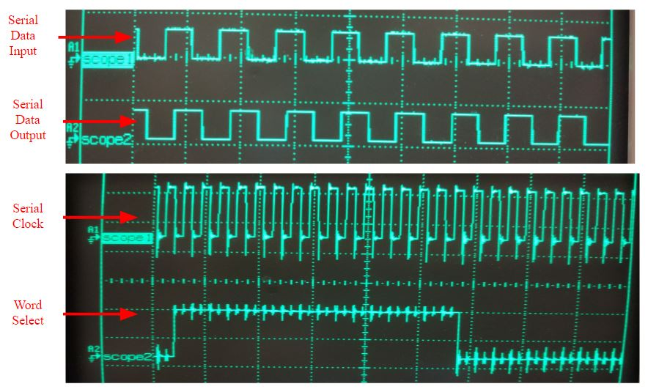

**Fig. 8.2**:FPGA Waveforms (Pass-Through Filter)

*8.3 I2C FPGA Testing*

Testing the PSOC controller with FPGA presented a few problems that had to be worked through. Grounding, external pin assignment, and the open drain circuit were all factors that caused delays for the I2C testing for implementation. These problems were worked through systematically and methodically and now the PSOC and FPGA are working in conjunction with each other with the FPGA responding to the stimulus from the PSOC.

Grounding was a key factor to get stable waveforms and after initial tests were done, analyses of the waveforms suggested that a grounding issue may be present. Also noticed is that the I2C slave was not responding to the master. It was later found that the I2C slave address pins that were routed to external pins were not being driven low or high and therefore were floating. The PSOC was addressing for a low so the pins were grounded through 1k ohm resistors and the slave immediately began responding.

At the same time there was also a need to revisit how the open drain was defined. The conditional statement in the chip.v file where all external pins are defined it was seen that there was previous miscommunication as far as how the open drain would be operated. The problem was expeditiously fixed inside the I2C serializer sub block and the conditional statement modified. This relatively simple change corrected the issue of multiple drive of the SDA line and now works as expected.

*6.8.4 Future Work for Usability*

As of right now testing, troubleshooting and modification still continues on the read sequence as the transaction is getting cut short for some reason. Work will continue on this module until the issue is resolved and full working I2C module is ready for next year’s team. Contact information has been given to both of next year’s teams to assist in the development of the RISC-V and the Digital Filter Chip designed in this project.

**Chapter 9: EDA Tools and Physical Design – D. Naik, J. Swift, and K. Cao**

*9.1 Setting up Mentor Graphics*

Once Pyxis has been installed on a Linux machine, users need to set up environmental variables to use the products. If the user is using a bash shell, a script can be placed in the .bashrc folder. This script will run every time the user logs in, which allows the user to avoid setting the variables on every log in. The instructions are the following.

1. cd /home/username/
2. vi .bashrc
3. insert following script

# .bashrc

# Source global definitions

if [ -f /etc/bashrc ]; then

        . /etc/bashrc

fi

# User specific aliases and functions

export MGC_HOME=/home/eda/pyxis/pyxis_v10.5_3/

export MGLS_LICENSE_FILE=1717@lmservices2

1. logout and re-login

Once the environmental variables are set up, the user can invoke the Pyxis tool from the command line. Use *$MGC_HOME/bin/dmgr_ic* to launch the Pyxis project manager.

The user will see the following screen:

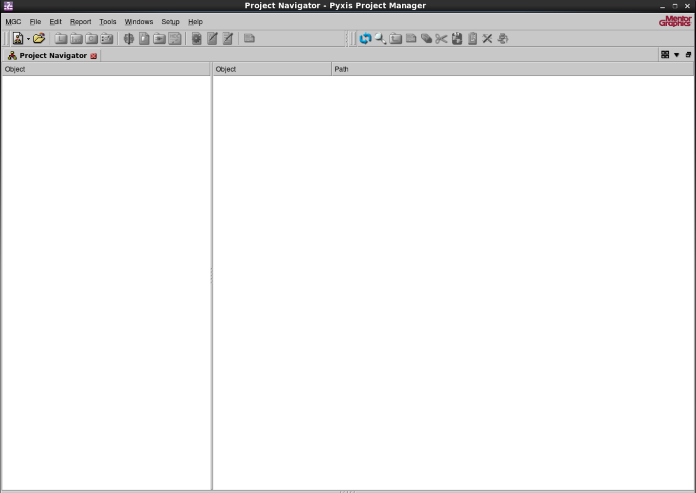

**Fig. 9.1:** Project Manager Window

Within this screen, click on “Create New Project” at the top right.

A project wizard will pop up. Select the project path. For this example, we are using the *generic13* libraries provided from Mentor Graphics. Find the path for the libraries. Click ok.

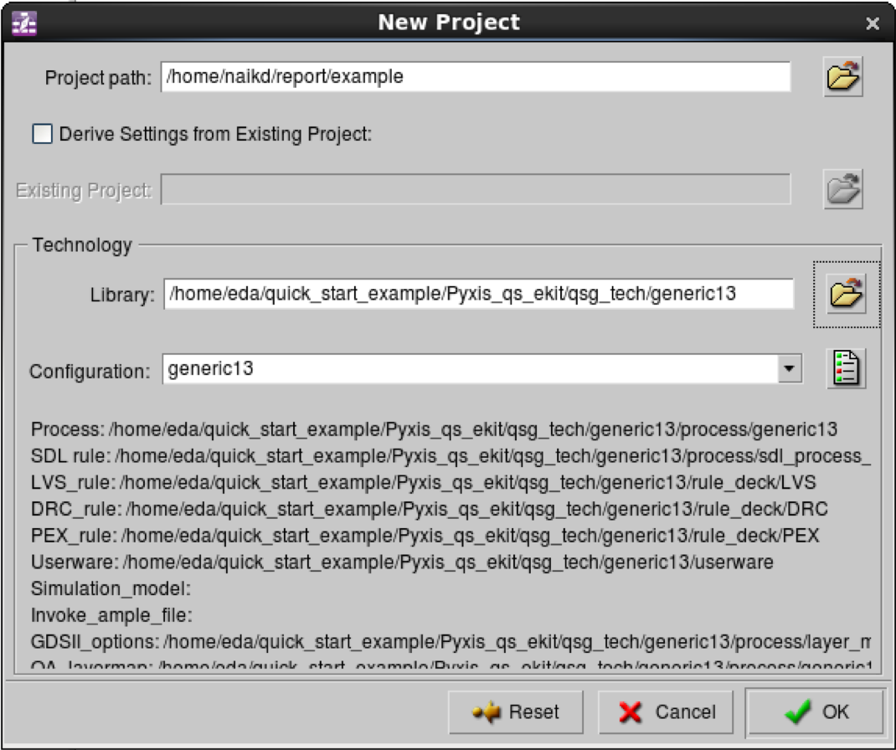

**Fig. 9.2:** New Project Wizard – Screen 1

In the next screen, click on “Add Standard Libraries” this will populate the screen. Click ok. The project is now set up. Within the manager, schematics and layouts can be created.

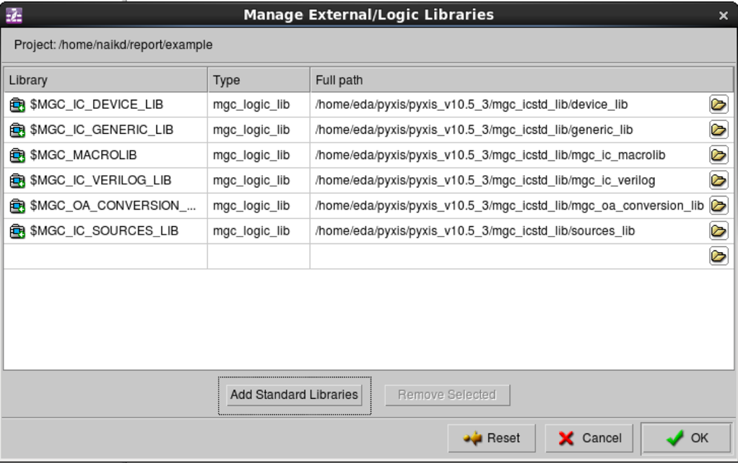

**Fig. 9.3:** New Project Wizard – Screen 2

*9.2 Physical Design*

Given the time constraint of the project and being only given the generic libraries, we decided to make a physical design of passive components to send out to manufacturing. The layout would consist of one resistor, fifty-six spiral inductors, and three capacitors. The fifty-six inductors were places in series to create a higher inductance and the three capacitors were places in parallel to create a high capacitance. Using polysilicon on the predefined layer POLY2, a resistor was created using the rectangle function. Figure 9.4 shows a 25ohm resistor that measures 38 by 40 μm in dimensions. Each rectangle is 2 μm wide with the spacing of all polysilicon wires to be at least 2 μm apart. The 3 by 3 μm contact was created from metal on the predefined layer M1 with a 2 by 2 μm carbon-oxide (CO layer) on top of the metal. These contacts serve as connectors to wire the like components together and also wire the components to the top layer of the chip where they will be assigned to pins.

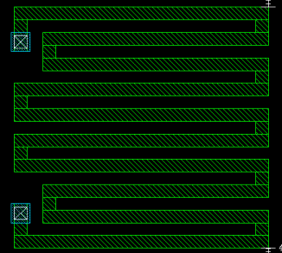

**Fig. 9.4:** 38 x 40 μm 25Ω Resistor

The inductor was the next component created from metal on the predefined layer M1. If time permitted, we would have produced a coiled conductor as well, but for now, the spiral inductor was chosen to be the type of inductor used on the chip. Taking into account the dimensions, the coil spacing, the number of turns, and the wire width, the inductor was calculated to be 1.068nH. The Stanford Microwave Integrated Circuits Laboratory (SMIrC Lab) produces an integrated spiral inductor calculator was available online in order to calculate the inductance based on the dimensions. This inductance is very small to measure when getting back the manufactured chip, therefore 56 inductors were placed in series in the layout in order to create a total inductance of 59.808nH, which may be a little easier to measure. Figure 9.5 shows a 56 by 58 μm spiral inductor. The same dimensioned contacts as before were placed at the beginning and end of the inductor using VIA1 as the layer that connects the M1 inductor to the M2 wire.

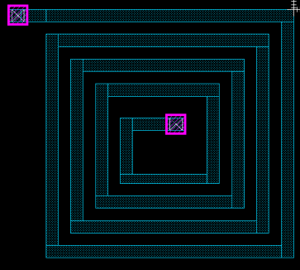

**Fig. 9.5:** 40 x 40 μm Spiral Inductor

The last component created was the capacitor. This component was created using polysilicon and metal. The polysilicon base measures 20 by 40 μm. A 2 by 23 μm metal wire was placed 2 μm down from the top of the polysilicon and 2 μm up from the bottom of the polysilicon. The wires extend 5 μm onto the polysilicon and the two 18 μm wires that extend out of the polysilicon are connected by a 2 by 36 μm wire. Once again, the same dimensioned contacts using the VIA1 layer and CO layer were placed onto the M1 wires of the capacitor in order to connect to the M2 wire that will connect all three capacitors in parallel. Figure 9.6 shows the capacitor with an unknown capacitance. The capacitance was not able to be found due to the lack of resources that could be gathered in the short amount of time that was given to create these passive components.

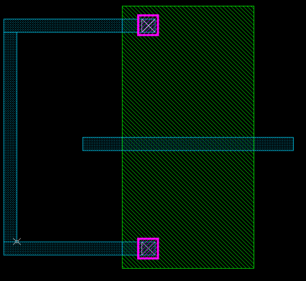

**Fig. 9.6:** 38 x 40 μm capacitor

**Chapter 10: Conclusion – Z. Nelson**

In conclusion, we were able to successfully deliver fully functional Verilog code that satisfies the goals of the project. We performed extensive testing via testbench simulations and additional testing on a FPGA using different input signals. We also went through the process of installing EDA tools and using them to create a simple circuit with a resistor, inductor, and capacitor on it. Documenting the chip design process and code we created will definitely save next year’s groups time. Overall, one of the most valuable skills we learned was being able to write high quality synthesizable Verilog code. Some of the team members plan on using this skill in industry after graduation. Overall, this senior project was a valuable experience for us because we learned about the many steps that need to be completed in order to produce a chip.

**References**

[1] Mosis.com, ‘About Us’, 2015.[Online]. Available: https://www.mosis.com/what-is-mosis. [Accessed: 11 November 2015].

[2] nxp.com, ‘*I2C-bus specification and user manual - UM10204*’, 2015. [Online]. Available: <http://www.nxp.com/documents/user_manual/UM10204.pdf>. [Accessed: 10 November 2015]

**Appendix A: Project Overview**

Biography 93

Engineering Standards and Realistic Constraints Form 95

Engineering Standards, Specifications, and Codes 96

Modern Engineering Tools 97

**Biography:**

*Kevin Cao:*

* Kevin is from Morris Plains, NJ and is a Computer Engineering major who is planning to enter the workforce after graduating at TCNJ. Kevin has interned as a software engineer at LGS Innovations, located in Florham Park, NJ.



*Whitley Forman:*

* Whitley is from Ocean Grove, NJ and is an Electrical Engineering major who is continuing his education in the electrical field and will be obtaining his Master Electrician’s license after graduation. He is planning on using his new knowledge and experience with his current business to expand into new ventures.



*Dhruvit Naik:*

* A resident of Mount Laurel, NJ, Dhruvit is a senior Computer Engineering major at TCNJ. He plans on entering the workforce after graduation and continuing his education in the coming years. He is the Vice-President of a startup, ThinkSOAS, INC.



*Zachary Nelson:*

* From Cream Ridge, NJ, Zachary is a Computer Engineering major who has enrolled in a Ph.D. program at Johns Hopkins University specializing in controls starting in Fall 2016. He has experience as a software engineering intern at Teletronics Technology Corporation and an undergraduate student researcher at TCNJ as part of the MUSE program.

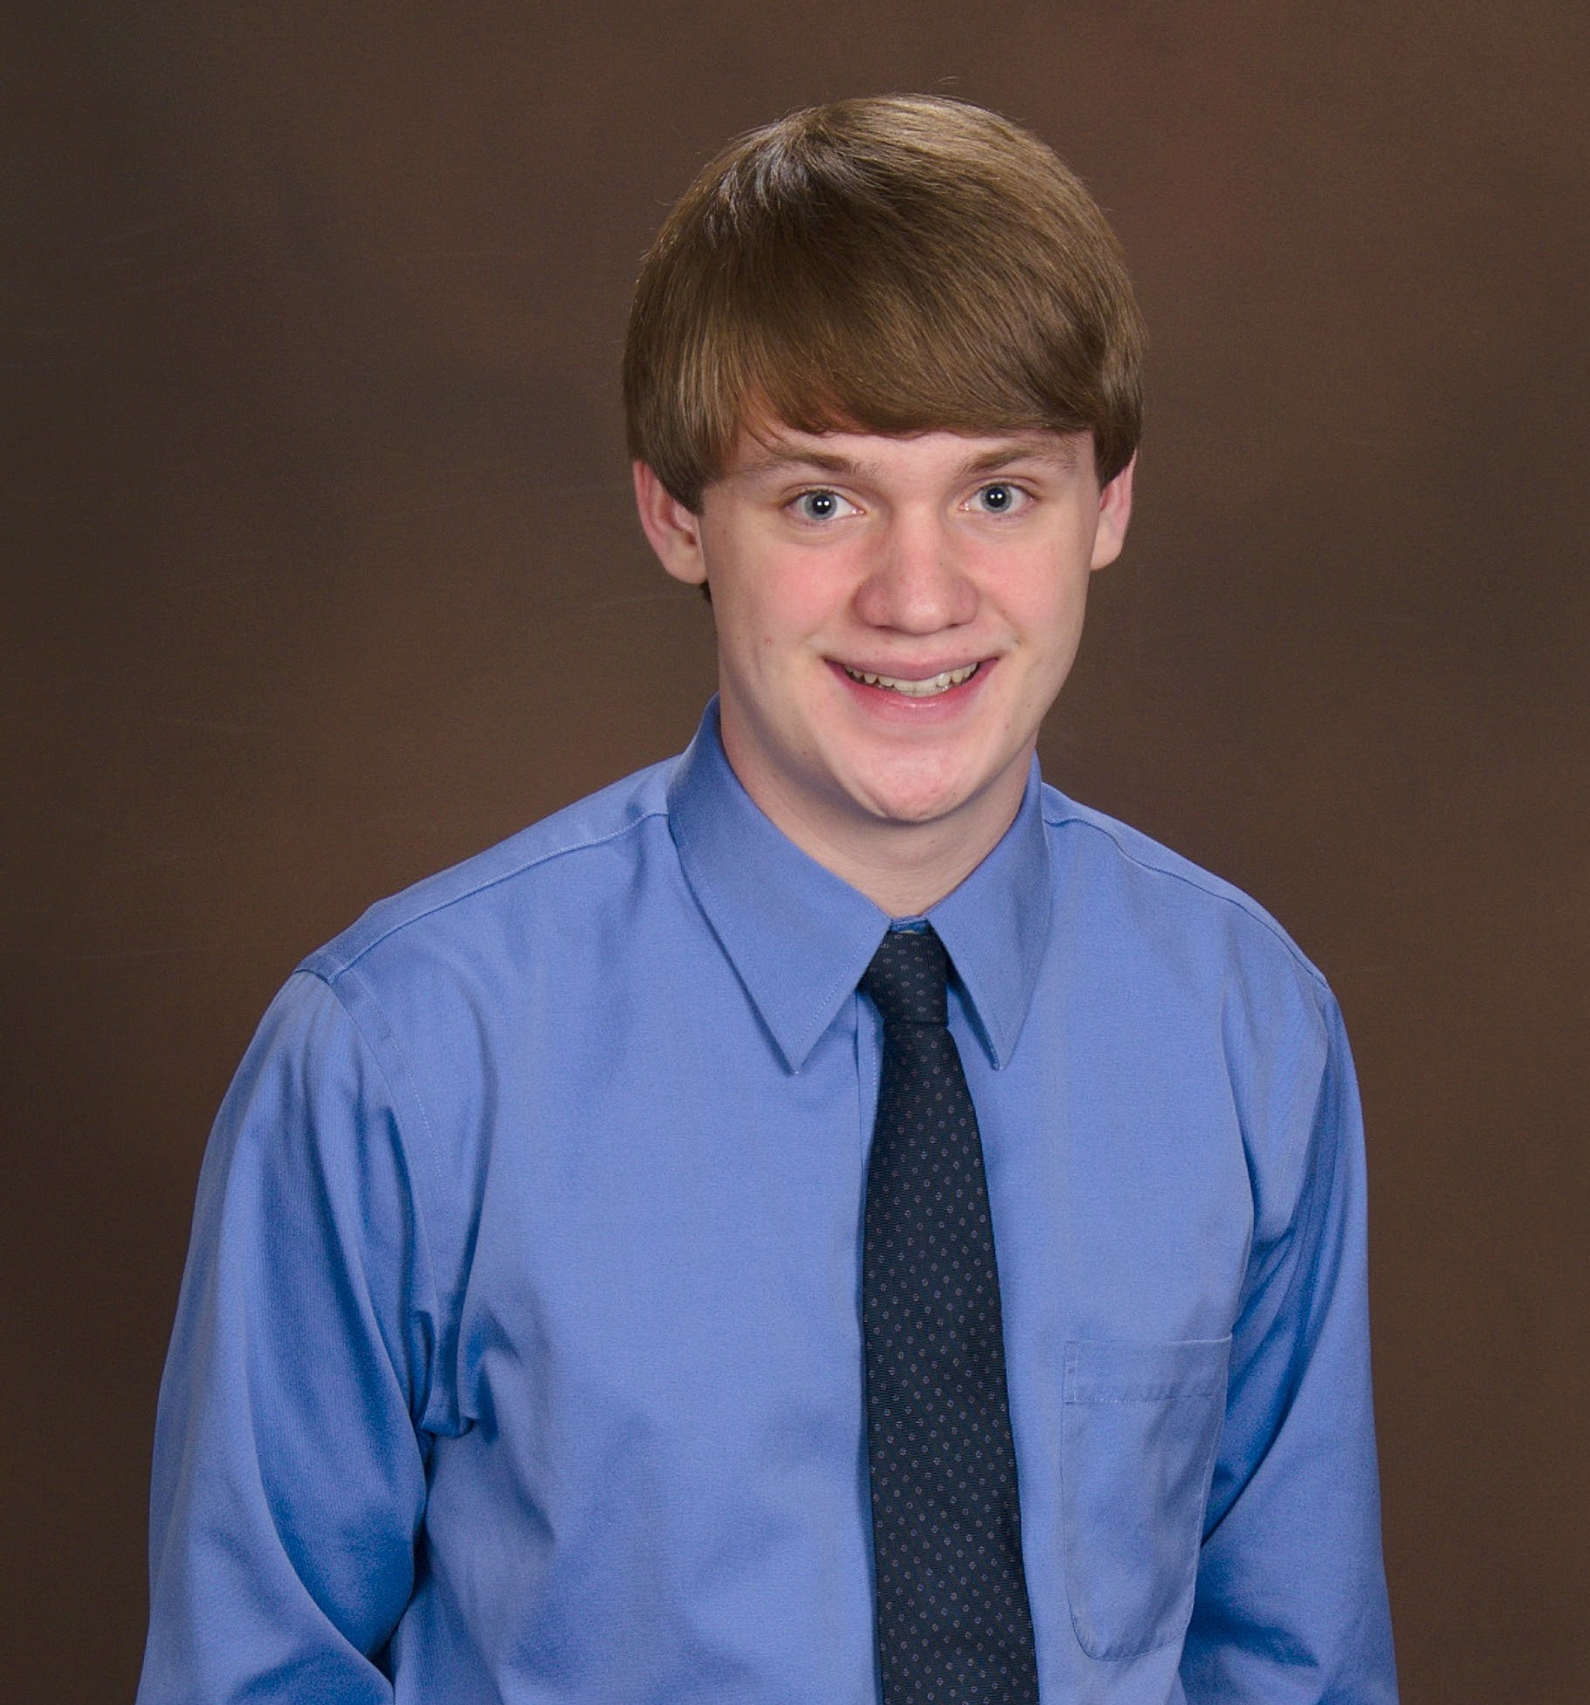

*Julie Swift:*

* From Robbinsville, NJ Juliann is a Computer Engineering major who is planning on entering the workforce after college. She has experience as a AutoCAD Designer interning at Linearization Technology and a Software Development Life Cycle Analyst interning at Educational Testing Services. She participated in the undergraduate student research program, MUSE, at TCNJ.



**Engineering Standards and Realistic Constraints Form:**

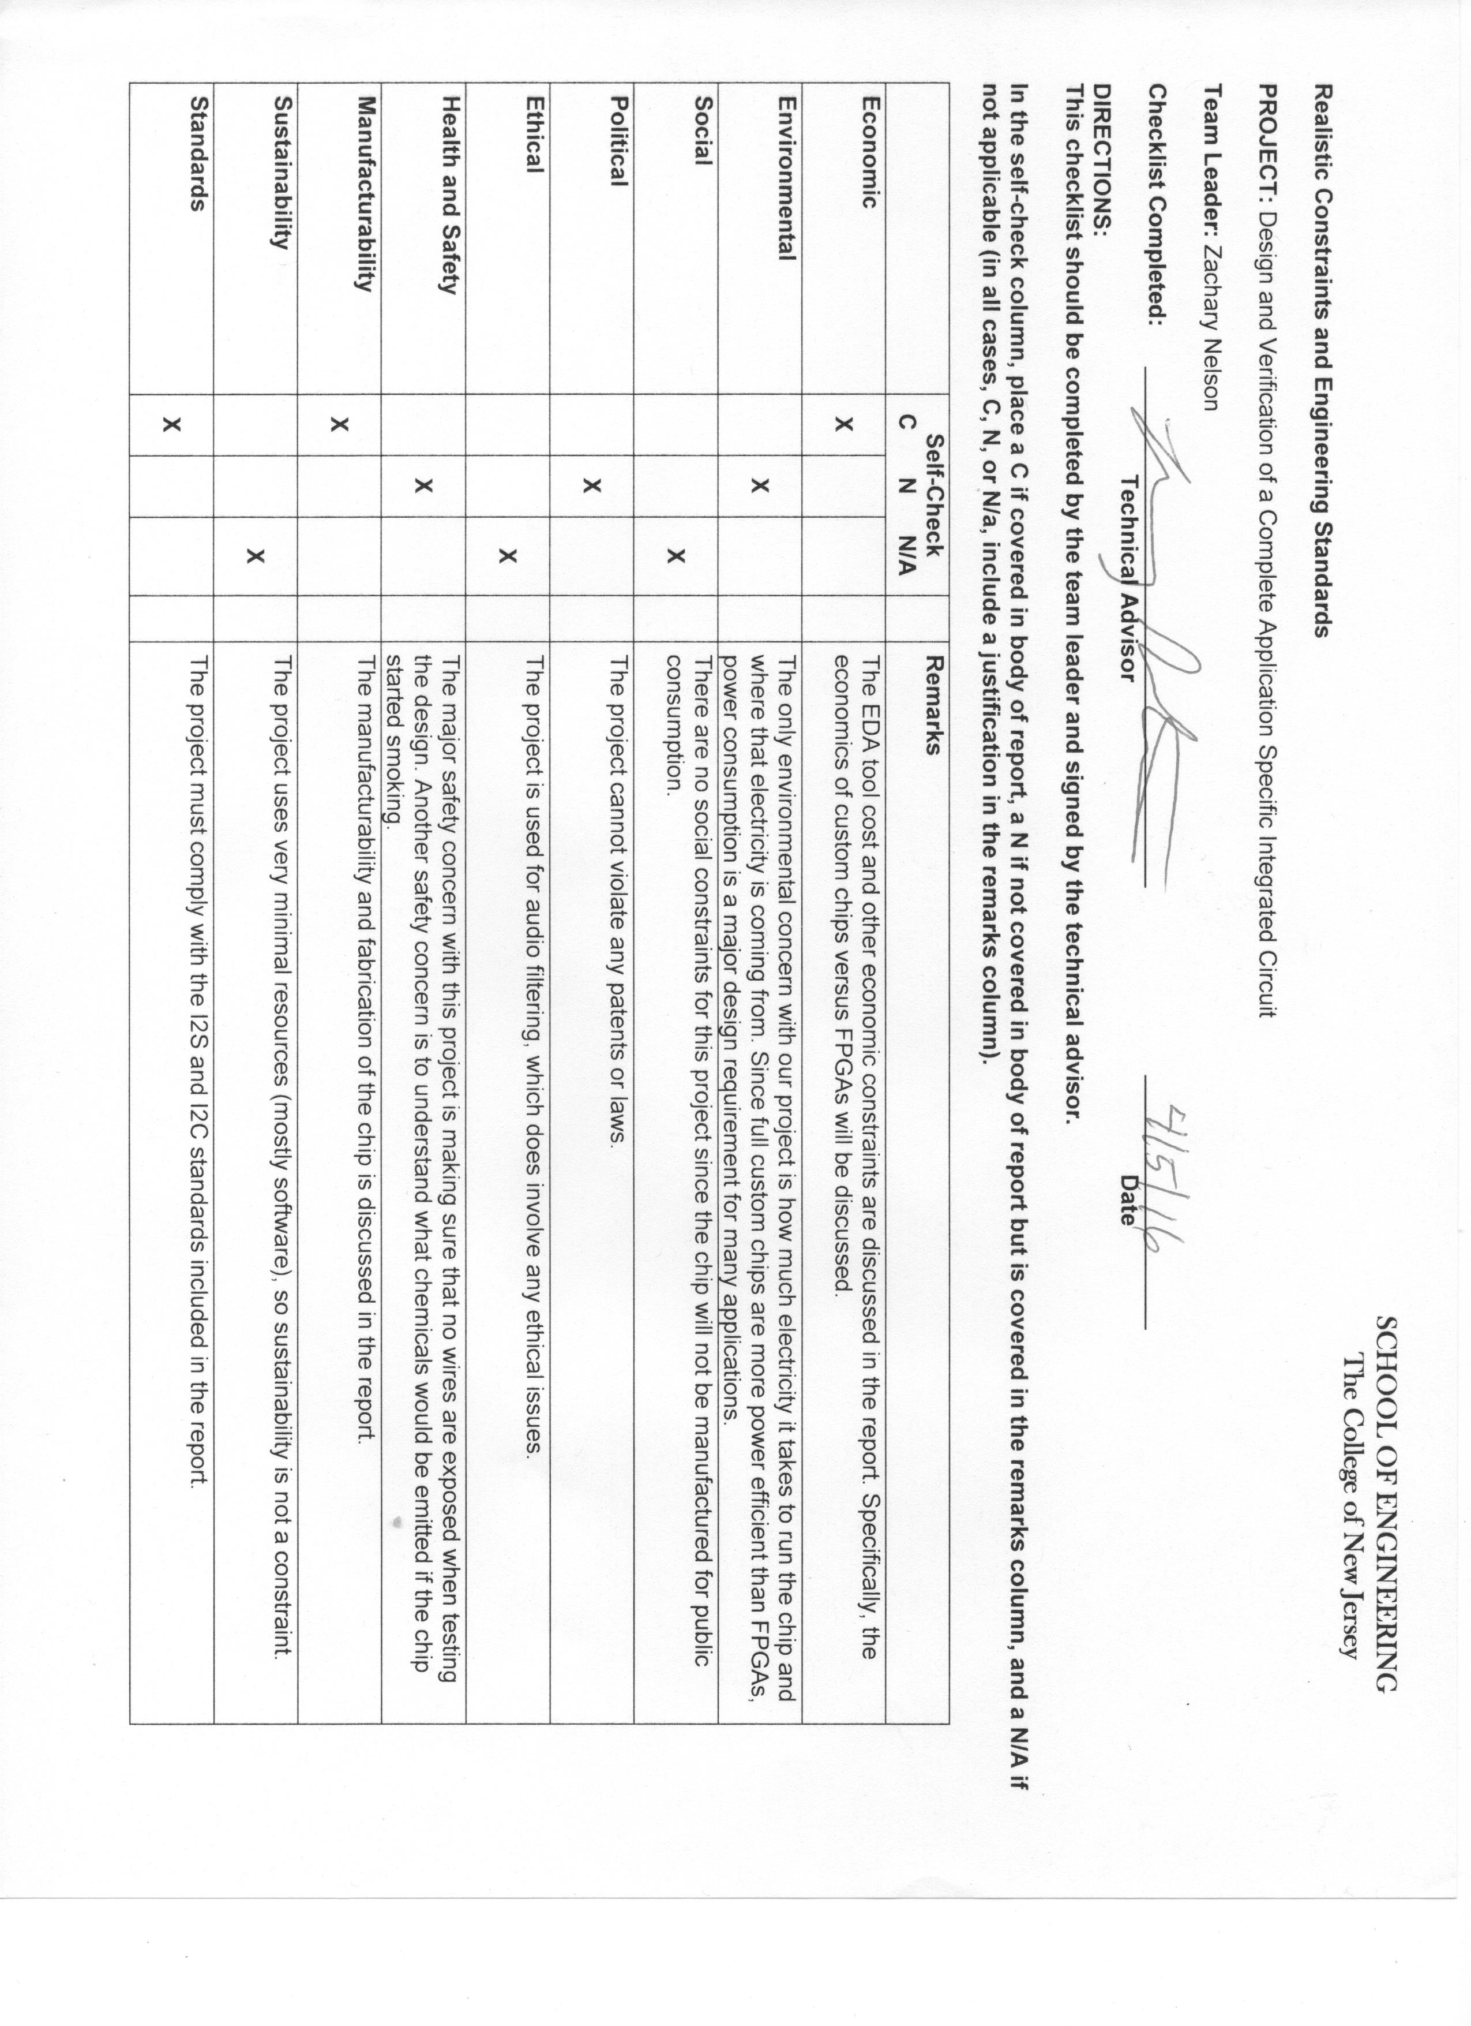

**Engineering Standards, Specifications, and Codes:**

* *DIP Package:* Dual in-line package (DIP) is a packaging standard that includes two rows of pins that extend from a rectangular plastic material. The spacing between the pins are meant to be compatible with breadboards. The details of this standard can be found in Appendix E. Joint Electron Device Engineering Council (JEDEC), “JEDEC Publication 95”, pp. 306-307.
* *GDSII Stream Format*: Graphic Database System (GDS) II is a binary file format that is commonly used in industry for transmitting the design of an integrated circuit. The details of this standard can be found in Appendix E. Calma Company, “GDS ${II}^{TM}$ Stream Format Manual”, Documentation No. B97E060, Release 6.0, February 1987.
* *I2C:* A serial communication standard that we used for uploading and reading registers to our FPGA. The details of this standard can be found in Appendix E. NXP Semiconductors, “ $I^{2}$ C-bus specification and user manual”, Rev. 6, April 2014.
* *I2S:* A serial communication standard for transferring digital audio. The I2S bus uses a bit clock line, word clock line, and data line. The details of this standard can be found in Appendix E. Phillips Semiconductors, “ $I^{2}S$ bus specification”, February 1986.
* *Verilog IEEE Standard 1364-2001:*A hardware description language (HDL) that can be used to design digital systems (such as an FPGA). This language is a high-level abstraction of a design that can be synthesized into low-level logic gates.

**Modern Engineering Tools:**

* *CORE 9*: System design software that we used to model the basic structure of the system. We also used it to keep track of the system requirements and use cases.
* *DropBox*: Cloud storage service that we used to store all confidential materials.
* *Git/GitHub*: Revision control software that allows a group to keep multiple versions of source code. We stored all documents and code in the public GitHub repository.
* *Red Hat® Enterprise Linux® Operating System*: Operating system that was required for all Mentor Graphics software (ModelSim and Pyxis).
* *Microsoft Project*: Project management tool that we used to keep track of the group’s schedule and progress.
* *ModelSim HDL Simulator*: Simulation and verification tool that we used to test our Verilog code.
* *Pyxis Custom IC Design Platform*: Multiple pieces of software that we used for the design of our simple chip.
* *Xilinx ISE Design Suite*: Design environment for Xilinx FPGA products. We used this tool for writing Verilog code, writing Verilog test benches, debugging Verilog code, synthesizing our design, and programming the FPGA.

**Appendix B: Management**

Schedule 99

Meeting Minutes 101

List of Contacts 123

Safety Considerations 124

Material List 125

Financial Budget 126

**Schedule:**

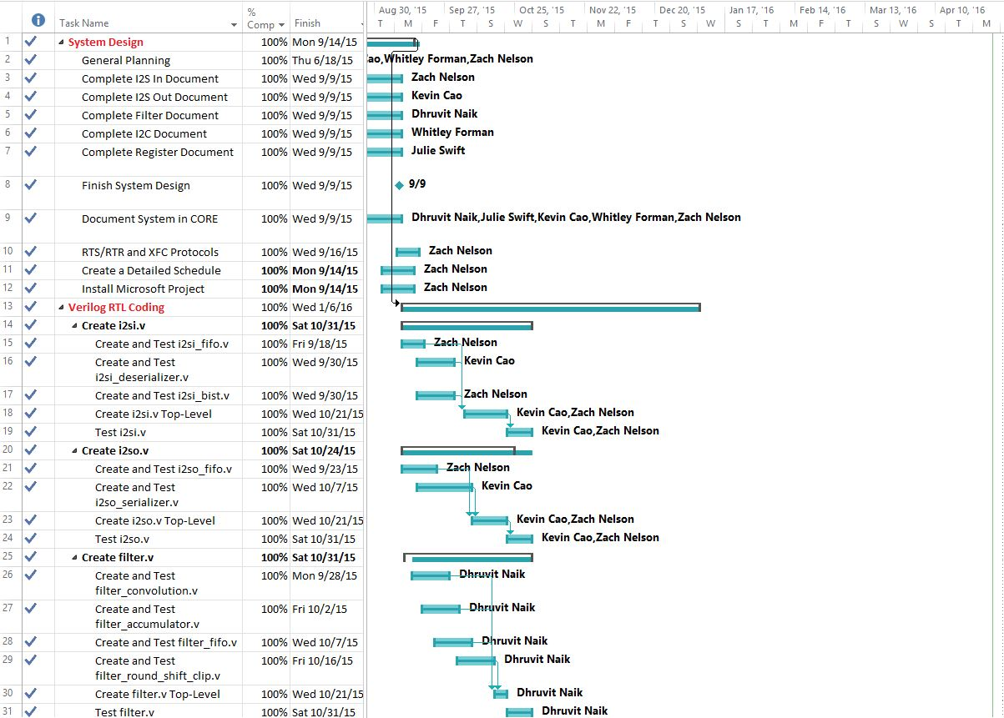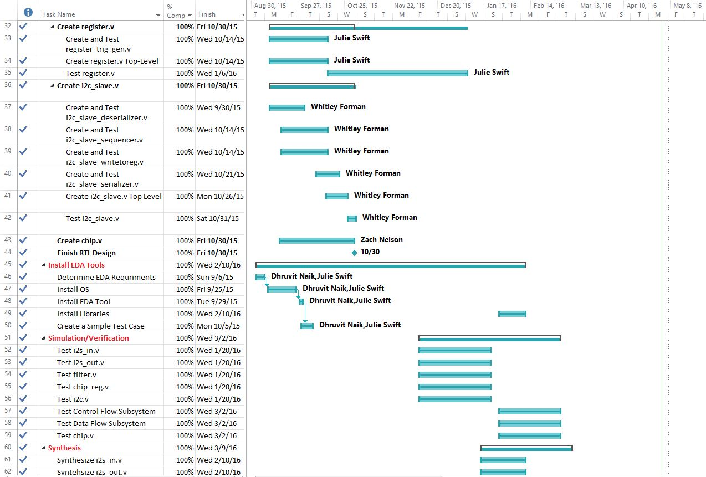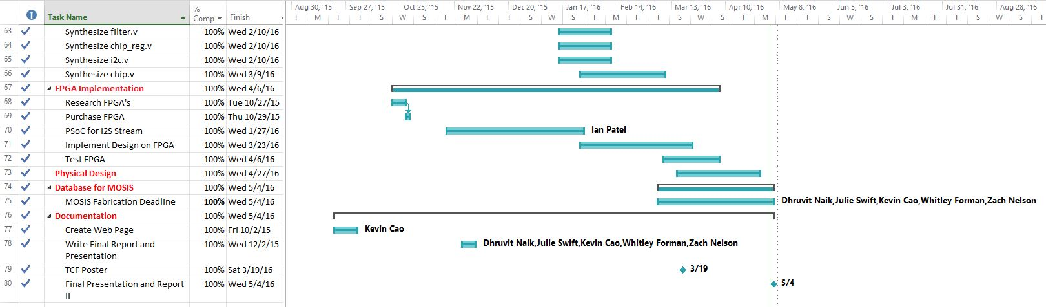

**Meeting Minutes:**

**Chip Requirements (June 11th Meeting)**

**Members in Attendance:** Dr. Pearlstein, Julie Swift and Zachary Nelson

* **Overall Goal**
  + **Produce an Audio Processing Integrated Circuit**
* I2S Interface
  + Audio Input: 2 channel stereo channel I2S (master interface)
  + Support audio input sample rates of 8kilosample/sec – 48kilosamples/sec
  + Output is the same sample rate as the input and I2S
  + Digital audio bit clock and the word select (ws) line will be controlled from master
  + Input and Output will be 2 channel 16 bits
* I2C Interface
  + Support single master configuration
  + 7-bit addressing and we will consume entire I2C address space
* Uses an external clock input
  + Clock frequency will be a minimum of 1200 times the audio sampling rate
  + Maximum clock rate will be 100 MHz
* Has an external reset pin
  + Power on reset
* Register Block
  + 512 bit frequency coefficients
  + 10k register bits
  + Register fields will include
    - Source select bit
      * Allows user to select between I2S and BIST (built in self test)
    - Filter Bypass Bit
      * 0 doesn’t bypass, 1 bypass
    - 512 16-bit signed coefficients stored as 2’s compliment
      * The effective radix point of the coefficients (4 bit number for data point, 4 bit number for coefficient)
    - Read only status register bits
      * Overflow/saturation detector – audio clipping
      * Input FIFO overrun
      * Output FIFO underrun
    - Control Bit Fields
      * 1 sticky bit to clear overrun
      * 1 sticky bit to clear underrun (stay until you clear them)
      * Clear Overflow Flag
      * Filter Order to Support
        + 9 bit number to represent 1 to 512
  + Presents an array of registers for hosts control and status monitoring (through I2C read and write operations).
* Provide built in self test function
  + Test gadgets for I2S
    - Test by converting I2S to audio coeffs
    - Audio coeffs to I2S
* Chips made by service call MOSIS
  + IBM7RF process, geometry, drawn gate length, 180nm gates, mixed signals,
  + Chip Area: no more than 3 by 3 squared mm
* Filter Audio
  + Implement an FIR filter on the input data based on the coefficients stored in the programmable registers
    - Programmable from 1-512 taps
    - Filter Order Control (9-bit number)
      * Support filter from 1-512 taps
    - Maintain intermediate precision of 4
* Produce a microcontroller platform to configure the audio input and output modules
  + UDA 1380
  + Produce a test fixture to show that the chip works
    - Sample analog audio and covert it to I2S
    - Receive I2S and convert it to analog audio
    - Allow user to create filter coeffs and upload them to the chip that was designed
    - Has to have software to configure the analog audio subsystem
    - Parametrize low pass filters, high pass, band pass, and comb filters
      * Use a button on a PSOC?
      * Could use slider on PSOC to change the frequency and upload the new coeffs to the chip
    - Create a board that we can plug the chip into to do testing
      * Bread board?
    - Will not have to design a printed circuit board for this chip

**June 18th Senior Project Meeting**

**Armstrong 144, 3:30 P.M – 5:05 P.M.**

**Members in Attendance:** Dr. Pearlstein, Zachary Nelson, Julie Swift, Whitley Forman and Dhruvit Naik

* Went through the CORE requirements hierarchy for the chip **(System Design Step)**
  + Zach will make the top-level requirements the elements from the chip block diagram so that the requirements are broken down in a more logical way
  + Zach will make an Enhanced Functional Flow Block Diagram (EFFBD) on CORE with the functions that were generated as part of creating the requirements
* Discussed the design flow of creating an integrated circuit
  + A figure illustrating this is on GitHub under Chip-Design/proj_asic/docs/design_flow.png
  + Major Steps
    - System Design
    - RTL Design
    - Logic Synthesis
    - Design for Test (DFT) Implementation – may be able to skip this
    - Floor Planning
    - Place and Optimization
    - Routing
    - Verification
* Deadline for the chip
  + November 30th: We would get the chip back in the Spring semester and be able to see if it works
  + March 2016: Would get the chip back after graduation and would implement our design on a FPGA during the Spring semester instead
* Dropbox will be used for storing private files
  + The rest of the code and documents will be stored on the public GitHub account
* Assigned Verilog modules to group members **(RTL Design Step)**
  + Everyone will start working on the modules over the summer
  + Zach: i2s_in.v and i2s_out.v
  + Julie: register.v
  + Whitley: i2c_slave.v
  + Dhruvit: filter.v
  + Kevin: chip.v
* Julie and Whitley need to hand in the NDA forms (electronically or in person)
* Kevin and Dhruvit need to accept the invite to the GitHub account

**July 7th I2S Senior Project Meeting**

**Dr. Pearlstein’s Office, 2:00 P.M – 5:10 P.M.**

**Members in Attendance:** Dr. Pearlstein and Zachary Nelson

* Register block bits will either start with “ro”, “rf”, or “trig”.
  + ro label for input.
  + rf label for outputs.
  + trig label when the bit causes something to trigger.
* Add the bit i2s_in_en to the I2S_IN block.
  + Low to high: coming out of reset.
  + High to low: goes back into a reset state.
* Need variables to characterize the BIST saw-tooth wave.
  + rf_bist_start_val (16 bit signed value) – start value.
  + rf_bist_inc (8 bit integer) – increment between 0 and 255.
  + rf_bist_upper_limit (16 bit signed value) – upper limit.
* We will create a synthesized sclk by dividing the system clock.
* Make all the flops clock with the system clock (always statements must be with clk).
* We will have a register holder that takes in one bit at a time.
* Add trig_i2sin_fifo_overrun_rst bit
  + Example:

if (ro_fifo_overrun) 🡪 happens when rts=1 and rtr=0

ro_fifo_overrun = 1

else if (trig_i2sin_fifo_overrun_rst)

ro_fifo_overrun = 0

**July 30th Senior Project Meeting**

**Dr. Pearlstein’s Office, 2:00 P.M – 3:40 P.M.**

**Members in Attendance:** Dr. Pearlstein and Zachary Nelson

* Discussed how register.v will use register addressing to access data.
* Discussed cell utilization and a rough approximation about how much area our chip will use (60% utilization)
* Went through **register_map.xlsx** with Dr. Pearlstein
  + Added new registers
  + Fixed register addressing
  + Added missing default values
* Added register fields that enable clipping for the filter and one that shifts the number of bit positions after the filter accumulator.
* Reviewed the block diagram of the **i2si.v** block.
  + This diagram seems to be correct and the block can start being designed and verification tests can be created.
* Discussed details of how the **i2so.v** will work.
  + Clock divider will go in this block
  + Zach wrote down a quick block diagram
* Block Documents Status
  + register.v – not started
  + i2si.v – near completion
  + i2so.v – not started
  + filter.v - not started
  + i2c.v - not started
* Zach and Kevin will switch roles.
  + Zach will be responsible for chip.v and can help with all blocks (especially i2s blocks)
  + Kevin will be responsible for the i2s blocks.

**September 2nd Register Senior Project Meeting**

**Dr. Pearlstein’s Office, 1:00-2:30**

**Members in Attendance:** Dr. Pearlstein, Zachary Nelson, and Julie Swift

* Project Goals Slide
  + Why are we doing this project?
    - This is not a common project for undergraduates because of the high cost associated with the fabrication of a chip.
    - Describe the MOSIS Education Service
    - Free fabrication for 3mm by 3mm
  + Also refer to this as VLSI
  + Explain the difference between an FPGA and an Integrated Circuit
  + Why did we choose to process audio as our application?
    - Complex and interesting enough
    - Not too hard so that this project is able to be completed
  + Take out parameterized filters
  + Put a picture of a chip
* Chip Overview Slide
  + I2S is digital but represents an analog signal
* DropBox is for confidential files while GitHub is for everything else
* I2C Slide
  + sda_in and sda_out are both interfaces
* Filter Slide
  + Fix the summation sign
* DFT Slide
  + We will most likely not be doing this task but it is good to have as background information.
* Gate Level Simulation
  + We will not do gate level simulation that intensively.
* Place and Route
  + We will not manually do the place and route, the EDA tools will do it for us.
  + We may be doing manual floor planning.
* Create a Block Level Testbenches Slide
  + We will have tb for each individual block as well as the overall chip
* Discussed interfaces for the register.v module
* Discussed a block diagram of the register.v module.
  + Ask Julie or Zach for more specifics
* MOSIS information
  + We can order one lot of 40 chips
  + We will fab using the Global Foundries 180 nm CMOS (7HV) process
  + MOSIS technology code for the 7HV process is GF_7HV
  + Customer Submission date for 7HV is **March 7th, 2016**

**September 2nd Senior Project Meeting**

**Armstrong Hall 137, 3:30 - 4:15 P.M.**

**Members in Attendance:** All Members

* Add a presentation slide on input/output cells
* The Format of the weekly meeting will be:
  + Discuss what the team has done over the past week
  + Discuss what the team is going to do over the next week and beyond
  + The most important thing is to discuss any roadblocks that we have
* One goal is to have the design implemented on a FPGA by the end of the fall semester
* Some tasks that can take place during the spring semester:
  + Place and Route
  + Verification
* We need to adopt a project management tool and create a schedule that is more sophisticated than the one that Dr. Katz has provided us with
  + One potential tool that we will look into is Microsoft Project
  + Be specific enough for about 3 milestones per week
* Manage the amount of time being put into senior project
  + Put the needed amount of time into the project but if we find ourselves each putting much more than 6 hours/week, we may need to narrow the scope of the project.
* Grading for Senior Project
  + 2 students will be graded by Dr. Hernandez and 3 students will be graded by Dr. Pearlstein
  + The rubrics for Senior Project I and II was distributed by Dr. Katz in an email
* What FPGA will we use for the project?
  + We could use one that is already in stock
  + We could purchase one with the $500 that the group has
* Julie and Dhruvit will be responsible for EDA Installation
  + Step 1: Figure out the EDA requirements and install OS
  + Step 2: Install EDA
  + Step 3: Simple test case with libraries from MOSIS and doing a place and route test
* We need to discuss who will be responsible for configuring the test fixtures.
* We will hold off on the website design until we hear more information.

**For Next Week:**

* We need to create a detailed plan/schedule for the project using a tool like Microsoft Project
* Everybody needs to finish their block documents for their specific modules
* Everybody needs to add the information about their module to the CORE 9 project

**September 9th Senior Project Meeting**

**Armstrong Hall 137 and 144: 4:00 – 5:15 P.M.**

**Members in Attendance:** All Members

**Next Week’s Work Plans:**

* **Zach**
  + Fix Schedule
  + RTR/RTS and XFC Protocol
  + Buying an FPGA and seeing if the school one will work
  + CORE for I2S Blocks
  + Start coding one of the I2S submodules (BIST Generator?)
* **Whitley**
  + Start coding the I2C module
  + CORE 9 for I2C Requirements
* **Julie**
  + EDA Tool Installation
  + Complete Register Block Documentation
  + Start coding the Register module
  + CORE 9 for Register Requirements
* **Kevin**
  + Complete one submodule for the I2S Block (Deserializer?)
  + Create test benches and test this submodule
  + CORE 9 for I2S Blocks
* **Dhruvit**
  + EDA Tool Installation
  + Start coding the Filter module
  + CORE 9 for the Filter module

**Meeting Notes:**

* The RTS/RTR and XFC protocols need to be in one place
  + Zach assigned as the owner to this
  + Should be finished by next Wednesday
* EDA Tools should be installed and a simple place and route test should be completed by next week
  + We will be downloading Mentor Tools
  + An action item is to contact by email or in person Mike about installing the tools
* Things that need to be added/changed for the Microsoft Project schedule
  + Creating test benches
  + Create test cases for individual blocks
  + Creating test cases
  + Correction: Microcontroller not “board” will be linked to the chip
  + Shorten the milestone names
  + Block level synthesis
  + Full chip simulation
* CORE requirements and use cases can be integrated to write test specifications
  + The new CORE license works
* Dr. Hernandez will give feedback on the schedule
* Dhruvit and Julie have access to 144-B
  + This is where we will be installing the EDA tools
  + Can we remotely connect to this computer-Ask Mike?
* Chip.v
  + Will instantiate everyone’s modules
  + We will need to create input/output submodules
* Create model in another environment that takes in the register states and inputs and produces the correct output
  + An end to end test case
  + This is used to verify that we are producing the correct outputs in our chip
  + Does not need to be the most sophisticated model due to time
* Test benches will be stored on the “tb” folder on GitHub
* FIFO will be very similar for all blocks
  + The only difference will be the size and the width
* Need to buy crystal oscillators (10, 20, or 100?)
* Whitley will do board design in spring semester
* PSoC configuration will take 1-2 weeks of time
  + Whitley may be assigned to this task

**September 23rd Senior Project Meeting**

**Armstrong Hall 137: 3:30-4:00 P.M.**

**Members in Attendance:** Dr. Orlando Hernandez, Zachary Nelson, Julie Swift, Dhruvit Naik and Kevin Cao

**Last Week’s Work:**

* Zach
  + Cleaned up RTS/RTR and XFC Protocols
  + Updated CORE 9 Files
  + Updated Schedule on Microsoft Project
    - Everyone agreed on due dates
    - Created a calendar on Google
  + Continued working on i2si_bist_gen.v
* Kevin
  + Continued working on i2si_deserializer.v
  + Looked into setting up the project website
* Dhruvit
  + Continued working on filter_convolution.v
* Julie
  + Continued working on register block document and register.v
* Whitley
  + Continued working on i2c_slave_deserializer.v

**Next Week’s Due Dates:**

* Friday, September 25th
  + Install Linux on Machine in Room 144B (Dhruvit and Julie)
* Monday, September 28th
  + Finish Design and Testing: filter_convolution.v (Dhruvit)
  + Install EDA Tool on Machine in Room 144b (Dhruvit)
* Wednesday, September 30th
  + Finish Design and Testing: i2c_salve_deserializer.v (Whitley)
  + Finish Design and Testing: i2si_bist_gen.v (Zach)
  + Finish Design and Testing: i2si_deserializer (Kevin)

**Meeting Notes:**

* We should have a testing specification when we perform testing
  + Multiple smaller unit tests are better than a couple of large comprehensive tests for our blocks
* Dr. Hernandez offered to present his presentation slides on Verilog to the group
  + All of the Verilog modules will have 3 always statements
  + The group will look over the slides and let Dr. Hernandez know if this will be beneficial

**September 30th Senior Project Meeting**

**Armstrong Hall 137: 3:30-3:30**

**Members in Attendance:** All Members

**Last Week’s Work:**

* Linux Installed
  + Permission errors
  + Need to email passwords
  + Root password: icchip2015
* Zach
  + Bist generator
  + Rts and rtr

**Next Week’s Due Dates:**

* Last Week:
  + Finish Design and Testing of i2si_deserializer.v (Zach and Kevin)
    - 1 week for the deserializer.v
  + filter_convolution.v (Dhruvit)
  + Testing of Whitley’s block
    - 1 week for testing
* Friday, September 2nd
  + Create Web Page (Kevin)
  + Finish Design and Testing of filter_accumulator.v (Dhuvit)
* Wednesday, September 7th
  + Finish Design and Testing of i2so_serializer.v (Zach and Kevin)
  + Finish EDA Tool Installation (Dhruvit and Julie)
  + Place and Route Test (Dhruvit and Julie)
  + PDR Presentation #2 (All)

**Meeting Notes:**

* Zach will make a test fixture
* Action items
  + Investigate the use of mentor tools for place and route ()
* Asynchronous vs synchronous reset
  + We will use asynchronous
  + Add to rtr protocols

**January 26th Senior Project Meeting**

**Armstrong Hall 148: 2:00PM – 2:45PM**

**Members in Attendance:** All Members

**Goals for Next Week:**

* Kevin
  + Fix BIST issues
  + Testbenches with different clock ratios
  + Learn how to use Mentor Tools
* Dhruvit
  + Fix Filter Warnings
  + Mentor Tools
* Whitley
  + Register/I2C Subsystem
  + Subsystem Test
* Zach
  + I2S/Filter Subsystem
  + Register Help
  + FPGA
* Julie
  + Register/I2C Subsystem
  + Subsystem Test
* Ian
  + PSoC Program

**February 2nd Senior Project Meeting**

**Armstrong Hall 148: 2:00PM – 3:00PM**

**Members in Attendance:** All Members

**Goals for Next Week:**

* Updated Microsoft Project Plan
  + Plan 2.0
* Coordinate with Ian
* Whitley
  + Last Week
    - Got the submodule test finished
  + Next Week
* Julie
  + Last Week
    - Got the submodule test finished
  + Next Week
    - Continue working on
* Kevin
  + Last Week
    - More testing on I2S
    - Looked into EDA tools
    - Matching tools with different stools
  + Next Week
    - Get libraries installed
    - Place and Route
    - Working with Dhruvit
* Zach
  + Last Week
    - Fixed issues
  + Next Week
    - Coordinate with Ian
    - Create New Plan
    - FPGA Implementation
* Dhruvit
  + Last Week
    - EDA tools are stables
  + Next Week
* Steps
  + Coding
  + Simulation/Verification
  + Synthesis 🡪 netlist
  + Physical Design
  + Place and Route
  + GSDII Masks File

OR you can start

* Manual schematic capture of IO cells

**February 10th Senior Project Meeting**

**Armstrong Hall 148: 2:00PM – 3:00PM**

**Members in Attendance:** All Members

* Zachary
  + Last Week
    - Created the presentation
    - Worked on the I2S/Filter Subsystem
    - Updated the top-level drawing
    - Created an updated schedule
    - Added all code to chip.v
      * All Verilog code is in chip.v and is synthesizable
      * Need help with a testbench
  + Next Week
    - Top-level testbench
    - Work on chip.v
* Whitley and Julie
  + Last Week
    - Register and I2C blocks working together
    - Loading register values works
  + Next Week
    - Top-level testbench
    - Implement FPGA for I2C
* Kevin
  + Last Week
    - Helped I2S/Filter module
    - EDA Tools tutorials
* Dhruvit
  + Last Week
  + Next Week
    - More verification of filter block

**March 1st Senior Project Meeting**

**Armstrong Hall 148: 2:00PM – 2:45PM**

**Members in Attendance:** All members

* Zach
  + Last Week
    - Uploaded Ian’s PSoC Program
    - Updated chip.v
    - Worked TCF poster
    - Updated schedule
    - Worked with PlanAhead Tutorial
    - Created document for final report
    - Realistic constraints form
    - Xilinx ISE will work
  + Next Week
    - Work with PlanAhead
    - Help finish Ian’s I2S PSoC Program
    - Work on TCF Poster
  + Questions
    - When should we give you a TCF poster draft by?
      * Before break
    - What speed is FPGA? -3, -2, -1
      * Look in the data sheet
    - Can you help with PlanAhead?
      * Will meet with Dr. Pearlstein
    - How do we specify the I/O ports?
      * Will meet with Dr. Pearlstein
* Julie
  + Last Week
    - Looked into EDA tools from Princeton
    - Updated register Verilog code
    - Updated register Excel document
  + Next Week
    - Physical Design
* Dhruvit
  + Last Week
    - Filter model in Java
    - Fixed issues with filter Verilog code
  + Next Week
    - Physical Design
* Kevin
  + Last Week
    - Top-level simulation/verifications
    - I2S debugging
  + Next Week
    - Continue verification
* Whitley
  + Last Week
    - Created multiple test benches with different register values
  + Next Week
    - Continue verification
* Additional Comments
  + Source and sink could come from UDA 1300
  + Might need to buy this

**March 8th Senior Project Meeting**

**Armstrong Hall 148: 2:00PM – 2:30PM**

**Members in Attendance:** Zach, Dhruvit, Kevin, Whitley, Dr. Hernandez, and Dr. Pearlstein

* Zach
  + Last Week
    - Finished TCF Poster
    - Learned how to use Plan Ahead software
    - Set up clock signal and specified I/O ports
    - Fixed Realistic Constraints Form
  + This Week
    - Warnings for Xilinx ISE
    - Finish design in Plan Ahead
    - Get poster printed
* Dhruvit
  + Last Week
    - Top-Level Simulation
    - Looked at Physical Design presentation
  + This Week
    - Get a plan for the physical design
* Julie
  + Last Week
    - Looked at Physical Design presentation
  + This Week
    - Get a plan for the physical design
* Kevin
  + Last Week
    - Top-Level Simulation
    - Text file comparison
  + This Week
    - Install Model-Sim (Dhruvit might help)
    - Fix warnings
    - Clean up code
* Whitley
  + Last Week
    - Top-Level Simulation
  + This Week
    - I2C PSoC Program
    - Fix I2C always block
* Automate testing process using make file

**March 22nd Senior Project Meeting**

**Armstrong Hall 148: 2:00PM – 3:00PM**

**Members in Attendance:** Zach, Dhruvit, Kevin, Whitley, and Dr. Pearlstein

* Zach
  + Last Week
    - Fixed Abstract
    - Worked with I2S PSoC program
    - Fixed some RTL issues
  + This Week
    - Work with Ian on PSoC program
    - Keep updating top-level
    - Get clock verified on FPGA
    - Open drain and resistor for I2C
    - Output voltage on Artix board
    - DA conversion in PSoC
* Dhruvit
  + Last Week
    - Researched how to use EDA tools
    - Having trouble logging into machine while on campus
  + This Week
    - Continue working with physical design
* Kevin
  + Last Week
    - Downloaded ModelSIM
    - I2S block works without optimization
  + This Week
    - Continue fixing synthesis warnings
* Whitley
  + Last Week
    - Started I2C PSoC program
  + This Week
    - Continue I2C PSoC program
    - Test I2C on FPGA

**March 29th Senior Project Meeting**

**Armstrong Hall 148: 2:00PM –**

**Members in Attendance:** Zach, Dhruvit, Kevin, Whitley, and Dr. Pearlstein

* Zach
  + Last Week
    - Got all correct port mappings
    - Fixed all but one FPGA warnings
    - Ian finished PSoC program and show me how to use it
      * I tested it and it seems to work
    - Wrote FPGA guide
    - Created a realistic test environment with I2S input stream
      * Nothing on I2S output (might be a reset issue)
    - Updated website
  + This Week
    - Further testing and debugging of FPGA
    - More code documentation
* Dhruvit
  + Last Week
    - Drew a transistor in EDA tools
  + This Week
    - Design rule check
    - Research on how to make inductor
    - Power and ground routing
    - MOSIS GSDII file requirements
    - Implementation warning
* Kevin
  + Last Week
    - Fixed warnings
  + This Week
    - Help Dhruvit
* Whitley
  + Last Week
    - Fixed I2C warnings
    - PSoC I2C program
  + This Week
    - I2C program
    - Default register state
* Julie
  + Last Week
    - Playing around and learning the EDA tool
    - Fixed overrun/underrun setting that Kevin told me to correct
    - Added comments to code
  + This Week
    - Help Dhruvit

**April 5th Senior Project Meeting**

**Armstrong Hall 148: 2:00PM – 3:00PM**

**Members in Attendance:** Zach, Dhruvit, Kevin, Whitley, Dr. Pearlstein, and Dr. Hernandez

* Zach
  + Last Week
    - Set up final report and presentation
    - Added comments to code
    - Fixed chip output
    - Passed sine, triangular, and square wave through FPGA
    - Started a testing document for FPGA
  + This Week
    - Work on reset warning
    - Further testing of FPGA (maybe with filtering and I2C)
  + Questions
    - VDDIO on PSoC? 🡪 Should be fixed now
* Dhruvit
  + Last Week
    - Made some changes to register.v, filter_mux.v, filter_round_truncate.v
    - Created a new testbench that does not use I2C
    - Worked with EDA tools
    - Worked on FPGA warning
  + This Week
    - Create different filter coefficient combinations to test on FPGA
    - Continue working with physical design of a chip
* Kevin
  + Last Week
    - Testing of chip.v
    - Worked with EDA tools
  + This Week
    - Continue working with physical design of a chip
* Whitley
  + Last Week
    - Worked on I2C PSoC program
  + This Week
    - Finish I2C PSoC program
    - Test I2C PSoC program on FPGA
* Julie
  + Last Week
    - Worked with EDA tools
  + This Week
    - Continue working with physical design of a chip

**April 12th Senior Project Update**

*Dhrvuit*:

* What I’ve Done Last Week
  + Get filter coefficients for a lowpass, highpass, bandpass (finished)
  + Look into mentor design checks and rules (working on it)
  + Get model data (next task)
* Goals for Upcoming Week
  + Get model data
  + Document Verilog code and Java model
* Blockers
  + None

*Julie*:

* Met with Dhruvit and reviewed progress and milestones that need to be accomplished in the EDA tool.
* Research towards the development of the resistor design using Pyxis layout and played around with the tools.

*Kevin*:

* What I’ve Done Last Week
  + Looked at tutorials of how to create a resistor in layout.
  + Began designing the resistor in layout
* Goals for Upcoming Week
  + Continue working on resistor layout
  + Determine types of layers needed
  + Verify resistor design
  + Create GDSII file
* Blockers
  + Found no tutorials for Mentor, only found tutorials for Cadence
  + Unsure of what layers to use for the resistor

*Whitley*:

* No report received

*Zach*:

* Goals for Past Week
  + Figure out what the “reset” warning means and if we can ignore it.
  + Further testing of the FPGA (maybe with filtering).
* What I Accomplished
  + I looked into the “reset” warning in more depth. First, I tried removing the reset signal from filter_round_truncate.v like Dhruvit previously did. I also found that the warning jumped to other modules. Next, I found a report online that claims this warning occurs when using an asynchronous reset and can be ignored. The report states “The above warning cites that while an RST signal was generated by the DCM, it does not drive clock pins such as flip-flop operations. This is because an asynchronous reset is used in the circuitry, and this does not pose any problem”. Next, I decided to test the reset signal on the FPGA. The reset signal is now defined from the red reset button on the FPGA. When the button is pressed, all of the outputs turn to zero. This means that the reset signal is reaching the submodule blocks. Overall, this makes me agree with the report I found and think that we can ignore the warning.
  + I recorded and verified the outputs of the FPGA test (passing audio stream through) in a FPGA Testing document. This document can be found at project_asic/fpga/FPGA Testing.docx.
  + Filled in the Appendix sections of the final report.
  + Updated the website.
* Goals for Upcoming Week
  + Work with Whitley to get the I2C PSoC program interfaced with the FPGA.
  + Work with Whitley to test the I2C PSoC program.
  + Test the FPGA with filtering enabled
    - Using I2C if the PSoC program is working
    - If not, I will create separate projects with different default filter coefficient values.
* Blockers
  + Dhruvit needs to give me filter coefficient values for a couple different types of filters.
  + Dhruvit also needs to use his filter model to find what the output audio signal should be for the input audio signals that I sent him.

**April 19th Senior Project Meeting**

**Armstrong Hall 148: 2:00PM –2:30PM**

**Members in Attendance:** Zach, Dhruvit, Kevin, Whitley, Julie, and Dr. Pearlstein

* Zach
  + Last Week
    - Worked with Whitley on testing/debugging I2C on FPGA
    - Tried testing filtering on FPGA but ran into issues
  + This Week
    - Meet with Dhruvit to finish testing filter
    - Meet with Whitley to continue debugging I2C
  + Notes
    - Make center frequency gain low
    - Fft will be constant for white noise
* Dhruvit
  + Last Week
    - Got signal outputs for a specific filter
    - Worked on modifying filter code
    - Worked with Mentor
  + This Week
    - Meet with Zach to finish testing filter
* Kevin
  + Last Week
  + This Week
    - Continue working with Mentor
* Whitley
  + Last Week
    - Worked on improving PSoC program
    - Met with Zach to test/debug I2C on FPGA
  + This Week
    - Meet with Zach to continue debugging I2C
* Julie
  + Last Week
    - Worked on report
  + This Week

Clean up code and continue working on report

**List of Contacts:**

* Ann Zsilavetz - Computer Science Program Assistant (zsilave2@tcnj.edu)
* Chris Collins - Lab Technician (collinsc@tcnj.edu)
* Katie Thacker - CORE University Program Coordinator (kthacker@vitechcorp.com)
* Michael Mensch – Information Technology (mensch@tcnj.edu)

**Safety Considerations:**

The major safety concern with this project involved interfacing the microcontroller with the FPGA. By taking the following precautions, no events compromising the safety of the team occurred. Since both the FPGA and microcontroller used 3.3V logic, we did not have to worry about any problems with high voltage. We made sure there were no loose wires by keeping our wiring as organized as possible. When working with the FPGA, we did not allow any food or drinks around the board in order to prevent damage. We were also aware of the fact that either the microcontroller or FPGA could start smoking. These chemicals could potentially be dangerous and we were aware to contact Chris Collins if this ever occurred.

**Material List:**

*Software Materials*:

* CORE 9 University
* Dropbox
* Git/GitHub
  + URL: <https://github.com/SeniorProject-2016/Chip-Design>
* Red Hat® Enterprise Linux® Operating System
* Microsoft Project 2013
* Mentor Graphics Software
* ISE Design Suite 14.7

*Hardware Materials*:

* CY8CKIT-050 PSoC 5LP Development Kit
* Nexys 4 Artix-7 FPGA Board
* Stock Room Materials (wires, wire cutters, etc.)

**Financial Budget:**

|  |  |  |
| --- | --- | --- |
| **Item** | **Cost** | **Comment** |
| CORE 9 University | $0.00 | Vitech’s CORE in the Classroom program |
| Dropbox | $0.00 | Free up to 2GB of storage |
| Git/GitHub | $0.00 | Free software |
| Linux RedHat Operating System | $0.00 | TCNJ Subscription |
| Microsoft Project 2013 | $0.00 | Free from the Computer Science Department’s DreamSpark Program |
| Mentor Graphics Software | $0.00 | TCNJ Subscription |
| ISE Design Suite 14.7 | $0.00 | Free software |
| CY8CKIT-050 PSoC 5LP Development Kit | $0.00 | School already owns |
| TI PCM9211 Digital Audio Transceiver and ADC | $72.87 | Purchased from Digilent |
| Nexys 4 Artix-7 FPGA Board | $192.41 | Purchased from Digilent |
| **Total Budget** | $500.00 |  |
| **Total Costs** | $265.28 |  |
| **End Balance** | $234.72 | Well under-budget |

**Appendix C: Source Code**

chip.v (top-level module) 4

Filter Code 4

filter.v 4

filter_accumulator.v 4

filter_mux.v 4

filter_stm.v 4

filter_storage.v 4

filter_round_truncate.v 4

I2C Code 4

i2c.v 4

i2c_deserializer.v 4

i2c_sequencer.v 4

i2c_serializer.v 4

I2S Input Code 4

fifo.v 4

i2s_in.v 4

i2si_bist_gen.v 4

i2si_deserializer.v 4

i2si_mux.v 4

i2si_synchronizer.v 4

I2S Output Code 4

i2s_out.v 4

i2so_serializer.v 4

Register Code 4

chip_reg.v 4

register.v 4

trig_generator.v 4

PSoC Code 4

I2S 4

WILL BE PROVID 'ED IN FINAL DRAFT

**I2S PSoC Code:**

/* ========================================

*

* Copyright The College of New Jersey, 2016

* All Rights Reserved

* UNPUBLISHED, LICENSED SOFTWARE.

*

* CONFIDENTIAL AND PROPRIETARY INFORMATION

* WHICH IS THE PROPERTY OF TCNJ.

*

* ========================================

*/

#include <project.h>

#include <stdio.h>

#include <stdlib.h>

**void** **DmaRxConfiguration**(**void**);

**void** **DmaTxConfiguration**(**void**);

/* DMA Configuration for RxDMA */

#define RxDMA_BYTES_PER_BURST 1

#define RxDMA_REQUEST_PER_BURST 1

#define RxDMA_SRC_BASE (CYDEV_PERIPH_BASE)

#define RxDMA_DST_BASE (CYDEV_SRAM_BASE)

/* DMA Configuration for TxDMA */

#define TxDMA_BYTES_PER_BURST 1

#define TxDMA_REQUEST_PER_BURST 1

#define TxDMA_SRC_BASE (CYDEV_SRAM_BASE)

#define TxDMA_DST_BASE (CYDEV_PERIPH_BASE)

/* Variable declarations for RxDMA */

**uint8_t** RxDMA_Chan_0;

**uint8_t** RxDMA_TD_0[**1**];

**uint8_t** RxDMA_Chan_1;

**uint8_t** RxDMA_TD_1[**1**];

/* Variable declarations for TxDMA */

**uint8_t** TxDMA_0_Chan;

**uint8_t** TxDMA_0_TD[**1**];

**uint8_t** TxDMA_1_Chan;

**uint8_t** TxDMA_1_TD[**1**];

/* The "N" that MATLAB prints */

#define TRANSFER_COUNT 48

/* Copy data that MATLAB produces in "data.txt" file */

**volatile** **uint16_t** signal1[TRANSFER_COUNT] =

{**0x0**, **0xFFFF**, **0xFFFF**, **0xFFFF**, **0xFFFF**, **0xFFFF**, **0xFFFF**, **0xFFFF**, **0xFFFF**, **0xFFFF**,

**0xFFFF**, **0xFFFF**, **0xFFFF**, **0xFFFF**, **0xFFFF**, **0xFFFF**, **0xFFFF**, **0xFFFF**, **0xFFFF**, **0xFFFF**,

**0xFFFF**, **0xFFFF**, **0xFFFF**, **0xFFFF**, **0xFFFF**, **0x0**, **0x0**, **0x0**, **0x0**, **0x0**,

**0x0**, **0x0**, **0x0**, **0x0**, **0x0**, **0x0**, **0x0**, **0x0**, **0x0**, **0x0**,

**0x0**, **0x0**, **0x0**, **0x0**, **0x0**, **0x0**, **0x0**, **0x0**};

**volatile** **uint16_t** signal2[TRANSFER_COUNT] =

{**0x0**, **0xFFFF**, **0xFFFF**, **0xFFFF**, **0xFFFF**, **0xFFFF**, **0xFFFF**, **0xFFFF**, **0xFFFF**, **0xFFFF**,

**0xFFFF**, **0xFFFF**, **0xFFFF**, **0xFFFF**, **0xFFFF**, **0xFFFF**, **0xFFFF**, **0xFFFF**, **0xFFFF**, **0xFFFF**,

**0xFFFF**, **0xFFFF**, **0xFFFF**, **0xFFFF**, **0xFFFF**, **0x0**, **0x0**, **0x0**, **0x0**, **0x0**,

**0x0**, **0x0**, **0x0**, **0x0**, **0x0**, **0x0**, **0x0**, **0x0**, **0x0**, **0x0**,

**0x0**, **0x0**, **0x0**, **0x0**, **0x0**, **0x0**, **0x0**, **0x0**};

#define BUFFER_SIZE 1024 /* number of samples to receive */

**volatile** **uint16_t** * ReceivedData; /* left IN buffer */

**volatile** **uint16_t** * dummy; /* right IN buffer, ignored */

**int** **main**()

{

**uint16_t** i = **0**;

ReceivedData = malloc(BUFFER_SIZE\***sizeof**(**uint16_t**));

dummy = malloc(BUFFER_SIZE\***sizeof**(**uint16_t**));

/* Enable global interrupts */

CyGlobalIntEnable;

/* Initialize received data array */

**for** (i = **0**; i < BUFFER_SIZE; i++)

ReceivedData[i] = i;

/* Configure DMAs for each direction */

DmaRxConfiguration();

DmaTxConfiguration();

/* Enable I2S component */

I2S_EnableTx(); /* Enable Tx direction */

I2S_1_EnableRx(); /* Enable Rx direction */

I2S_Start();

I2S_1_Start();

CyDelay(**3000**); /* Wait for data transmissions to complete */

/* There's probably a better way to do that than simply waiting... */

UART_Start(); /* Enabling the UART */

/* Send the data to computer through the UART component, serial to USB */

**for**(i = **0**; i < BUFFER_SIZE; i++)

{

**uint8_t** part1 = (ReceivedData[i] >> **8**) & **0x00ff**; /* get first byte */

**uint8_t** part2 = (ReceivedData[i] >> **0**) & **0x00ff**; /* get second byte */

**char** part1_string[**5**];

**char** part2_string[**5**];

sprintf(part1_string, "%02X", part1);

sprintf(part2_string, "%02X", part2);

UART_PutString(part1_string); /* print first byte through UART */

UART_PutString(", ");

UART_PutString(part2_string); /* print second byte through UART */

UART_PutString("**\n\r**");

}

/* Wait forever */

**for**(;;);

}

/* Rx DMA Config */

**void** **DmaRxConfiguration**(**void**)

{

/* Init DMA, 1 byte bursts, each burst requires a request */

RxDMA_Chan_0 = RxDMA_0_DmaInitialize(RxDMA_BYTES_PER_BURST, RxDMA_REQUEST_PER_BURST,

HI16(RxDMA_SRC_BASE), HI16(RxDMA_DST_BASE));

RxDMA_Chan_1 = RxDMA_1_DmaInitialize(RxDMA_BYTES_PER_BURST, RxDMA_REQUEST_PER_BURST,

HI16(RxDMA_SRC_BASE), HI16(RxDMA_DST_BASE));

RxDMA_TD_0[**0**] = CyDmaTdAllocate();

RxDMA_TD_1[**0**] = CyDmaTdAllocate();

/* Configure this Td chain, get BUFFER_SIZE samples */

CyDmaTdSetConfiguration(RxDMA_TD_0[**0**], **2**\*BUFFER_SIZE, DMA_DISABLE_TD, TD_INC_DST_ADR | RxDMA_0__TD_TERMOUT_EN | CY_DMA_TD_SWAP_EN);

CyDmaTdSetConfiguration(RxDMA_TD_1[**0**], **2**\*BUFFER_SIZE, DMA_DISABLE_TD, TD_INC_DST_ADR | RxDMA_1__TD_TERMOUT_EN | CY_DMA_TD_SWAP_EN);

/* From the I2S to the memory */

CyDmaTdSetAddress(RxDMA_TD_0[**0**], LO16((uint32)I2S_1_RX_CH0_F0_PTR), LO16((uint32)ReceivedData));

CyDmaTdSetAddress(RxDMA_TD_1[**0**], LO16((uint32)I2S_1_RX_CH0_F1_PTR), LO16((uint32)dummy));

/* Associate the TD with the channel */

CyDmaChSetInitialTd(RxDMA_Chan_0, RxDMA_TD_0[**0**]);

CyDmaChSetInitialTd(RxDMA_Chan_1, RxDMA_TD_1[**0**]);

/* Enable the channel */

CyDmaChEnable(RxDMA_Chan_0, **1**);

CyDmaChEnable(RxDMA_Chan_1, **1**);

}

/* Tx DMA Config */

**void** **DmaTxConfiguration**(**void**)

{

/* Init DMA, 1 byte bursts, each burst requires a request */

TxDMA_0_Chan = TxDMA_0_DmaInitialize(TxDMA_BYTES_PER_BURST, TxDMA_REQUEST_PER_BURST,

HI16(TxDMA_SRC_BASE), HI16(TxDMA_DST_BASE));

TxDMA_1_Chan = TxDMA_1_DmaInitialize(TxDMA_BYTES_PER_BURST, TxDMA_REQUEST_PER_BURST,

HI16(TxDMA_SRC_BASE), HI16(TxDMA_DST_BASE));

TxDMA_0_TD[**0**] = CyDmaTdAllocate();

TxDMA_1_TD[**0**] = CyDmaTdAllocate();

/* Configure this Td chain, send TRANSFER_COUNT samples and then restarts itself */

CyDmaTdSetConfiguration(TxDMA_0_TD[**0**], **2**\*TRANSFER_COUNT, TxDMA_0_TD[**0**], TD_INC_SRC_ADR);

CyDmaTdSetConfiguration(TxDMA_1_TD[**0**], **2**\*TRANSFER_COUNT, TxDMA_1_TD[**0**], TD_INC_SRC_ADR);

/* From the ADC to the I2S */

CyDmaTdSetAddress(TxDMA_0_TD[**0**], LO16((uint32)signal1), LO16((uint32)I2S_TX_CH0_F0_PTR));

CyDmaTdSetAddress(TxDMA_1_TD[**0**], LO16((uint32)signal2), LO16((uint32)I2S_TX_CH0_F1_PTR));

/* Associate the TD with the channel */

CyDmaChSetInitialTd(TxDMA_0_Chan, TxDMA_0_TD[**0**]);

CyDmaChSetInitialTd(TxDMA_1_Chan, TxDMA_1_TD[**0**]);

/* Enable the channel */

CyDmaChEnable(TxDMA_0_Chan, **1**);

CyDmaChEnable(TxDMA_1_Chan, **1**);

}

/* END OF FILE */

**Appendix D: Test Benches**

chip.v (top-level module) 4

WILL BE PROVIDED IN FINAL DRAFT

**Appendix E: Industry Specifications**

DIP Package 4

GDSII Stream Format 4

I2C Specification 4

I2S Specification 4